The timekeeping system

Employees clock in to start work and clock out at end of day using bundy clocks or some kind of electronic equipment to record the workers’ hours. For our purposes, we will simply let users click on a button on a web page to punch in or punch out and record the time.

To record the time, we need the

-employee id

-the date

-the time in

-the time out

Other timekeeping systems require a job (or project; companies oftentimes have several projects going on simultaneously) the employee will work on so they can keep track of how many worker hours were spent on a project, but to keep things simple, we will not require a job or project.

The tables we need are

-employees table (already present)

-timecard table (for time-in/time-out)

-timesheet table (for the summary)

Here are the SQL statements we will use to create the timecards and the timesheets tables:

use empdb;

drop table if exists timecards;

create table timecards

(

id int not null auto_increment primary key,

empid char(4) references employees(empid),

thedate date not null,

timein time not null,

timeout time default null,

updated_at timestamp default null on update current_timestamp

);

drop table if exists timesheets;

create table timesheets

(

id int not null auto_increment primary key,

period int not null,

empid char(4) references employees(empid),

thedate date not null,

timein time not null,

timeout time not null,

hours float not null

);

So here is what we will type on MySQL Workbench:

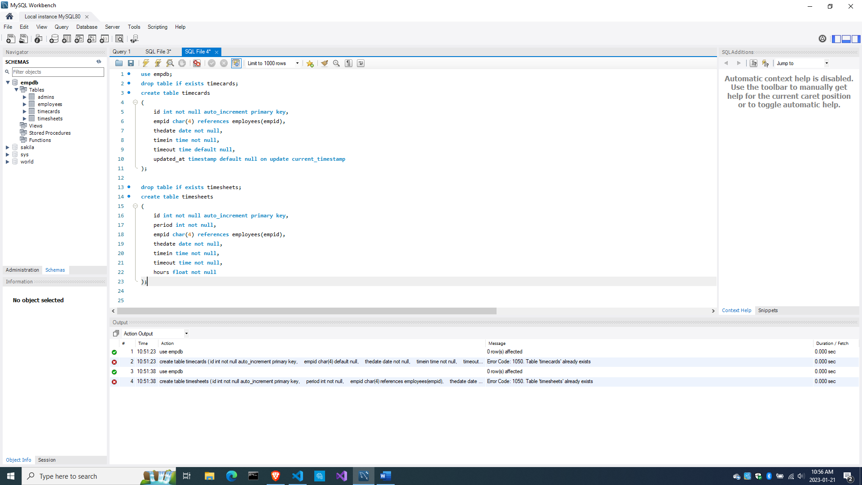

With this, we can start with the timekeeping subsystem.

Create the bundy project

Create a new project named bundy. To save us time, simply copy the whole lorem folder into a new folder called bundy in File Explorer.

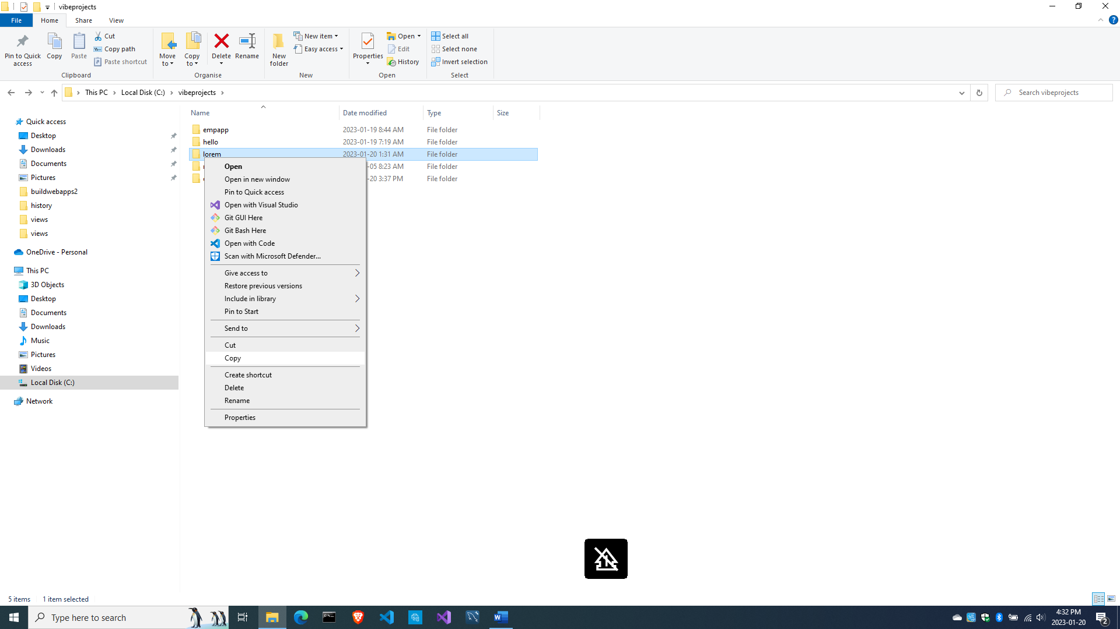

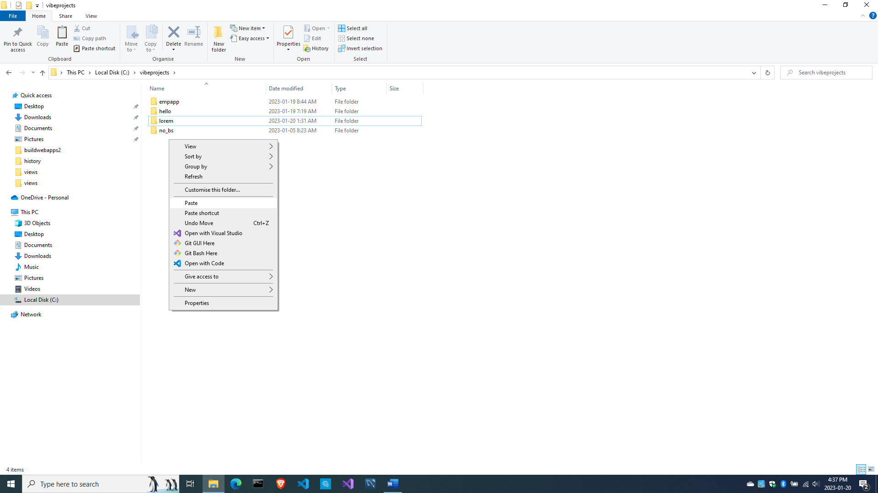

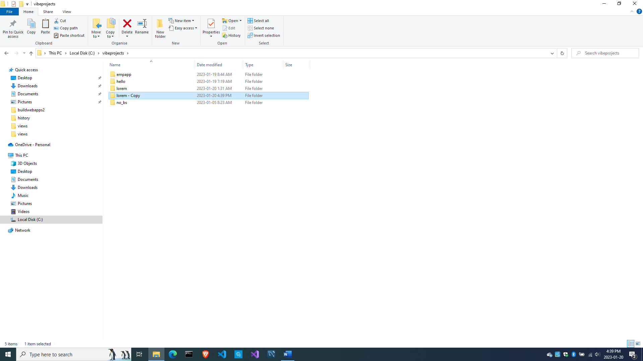

Then simply rename lorem – Copy into bundy

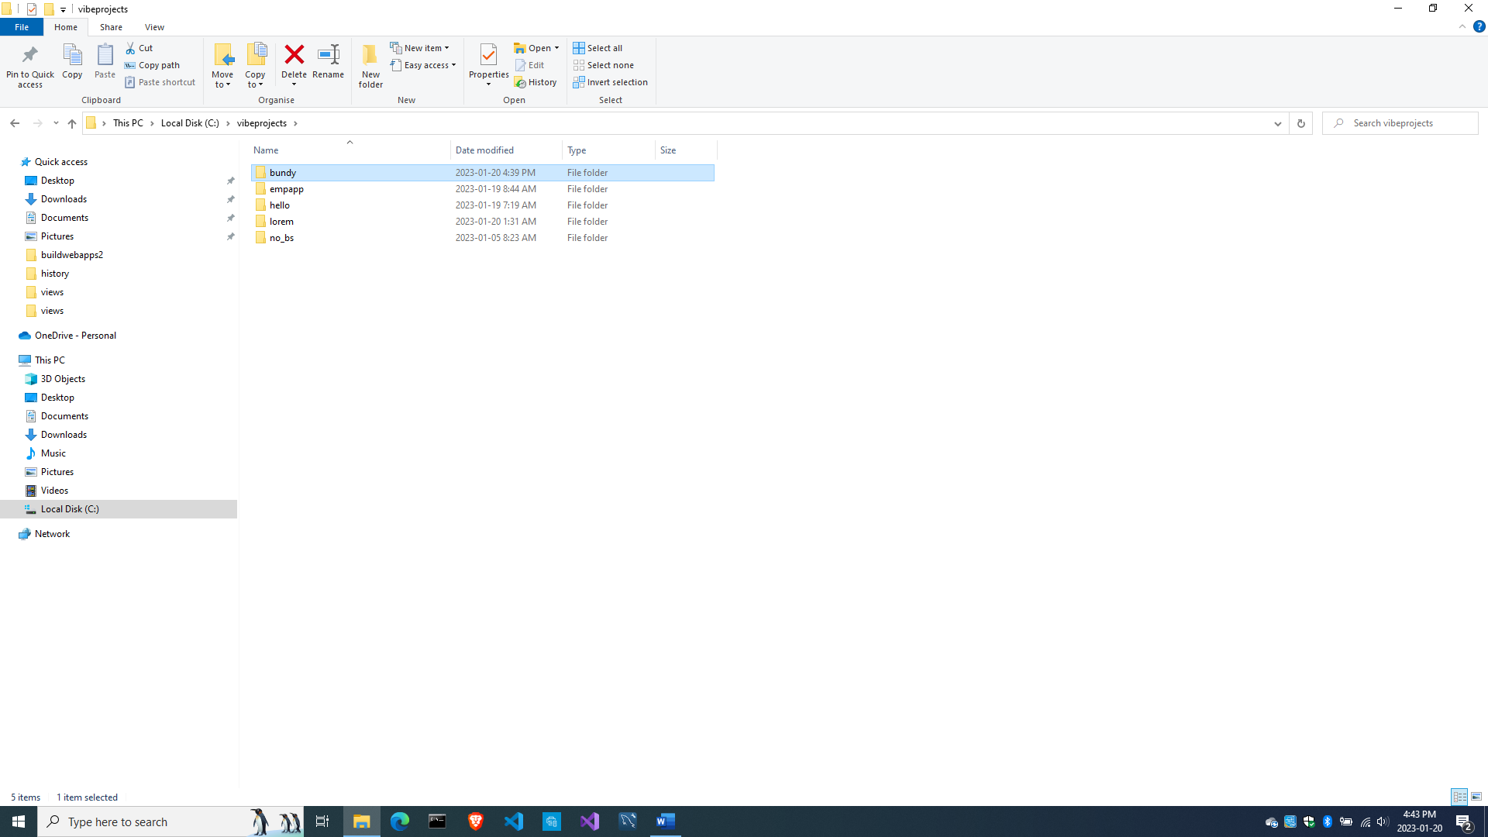

Then open the bundy folder in VS Code.

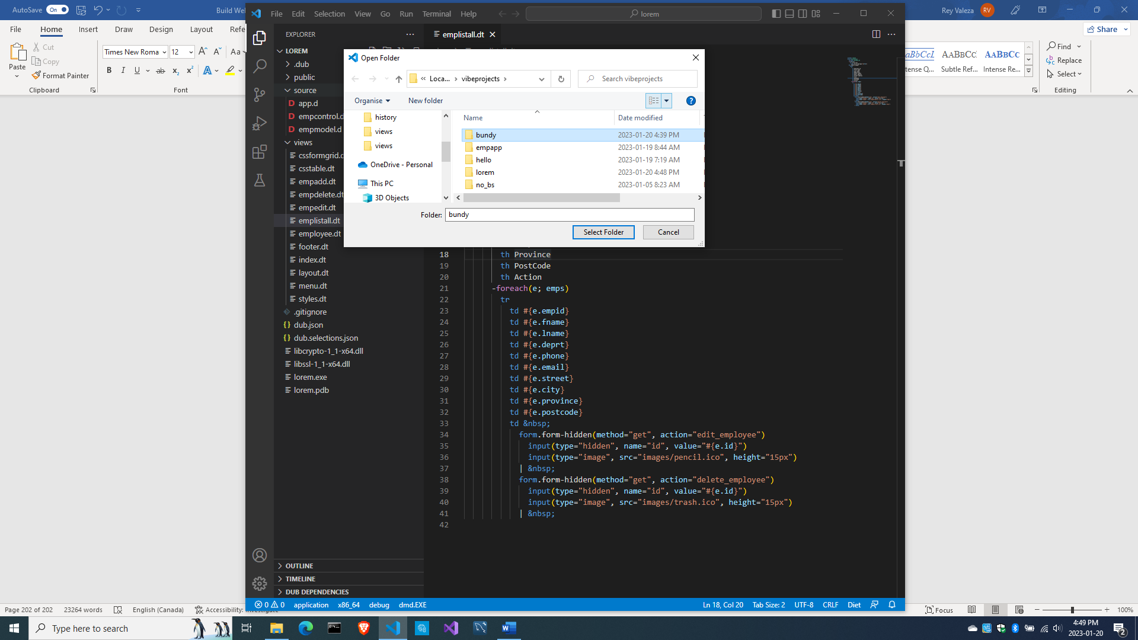

And edit dub.json so it doesn’t get confused. Rename ‘lorem’ to ‘bundy’.

{

  "authors": [

    "Owner"

  ],

  "copyright": "Copyright © 2023, Owner",

  "dependencies": {

    "mysql-native": "~>3.2.0",

    "vibe-d": "~>0.9"

  },

  "description": "A simple vibe.d server application.",

  "license": "proprietary",

  "name": "bundy"

}

And compile and run to make sure everything’s working.

c:\vibeprojects>**cd bundy**

c:\vibeprojects\bundy>**dub**

Now let’s change the look for this project.

A new menu look

Let us have a revamped look for this project.

Edit views\layout.dt

doctype 5

html

  head

    title Employee Timekeeping System

    include csslayout.dt

  body

    div.container

      div.menu

        include menu.dt

      div.content

        block maincontent

      div.footer

        include footer.dt

Then rename views\styles.dt into views\csslayout.dt with this contents

:css

  body

  {

    margin: 0;

    padding: 0;

  }

  .container

  {

    display: grid;

    grid-template-rows: 30px auto 30px;

    height: 100%;

    width: 100%;

    margin: 0;

    padding: 0;

  }

  .menu

  {

    margin: 0;

    padding: 0;

  }

  /*modal form styles******************************************/

  .modal-form

  {

    position: fixed;

    font-family: 'Segoe UI', Tahoma, Geneva, Verdana, sans-serif;

    top: 0;

    right: 0;

    bottom: 0;

    left: 0;

    background: rgba(0,0,0,0.5);

    z-index: 99999;

    opacity: 0;

    pointer-events: none;

  }

  #login:target, #find_employee:target

  {

    opacity: 1;

    pointer-events: auto;

  }

  .modal-form-grid

  {

    display: grid;

    grid-template: 30px 30px 30px / 1fr 1fr;

    grid-gap: 10px;

  }

  .text-control

  {

    grid-column: 1 / 3;

  }

  #but-reset

  {

    grid-column: 1 / 2;

  }

  #but-submit

  {

    grid-column: 2 / 3;

  }

  .modal-form-wrapper-login

  {

    width: 250px;

    position: absolute;

    right: 0;

    margin-top: 40px;

    padding: 25px 20px;

    border-radius: 10px;

    text-align: center;

    background-color: whitesmoke;

  }

  .modal-form-wrapper-find_employee

  {

    width: 250px;

    position: relative;

    left: 280px;

    margin-top: 40px;

    padding: 25px 20px;

    border-radius: 10px;

    text-align: center;

    background-color: whitesmoke;

  }

  /*end of modal form styles*/

  /*content styles**************************************************/

  .content

  {

    padding: 40px 30px;

    font-family: Sans-serif;

  }

  /*end of content styles/*

  /*footer styles***************************************************/

  .footer

  {

    position: fixed;

    bottom: 0;

    width: 100%;

    background-color: lightgray;

    padding: 5px 0;

  }

  .copyright

  {

    font-family: Verdana, Geneva, Tahoma, sans-serif;

    font-size: 14px;

    text-align: center;

    color: teal;

  }

  .error-div

  {

    margin: 5px 0;

  }

  .error-message

  {

    color: brown;

    font-weight: bold;

  }

  .center-align

  {

    margin: 0 auto;

    text-align: center;

  }

  .right-align

  {

    text-align: right;

  }

  .form-hidden

  {

    padding: 0;

    margin: 0;

    display: inline;

  }

Next, edit views\menu.dt.

include cssmenu.dt

nav

  ul

    li

      a(href="/") Home

    li

      a(href="#") Punch card

      ul

        li

          a(href="time_in") Punch in

        li

          a(href="time_out") Punch out

        li

          a(href="card_review") View cards

        li

          a(href="create_timesheet") Create timesheet

    li

      a(href="#") Employees

      ul

        li

          a(href="all_employees") Show all employees

        li

          a(href="#find_employee") Find an employee

        li

          a(href="add_employee") Add new employee

  ul.link-right

    li

      a(href="#login") Login

div#find_employee.modal-form

  div.modal-form-wrapper-find_employee

    form.modal-form-grid(method="post", action="find_employee")

      input.text-control(name="fname", type="text", placeholder=" First name", required)

      input.text-control(name="lname", type="text", placeholder=" Last name", required)

      input#but-reset(type="reset", value="Clear")

      input#but-submit(type="submit", value="Find")

    a.close(href="#close") Cancel

div#login.modal-form

  div.modal-form-wrapper-login

    form.modal-form-grid(method="post", action="login")

      input.text-control(name="email", type="email", placeholder=" email address")

      input.text-control(name="password", type="password", placeholder=" password")

      input#but-reset(type="reset", value="Clear")

      input#but-submit(type="submit", value="Login")

    a.close(href="#close") Cancel

This template needs views\cssmenu.dt, so let’s create it.

:css

  nav

  {

    margin: 0 auto;

    padding:0;

    width: 100%;

    height: auto;

    display: inline-block;

    background: teal; /*#37bc9b;*/

    font-family: Verdana, Geneva, Tahoma, sans-serif;

  }

  nav ul

  {

    margin:0;

    padding:0;

    list-style-type:none;

    float:left;

    display:inline-block;

  }

  nav ul li

  {

    position: relative;

    margin: 0;

    float: left;

    display: inline-block;

  }

  li > a:after { content: ' »'; } /* Change this in order to change the Dropdown symbol */

  li > a:only-child:after { content: ''; }

  nav ul li a

  {

    padding: 15px 20px;

    display: inline-block;

    color: white;

    text-decoration: none;

  }

  nav ul li a:hover

  {

    opacity: 0.5;

  }

  nav ul li ul

  {

    display: none;

    position: absolute;

    left: 0;

    background: #076;

    float: left;

    width: 200px;

  }

  nav ul li ul li

  {

    width: 100%;

    border-bottom: 1px solid rgba(255,255,255,.3);

  }

  nav ul li ul li a

  {

    padding: 10px 20px;

  }

  nav ul li:hover ul

  {

    display: block;

  }

  .link-right

  {

    float: right;

    margin-right: 20px;

  }

Now let’s see what we did.

c:\vibeprojects\bundy>**dub**

Starting Performing "debug" build using C:\D\dmd2\windows\bin\dmd.exe for x86_64.

Up-to-date taggedalgebraic 0.11.22: target for configuration [library] is up to date.

Up-to-date eventcore 0.9.21: target for configuration [winapi] is up to date.

…

Compiling Diet HTML template empadd.dt...

Compiling Diet HTML template emplistall.dt...

Compiling Diet HTML template empedit.dt...

Compiling Diet HTML template empdelete.dt...

Compiling Diet HTML template employee.dt...

Linking bundy

Finished To force a rebuild of up-to-date targets, run again with --force

Copying files for vibe-d:tls...

Running bundy.exe

[main(----) INF] Listening for requests on http://[::1]:8080/

[main(----) INF] Listening for requests on <http://127.0.0.1:8080/>

And we see this:

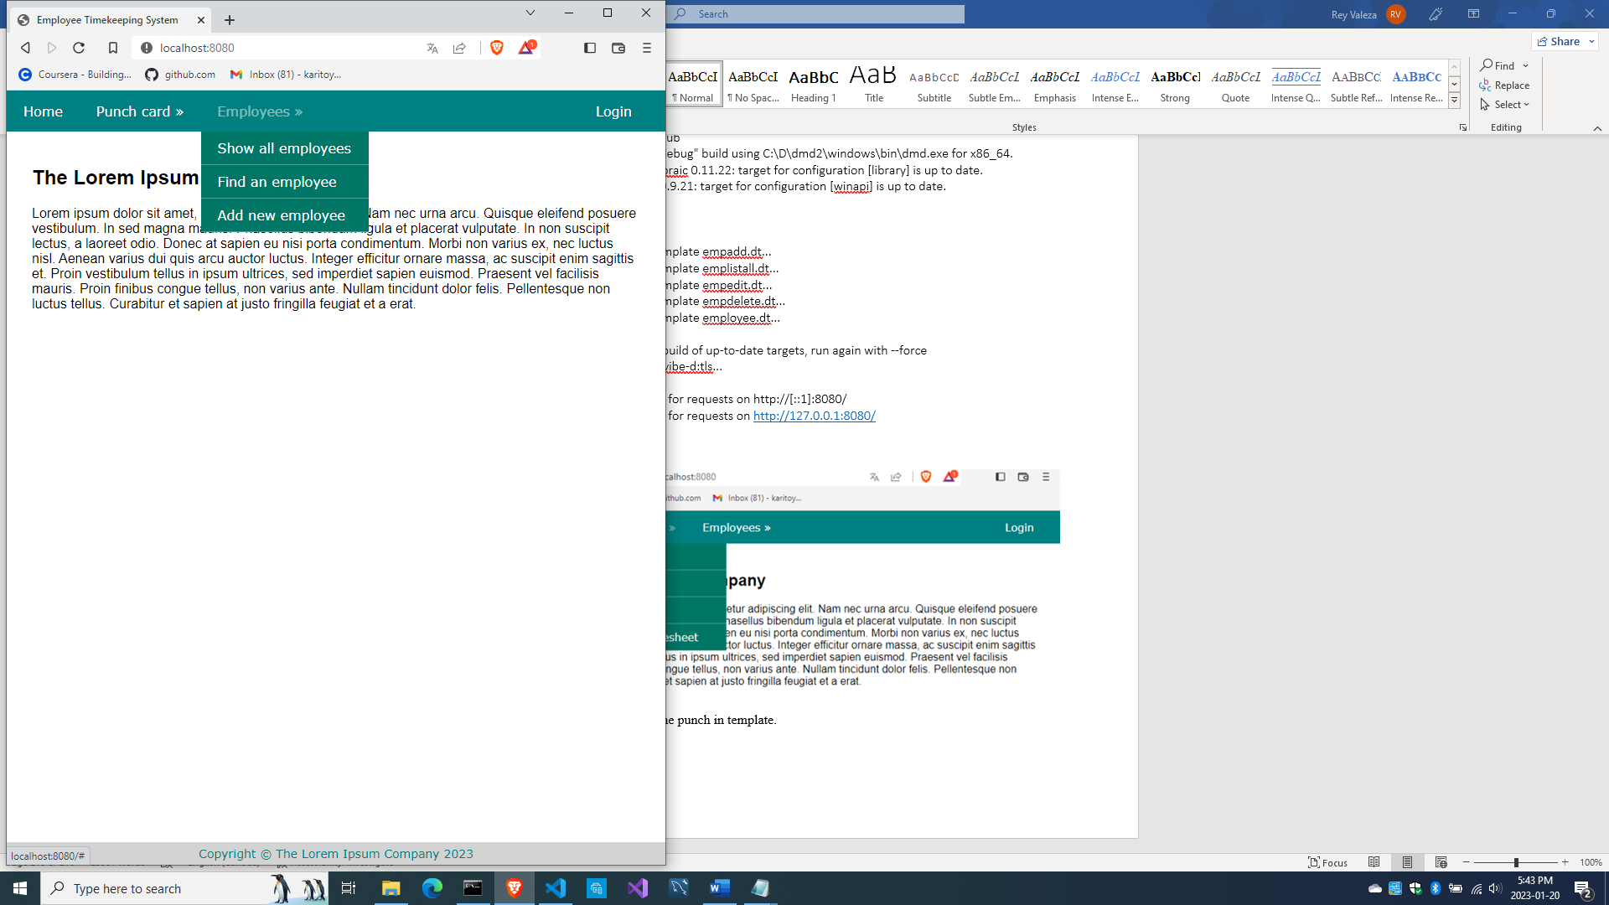

Okay, now let’s revamp the views\emplistall.dt.

extends layout

block maincontent

  include csstable

  -if(error)

    div.error-div

      span.error-message #{error}

  h2 Employees of The Lorem Ipsum Company

  div.table-wrapper

    table

      tr

        th First name

        th Last name

        th Department

        th Phone number

        th Email address

        th Action

      -foreach(e; emps)

        tr

          td #{e.fname}

          td #{e.lname}

          td #{e.deprt}

          td #{e.phone}

          td #{e.email}

          td &nbsp;

            form.form-hidden(method="get", action="edit_employee")

              input(type="hidden", name="id", value="#{e.id}")

              input(type="image", src="images/pencil.ico", height="15px")

            | &nbsp;

            form.form-hidden(method="get", action="delete_employee")

              input(type="hidden", name="id", value="#{e.id}")

              input(type="image", src="images/trash.ico", height="15px")

            | &nbsp;

And edit views\csstable.dt.

:css

  .table-wrapper

  {

    margin: 20px auto;

  }

  table

  {

    padding: 10px 0;

    border-spacing: 0;

    border-collapse: collapse;

  }

  table td, table th

  {

    margin: 0;

    padding: 2px 10px;

  }

  .no-border

  {

    border: 0;

  }

  tr:nth-child(odd)

  {

    background: whitesmoke;

  }

Now let’s review what we just did again. Compile and run and refresh the browser. Remember to login to view the employees.

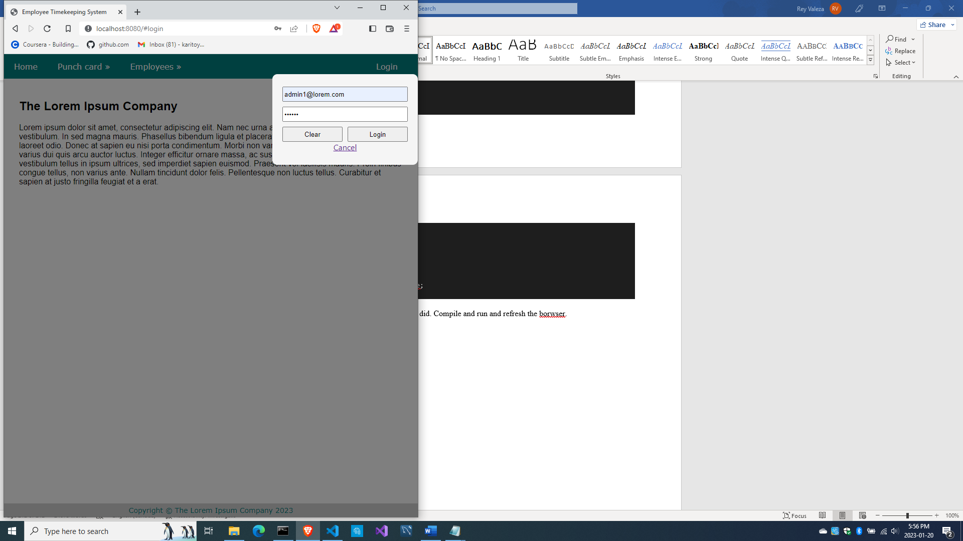

And we get this.

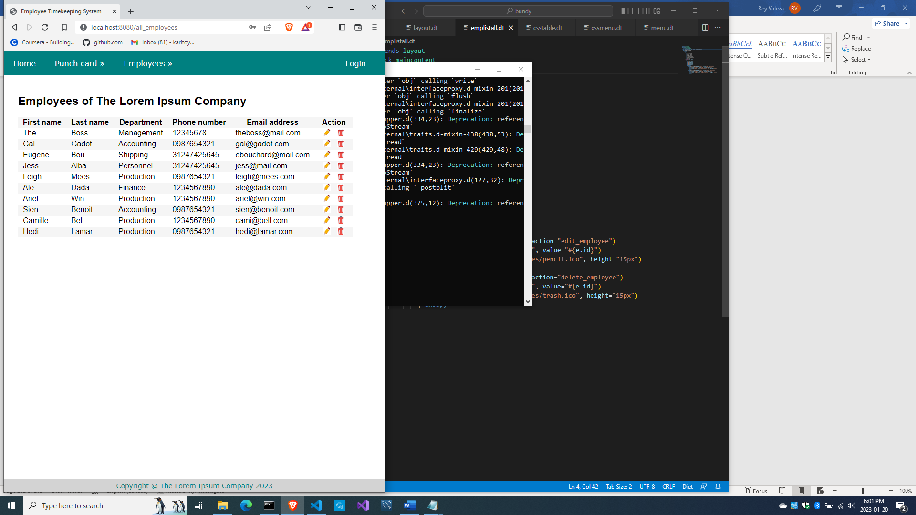

Let’s rename source\empcontrol.d to source\bundycontrol.d.

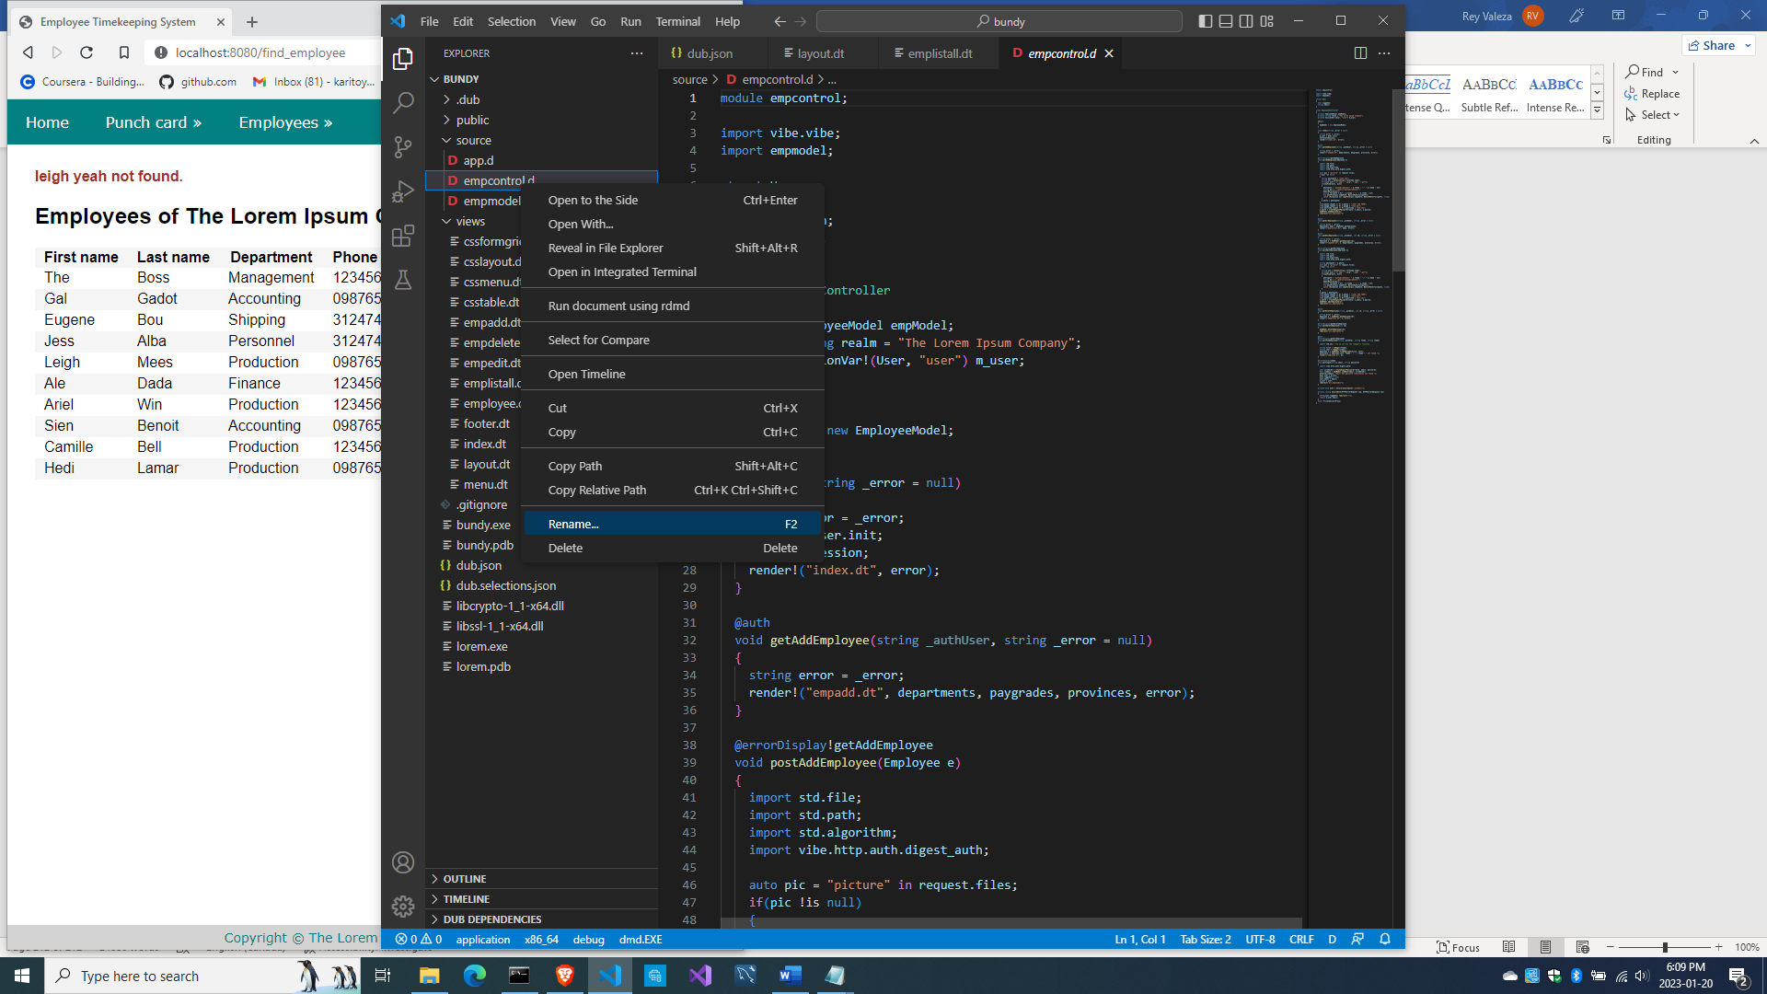

And change the class name to BundyController

module bundycontrol;

import vibe.vibe;

import empmodel;

struct User

{

  bool loggedIn;

  string email;

}

class BundyController

{

  private EmployeeModel empModel;

  private string realm = "The Lorem Ipsum Company";

  private SessionVar!(User, "user") m_user;

  this()

  {

    empModel = new EmployeeModel;

  }

...

And edit source\app.d to instantiate BundyController instead, after importing bundycontrol.

import bundycontrol;

then

  router.registerWebInterface(new BundyController);

and compile and run to test the whole thing.

So here’s the whole source\app.d for now:

import vibe.vibe;

import bundycontrol;

void main()

{

  auto settings = new HTTPServerSettings;

  settings.port = 8080;

  settings.bindAddresses = ["::1", "127.0.0.1"];

  settings.sessionStore = new MemorySessionStore;

  auto router = new URLRouter;

  router.get("*", serveStaticFiles("public/"));

  router.registerWebInterface(new BundyController);

  auto listener = listenHTTP(settings, router);

  scope (exit) listener.stopListening();

  runApplication();

}

So here’s all of source\bundycontrol.d for now:

module bundycontrol;

import vibe.vibe;

import empmodel;

struct User

{

  bool loggedIn;

  string email;

}

class BundyController

{

  private EmployeeModel empModel;

  private string realm = "The Lorem Ipsum Company";

  private SessionVar!(User, "user") m_user;

  this()

  {

    empModel = new EmployeeModel;

  }

  void index(string _error = null)

  {

    string error = _error;

    m_user = User.init;

    terminateSession;

    render!("index.dt", error);

  }

  @auth

  void getAddEmployee(string _authUser, string _error = null)

  {

    string error = _error;

    render!("empadd.dt", departments, paygrades, provinces, error);

  }

  @errorDisplay!getAddEmployee

  void postAddEmployee(Employee e)

  {

    import std.file;

    import std.path;

    import std.algorithm;

    import vibe.http.auth.digest_auth;

    auto pic = "picture" in request.files;

    if(pic !is null)

    {

      string photopath = "none yet";

      string ext = extension(pic.filename.name);

      string[] exts = [".jpg", ".jpeg", ".png", ".gif"];

      if(canFind(exts, ext))

      {

        photopath = "uploads/photos/" ~ e.fname ~ "_" ~ e.lname ~ ext;

        string dir = "./public/uploads/photos/";

        mkdirRecurse(dir);

        string fullpath = dir ~ e.fname ~ "_" ~ e.lname ~ ext;

        try moveFile(pic.tempPath, NativePath(fullpath));

        catch (Exception ex) copyFile(pic.tempPath, NativePath(fullpath), true);

      }

      e.photo = photopath;

    }

    if(e.phone.length == 0) e.phone = "(123) 456 7890";

    if(e.paygd.length == 0) e.paygd = "none yet";

    if(e.postcode.length == 0) e.postcode = "A1A 1A1";

    e.pword = createDigestPassword(realm, e.email, e.pword);

    empModel.addEmployee(e);

    redirect("all_employees");

  }

  @auth

  void getAllEmployees(string _authUser, string _error = null)

  {

    string error = _error;

    Employee[] emps = empModel.getEmployees;

    render!("emplistall.dt", emps, error);

  }

  @auth

  void getEditEmployee(string _authUser, int id, string _error = null)

  {

    string error = _error;

    Employee e = empModel.getEmployee(id);

    render!("empedit.dt", e, departments, paygrades, provinces, error);

  }

  @errorDisplay!getEditEmployee

  void postEditEmployee(Employee e)

  {

    import std.file;

    import std.path;

    import std.algorithm;

    import vibe.http.auth.digest_auth;

    string photopath = e.photo;

    auto pic = "picture" in request.files;

    if(pic !is null)

    {

      string ext = extension(pic.filename.name);

      string[] exts = [".jpg", ".jpeg", ".png", ".gif"];

      if(canFind(exts, ext))

      {

        photopath = "uploads/photos/" ~ e.fname ~ "_" ~ e.lname ~ ext;

        string dir = "./public/uploads/photos/";

        mkdirRecurse(dir);

        string fullpath = dir ~ e.fname ~ "_" ~ e.lname ~ ext;

        try moveFile(pic.tempPath, NativePath(fullpath));

        catch (Exception ex) copyFile(pic.tempPath, NativePath(fullpath), true);

      }

    }

    e.photo = photopath;

    if(e.phone.length == 0) e.phone = "(123) 456 7890";

    if(e.paygd.length == 0) e.paygd = "none yet";

    if(e.postcode.length == 0) e.postcode = "A1A 1A1";

    e.pword = createDigestPassword(realm, e.email, e.pword);

    empModel.editEmployee(e);

    redirect("all_employees");

  }

  @auth

  void getDeleteEmployee(string _authUser, int id, string _error = null)

  {

    string error = _error;

    Employee e = empModel.getEmployee(id);

    render!("empdelete.dt", e, error);

  }

  @errorDisplay!getDeleteEmployee

  void postDeleteEmployee(int id)

  {

    empModel.deleteEmployee(id);

    redirect("all_employees");

  }

  @auth

  @errorDisplay!getAllEmployees

  void postFindEmployee(string _authUser, string fname, string lname)

  {

    import std.uni; //so we can use the toUpper() function

    string first = toUpper(fname);

    string last = toUpper(lname);

    Employee e = empModel.findEmployee(first, last);

    enforce(e != Employee.init, first ~ " " ~ last ~ " not found.");

    render!("employee.dt", e);

  }

  @errorDisplay!index

  void postLogin(string email, string password)

  {

    import vibe.http.auth.digest_auth;

    auto scrambled = createDigestPassword(realm, email, password);

    bool isAdmin = empModel.isAdmin(email, scrambled);

    enforce(isAdmin, "Email and password combination not found.");

    User user = m_user;

    user.loggedIn = true;

    user.email = email;

    m_user = user;

    redirect("all_employees");

  }

  private enum auth = before!ensureAuth("_authUser");

  private string ensureAuth(HTTPServerRequest req, HTTPServerResponse res)

  {

    if(!m_user.loggedIn) redirect("/");

    return m_user.email;

  }

  mixin PrivateAccessProxy;

}

Now we can start with the timekeeping part.

Creating the time-in form

Create views\timein.dt.

extends layout

block maincontent

  include cssformgrid.dt

  div.form-grid-wrapper

    br

    h1#time.center-align

    br

    form.form-grid(method="post", action="time_in")

      label.form-grid-label Employee:

      select#empid.form-grid-input(name="empid")

        -foreach(e; emps)

          option(value="#{e.empid}") #{e.empid} - #{e.fname} #{e.lname}

      div

      div

        input.form-grid-button(type="submit", value="Punch in!")

  :javascript

    const displayTime = document.querySelector("#time");

    function showTime() {

      let time = new Date();

      displayTime.innerText = time.toLocaleString("en-CA", { hour12: true });

      setTimeout(showTime, 1000);

    }

    showTime();

and edit source\bundycontrol.d and add this method:

  void getTimeIn()

  {

    Employee[] emps = empModel.getEmployees;

    render!("timein.dt", emps);

  }

Now compile, run, refresh the browser and access the Punch in page

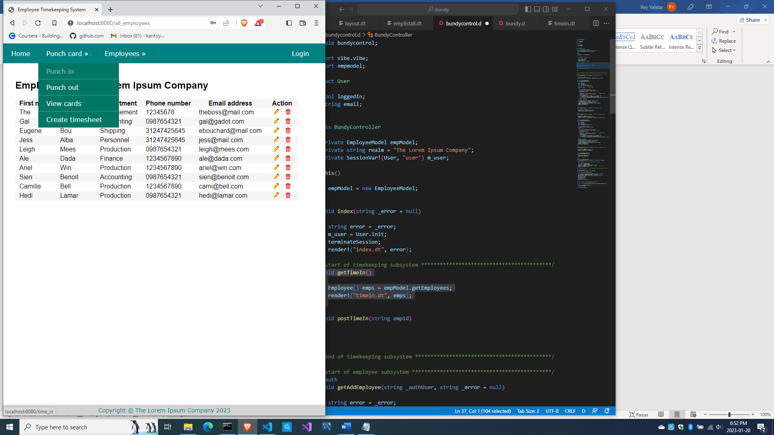

And this should show

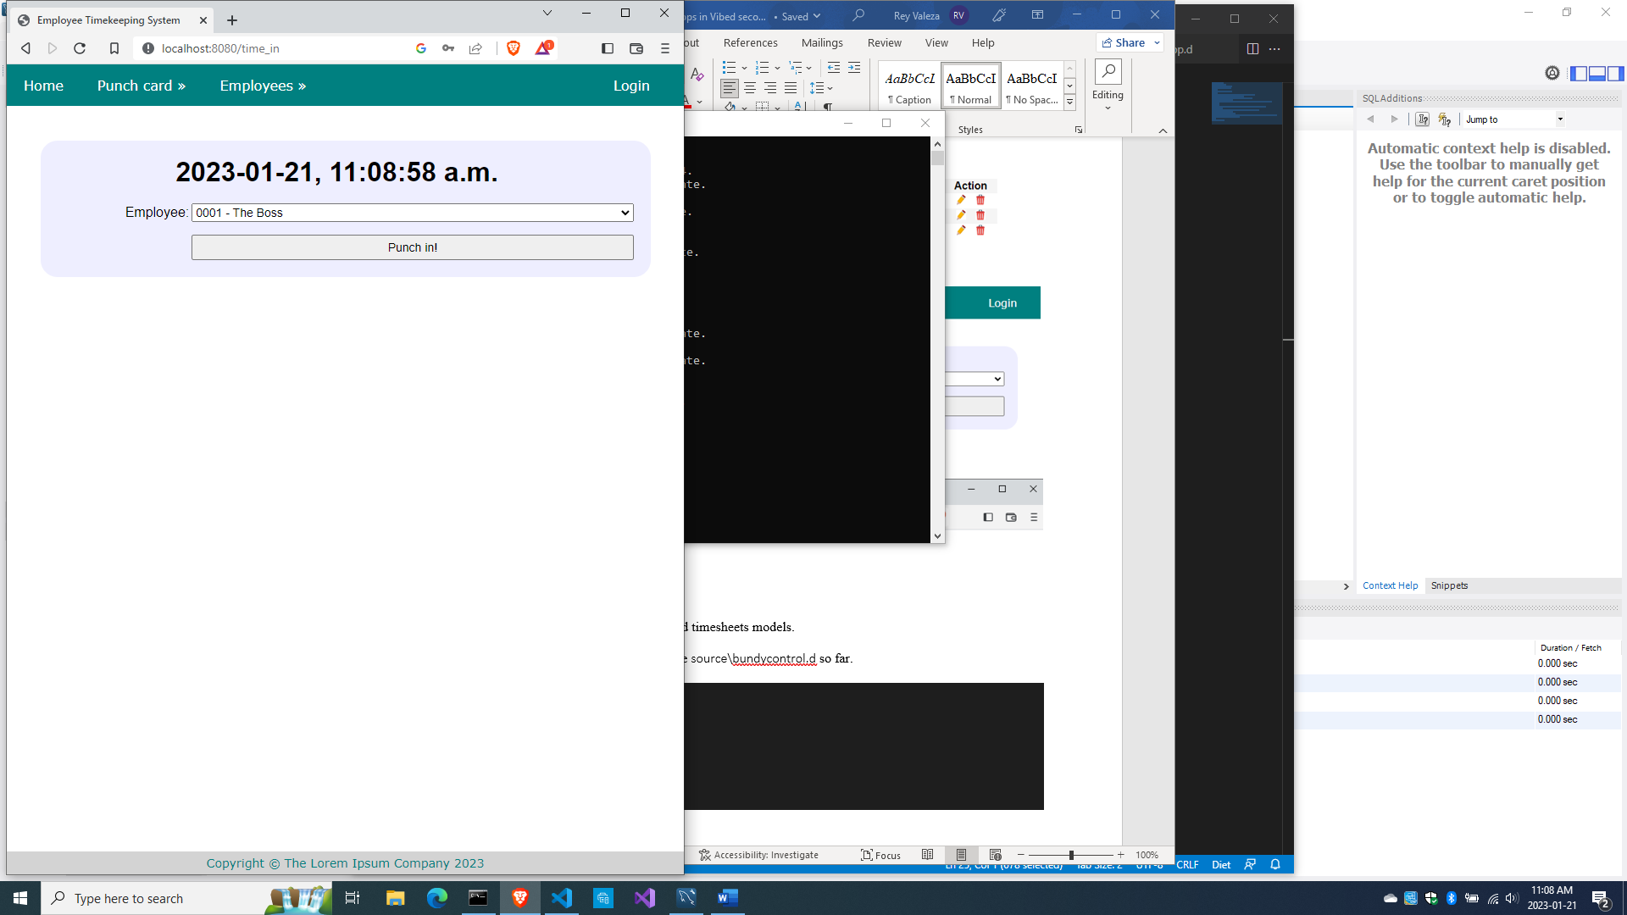

But when you press ‘Punch in!’, you get this message

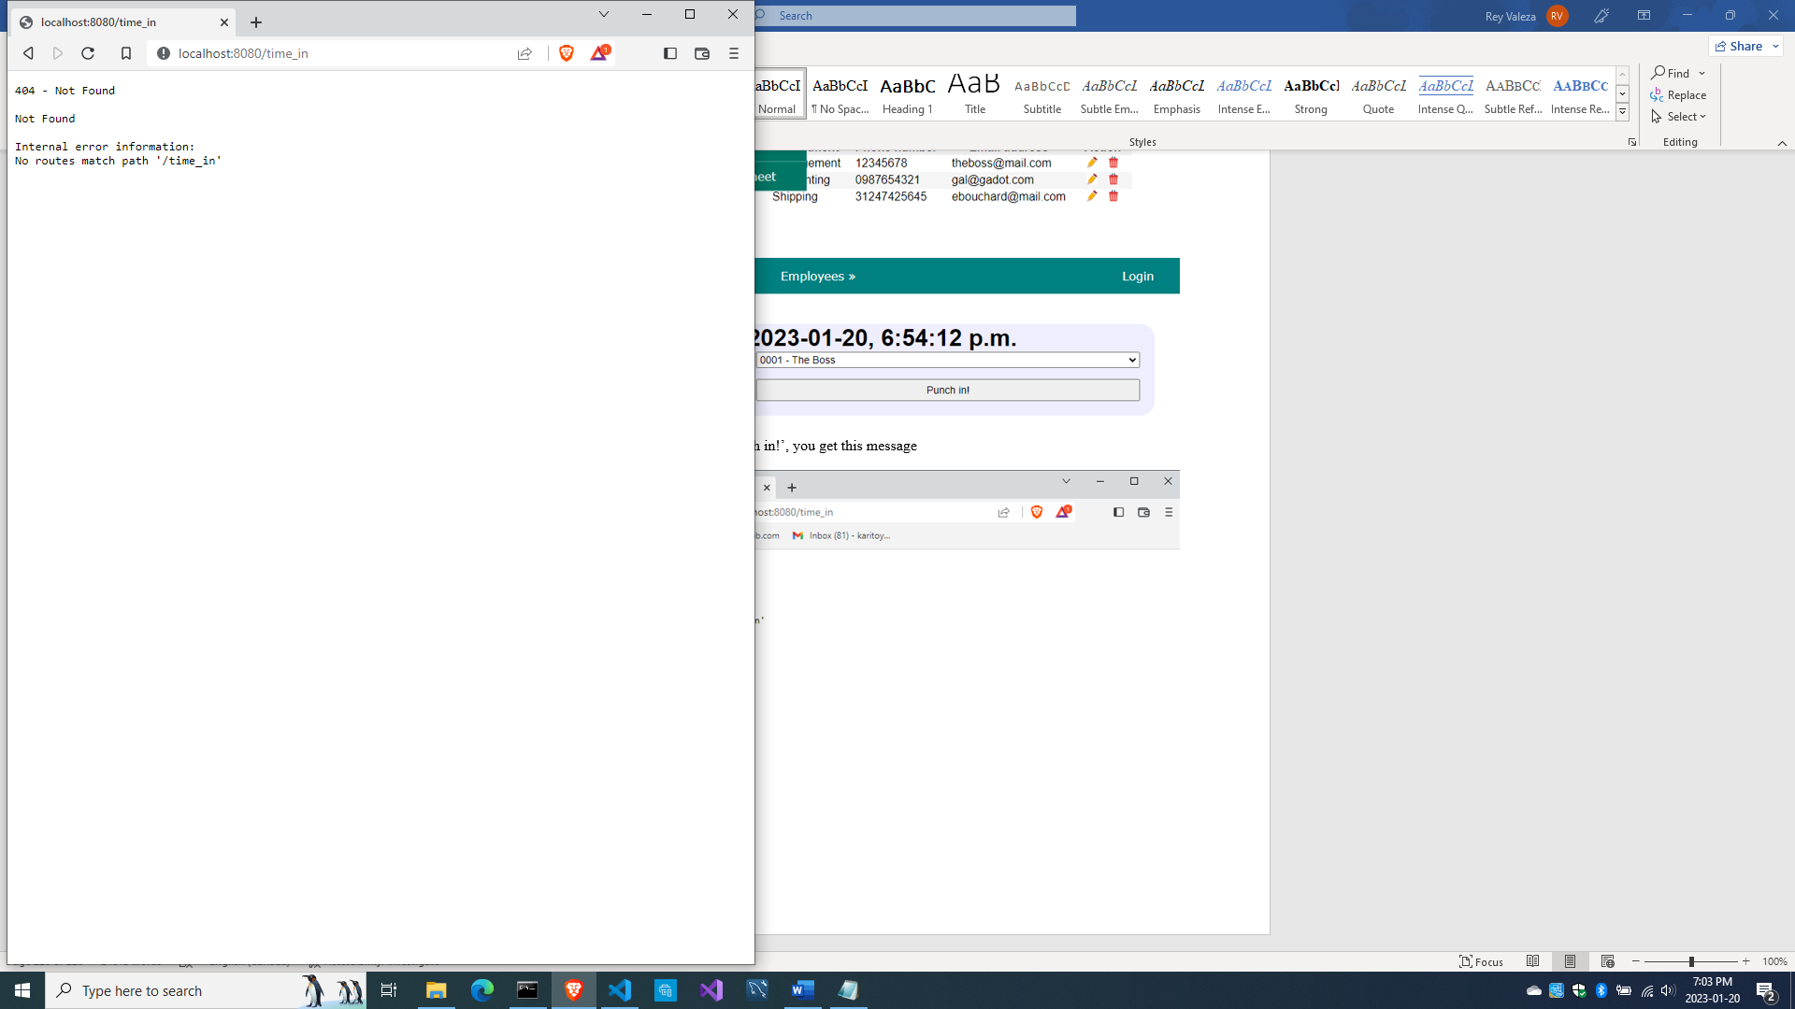

Time to create the timecards and timesheets models.

Meanwhile, here is the complete source\bundycontrol.d so far.

module bundycontrol;

import vibe.vibe;

import empmodel;

struct User

{

  bool loggedIn;

  string email;

}

class BundyController

{

  private EmployeeModel empModel;

  private string realm = "The Lorem Ipsum Company";

  private SessionVar!(User, "user") m_user;

  this()

  {

    empModel = new EmployeeModel;

  }

  void index(string _error = null)

  {

    string error = _error;

    m_user = User.init;

    terminateSession;

    render!("index.dt", error);

  }

/* start of employee subsystem *********************************************/

  @auth

  void getAddEmployee(string _authUser, string _error = null)

  {

    string error = _error;

    render!("empadd.dt", departments, paygrades, provinces, error);

  }

  @errorDisplay!getAddEmployee

  void postAddEmployee(Employee e)

  {

    import std.file;

    import std.path;

    import std.algorithm;

    import vibe.http.auth.digest_auth;

    auto pic = "picture" in request.files;

    if(pic !is null)

    {

      string photopath = "none yet";

      string ext = extension(pic.filename.name);

      string[] exts = [".jpg", ".jpeg", ".png", ".gif"];

      if(canFind(exts, ext))

      {

        photopath = "uploads/photos/" ~ e.fname ~ "_" ~ e.lname ~ ext;

        string dir = "./public/uploads/photos/";

        mkdirRecurse(dir);

        string fullpath = dir ~ e.fname ~ "_" ~ e.lname ~ ext;

        try moveFile(pic.tempPath, NativePath(fullpath));

        catch (Exception ex) copyFile(pic.tempPath, NativePath(fullpath), true);

      }

      e.photo = photopath;

    }

    if(e.phone.length == 0) e.phone = "(123) 456 7890";

    if(e.paygd.length == 0) e.paygd = "none yet";

    if(e.postcode.length == 0) e.postcode = "A1A 1A1";

    e.pword = createDigestPassword(realm, e.email, e.pword);

    empModel.addEmployee(e);

    redirect("all_employees");

  }

  @auth

  void getAllEmployees(string _authUser, string _error = null)

  {

    string error = _error;

    Employee[] emps = empModel.getEmployees;

    render!("emplistall.dt", emps, error);

  }

  @auth

  void getEditEmployee(string _authUser, int id, string _error = null)

  {

    string error = _error;

    Employee e = empModel.getEmployee(id);

    render!("empedit.dt", e, departments, paygrades, provinces, error);

  }

  @errorDisplay!getEditEmployee

  void postEditEmployee(Employee e)

  {

    import std.file;

    import std.path;

    import std.algorithm;

    import vibe.http.auth.digest_auth;

    string photopath = e.photo;

    auto pic = "picture" in request.files;

    if(pic !is null)

    {

      string ext = extension(pic.filename.name);

      string[] exts = [".jpg", ".jpeg", ".png", ".gif"];

      if(canFind(exts, ext))

      {

        photopath = "uploads/photos/" ~ e.fname ~ "_" ~ e.lname ~ ext;

        string dir = "./public/uploads/photos/";

        mkdirRecurse(dir);

        string fullpath = dir ~ e.fname ~ "_" ~ e.lname ~ ext;

        try moveFile(pic.tempPath, NativePath(fullpath));

        catch (Exception ex) copyFile(pic.tempPath, NativePath(fullpath), true);

      }

    }

    e.photo = photopath;

    if(e.phone.length == 0) e.phone = "(123) 456 7890";

    if(e.paygd.length == 0) e.paygd = "none yet";

    if(e.postcode.length == 0) e.postcode = "A1A 1A1";

    e.pword = createDigestPassword(realm, e.email, e.pword);

    empModel.editEmployee(e);

    redirect("all_employees");

  }

  @auth

  void getDeleteEmployee(string _authUser, int id, string _error = null)

  {

    string error = _error;

    Employee e = empModel.getEmployee(id);

    render!("empdelete.dt", e, error);

  }

  @errorDisplay!getDeleteEmployee

  void postDeleteEmployee(int id)

  {

    empModel.deleteEmployee(id);

    redirect("all_employees");

  }

  @auth

  @errorDisplay!getAllEmployees

  void postFindEmployee(string _authUser, string fname, string lname)

  {

    import std.uni; //so we can use the toUpper() function

    string first = toUpper(fname);

    string last = toUpper(lname);

    Employee e = empModel.findEmployee(first, last);

    enforce(e != Employee.init, first ~ " " ~ last ~ " not found.");

    render!("employee.dt", e);

  }

/* end of employee subsystem ***********************************************/

  @errorDisplay!index

  void postLogin(string email, string password)

  {

    import vibe.http.auth.digest_auth;

    auto scrambled = createDigestPassword(realm, email, password);

    bool isAdmin = empModel.isAdmin(email, scrambled);

    enforce(isAdmin, "Email and password combination not found.");

    User user = m_user;

    user.loggedIn = true;

    user.email = email;

    m_user = user;

    redirect("all_employees");

  }

  private enum auth = before!ensureAuth("_authUser");

  private string ensureAuth(HTTPServerRequest req, HTTPServerResponse res)

  {

    if(!m_user.loggedIn) redirect("/");

    return m_user.email;

  }

  mixin PrivateAccessProxy;

/* start of timekeeping subsystem ******************************************/

  void getTimeIn()

  {

    Employee[] emps = empModel.getEmployees;

    render!("timein.dt", emps);

  }

/* end of timekeeping subsystem ********************************************/

}

The timecard model

This is the schema we defined for our punch card system:

create table timecards

(

id int not null auto_increment primary key,

empid char(4) references employees(empid),

thedate date not null,

timein time not null,

timeout time default null,

updated_at timestamp default null on update current_timestamp

);

create table timesheets

(

id int not null auto_increment primary key,

period int not null,

empid char(4) references employees(empid),

thedate date not null,

timein time not null,

timeout time not null,

hours float not null

);

So here is source\cardmodel.d

module cardmodel;

import mysql;

import std.array;

import std.conv;

struct Timecard

{

  int id;

  string empid;

  string thedate;

  string timein;

  string timeout;

}

class TimecardModel

{

  Connection conn;

  this()

  {

    string url = "host=localhost;port=3306;user=owner;pwd=qwerty;db=empdb";

    conn = new Connection(url);

    scope(exit) conn.close;

  }

  bool timeIn(string empid)

  {

    string sql = "insert into timecards(empid, thedate, timein) values(?, curdate(), curtime())";

    Prepared pstmt = conn.prepare(sql);

    pstmt.setArgs(empid);

    conn.exec(pstmt);

    return true;

  }

  bool noTimeInYet(string empid)

  {

    string sql = "select * from timecards where empid=? and thedate=?";

    Prepared pstmt = conn.prepare(sql);

    string today = getToday;

    pstmt.setArgs(empid, today);

    Row[] rows = conn.query(pstmt).array;

    if(rows.length == 0) return true;

    return false;

  }

  string getToday()

  {

    Row[] rows = conn.query("select curdate() + 0").array;

    return to!string(rows[0][0]);

  }

  Timecard[] getCards()

  {

    Timecard[] cards;

    string sql = "select * from timecards order by thedate desc, timein desc";

    Row[] rows = conn.query(sql).array;

    if(rows.length == 0) return cards;

    foreach(row; rows)

    {

      Timecard c;

      c.id = to!int(to!string(row[0]));

      c.empid = to!string(row[1]);

      c.thedate = to!string(row[2]);

      c.timein = to!string(row[3]);

      c.timeout = to!string(row[4]);

      cards ~= c;

    }

    return cards;

  }

}

And here is source\bundycontrol.d

module bundycontrol;

import vibe.vibe;

import empmodel;

import cardmodel;

struct User

{

  bool loggedIn;

  string email;

}

class BundyController

{

  private EmployeeModel empModel;

  private TimecardModel cardModel;

  private string realm = "The Lorem Ipsum Company";

  private SessionVar!(User, "user") m_user;

  this()

  {

    empModel = new EmployeeModel;

    cardModel = new TimecardModel;

  }

  void index(string _error = null)

  {

    string error = _error;

    m_user = User.init;

    terminateSession;

    render!("index.dt", error);

  }

/* start of employee subsystem *********************************************/

  @auth

  void getAddEmployee(string _authUser, string _error = null)

  {

    string error = _error;

    render!("empadd.dt", departments, paygrades, provinces, error);

  }

  @errorDisplay!getAddEmployee

  void postAddEmployee(Employee e)

  {

    import std.file;

    import std.path;

    import std.algorithm;

    import vibe.http.auth.digest_auth;

    auto pic = "picture" in request.files;

    if(pic !is null)

    {

      string photopath = "none yet";

      string ext = extension(pic.filename.name);

      string[] exts = [".jpg", ".jpeg", ".png", ".gif"];

      if(canFind(exts, ext))

      {

        photopath = "uploads/photos/" ~ e.fname ~ "_" ~ e.lname ~ ext;

        string dir = "./public/uploads/photos/";

        mkdirRecurse(dir);

        string fullpath = dir ~ e.fname ~ "_" ~ e.lname ~ ext;

        try moveFile(pic.tempPath, NativePath(fullpath));

        catch (Exception ex) copyFile(pic.tempPath, NativePath(fullpath), true);

      }

      e.photo = photopath;

    }

    if(e.phone.length == 0) e.phone = "(123) 456 7890";

    if(e.paygd.length == 0) e.paygd = "none yet";

    if(e.postcode.length == 0) e.postcode = "A1A 1A1";

    e.pword = createDigestPassword(realm, e.email, e.pword);

    empModel.addEmployee(e);

    redirect("all_employees");

  }

  @auth

  void getAllEmployees(string _authUser, string _error = null)

  {

    string error = _error;

    Employee[] emps = empModel.getEmployees;

    render!("emplistall.dt", emps, error);

  }

  @auth

  void getEditEmployee(string _authUser, int id, string _error = null)

  {

    string error = _error;

    Employee e = empModel.getEmployee(id);

    render!("empedit.dt", e, departments, paygrades, provinces, error);

  }

  @errorDisplay!getEditEmployee

  void postEditEmployee(Employee e)

  {

    import std.file;

    import std.path;

    import std.algorithm;

    import vibe.http.auth.digest_auth;

    string photopath = e.photo;

    auto pic = "picture" in request.files;

    if(pic !is null)

    {

      string ext = extension(pic.filename.name);

      string[] exts = [".jpg", ".jpeg", ".png", ".gif"];

      if(canFind(exts, ext))

      {

        photopath = "uploads/photos/" ~ e.fname ~ "_" ~ e.lname ~ ext;

        string dir = "./public/uploads/photos/";

        mkdirRecurse(dir);

        string fullpath = dir ~ e.fname ~ "_" ~ e.lname ~ ext;

        try moveFile(pic.tempPath, NativePath(fullpath));

        catch (Exception ex) copyFile(pic.tempPath, NativePath(fullpath), true);

      }

    }

    e.photo = photopath;

    if(e.phone.length == 0) e.phone = "(123) 456 7890";

    if(e.paygd.length == 0) e.paygd = "none yet";

    if(e.postcode.length == 0) e.postcode = "A1A 1A1";

    e.pword = createDigestPassword(realm, e.email, e.pword);

    empModel.editEmployee(e);

    redirect("all_employees");

  }

  @auth

  void getDeleteEmployee(string _authUser, int id, string _error = null)

  {

    string error = _error;

    Employee e = empModel.getEmployee(id);

    render!("empdelete.dt", e, error);

  }

  @errorDisplay!getDeleteEmployee

  void postDeleteEmployee(int id)

  {

    empModel.deleteEmployee(id);

    redirect("all_employees");

  }

  @auth

  @errorDisplay!getAllEmployees

  void postFindEmployee(string _authUser, string fname, string lname)

  {

    import std.uni; //so we can use the toUpper() function

    string first = toUpper(fname);

    string last = toUpper(lname);

    Employee e = empModel.findEmployee(first, last);

    enforce(e != Employee.init, first ~ " " ~ last ~ " not found.");

    render!("employee.dt", e);

  }

/* end of employee subsystem ***********************************************/

  @errorDisplay!index

  void postLogin(string email, string password)

  {

    import vibe.http.auth.digest_auth;

    auto scrambled = createDigestPassword(realm, email, password);

    bool isAdmin = empModel.isAdmin(email, scrambled);

    enforce(isAdmin, "Email and password combination not found.");

    User user = m_user;

    user.loggedIn = true;

    user.email = email;

    m_user = user;

    redirect("all_employees");

  }

  private enum auth = before!ensureAuth("_authUser");

  private string ensureAuth(HTTPServerRequest req, HTTPServerResponse res)

  {

    if(!m_user.loggedIn) redirect("/");

    return m_user.email;

  }

  mixin PrivateAccessProxy;

/* start of timekeeping subsystem ******************************************/

  void getTimeIn()

  {

    Employee[] emps = empModel.getEmployees;

    render!("timein.dt", emps);

  }

  @errorDisplay!getAllCards

  void postTimeIn(string empid)

  {

    string fullname = getFullname(empid);

    //the record should not exist, otherwise employee already punched in earlier

    enforce(cardModel.noTimeIn(empid), fullname ~ " already punched in today");

    cardModel.timeIn(empid);

    redirect("all_cards");

  }

  string getFullname(string empid)

  {

    Employee e = empModel.getEmployee(empid);

    string fullname = to!string(e.fname) ~ " " ~ to!string(e.lname);

    return fullname;

  }

  void getAllCards(string _error)

  {

    string error = _error;

    bool loggedIn = m_user.loggedIn;

    string today = getToday;

    Timecard[] cards = cardModel.getCards();

    render!("cardlistall.dt", cards, today, error, loggedIn);

  }

  string getToday()

  {

    import std.datetime.date;

    auto time = Clock.currTime;

    return to!string(Date(time.year, time.month, time.day));

  }

/* end of timekeeping subsystem ********************************************/

}

And here is views\timein.dt

extends layout

block maincontent

  include cssformgrid.dt

  div.form-grid-wrapper

    br

    h1#time.center-align

    br

    form.form-grid(method="post", action="time_in")

      label.form-grid-label Employee:

      select#empid.form-grid-input(name="empid")

        -foreach(e; emps)

          option(value="#{e.empid}") #{e.empid} - #{e.fname} #{e.lname}

      div

      div

        input.form-grid-button(type="submit", value="Punch in!")

  :javascript

    const displayTime = document.querySelector("#time");

    function showTime() {

      let time = new Date();

      displayTime.innerText = time.toLocaleString("en-CA", { hour12: true });

      setTimeout(showTime, 1000);

    }

    showTime();

And here is views\cardlistall.dt

extends layout

block maincontent

  include csstable.dt

  h2 Time cards as of #{today}

  div.table-wrapper

    -if(error)

      div.error-div

        span.error-message #{error}

    table

      tr

        th Date

        th Emp #

        th Time in

        th Time out

        -if(loggedIn)

          th Action

      -foreach(c; cards)

        tr

          td #{c.thedate}

          td #{c.empid}

          td #{c.timein}

          td #{c.timeout}

          -if(loggedIn)

            td &nbsp;

              form.form-hidden(method="get", action="edit_timecard")

                input(type="hidden", name="id", value="#{c.id}")

                input(type="image", src="images/pencil.ico", height="15px")

              | &nbsp;

              form.form-hidden(method="get", action="delete_timecard")

                input(type="hidden", name="id", value="#{c.id}")

                input(type="image", src="images/trash.ico", height="15px")

              | &nbsp;

Those code should cover the actions from time-in data entry to showing the list of all who punched in.

Compile, run and refresh your browser. There is no need to login for the punch card system.

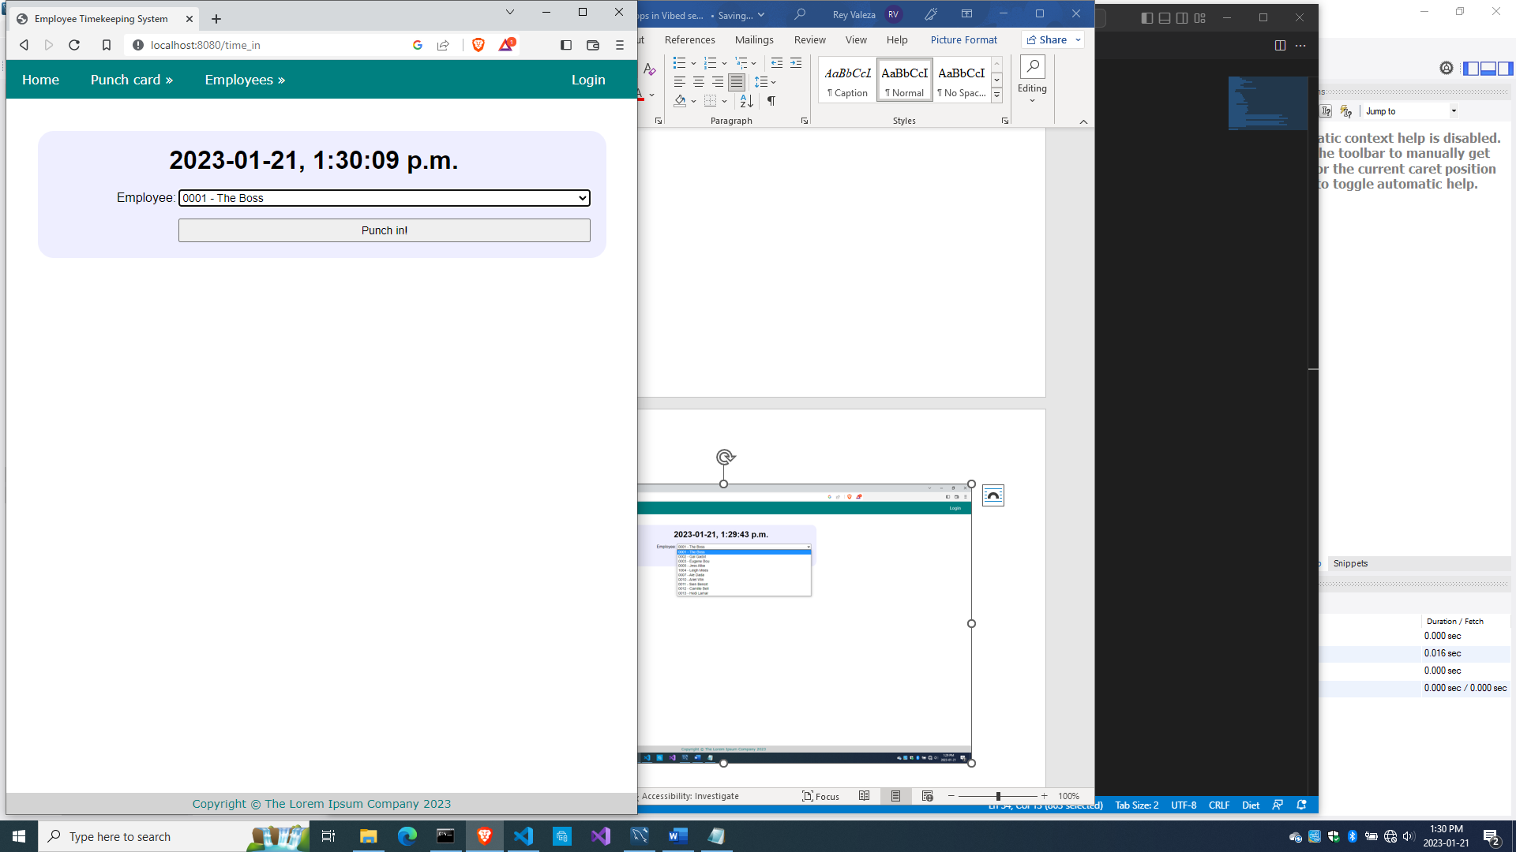

After you punched in some employees, you should see this.

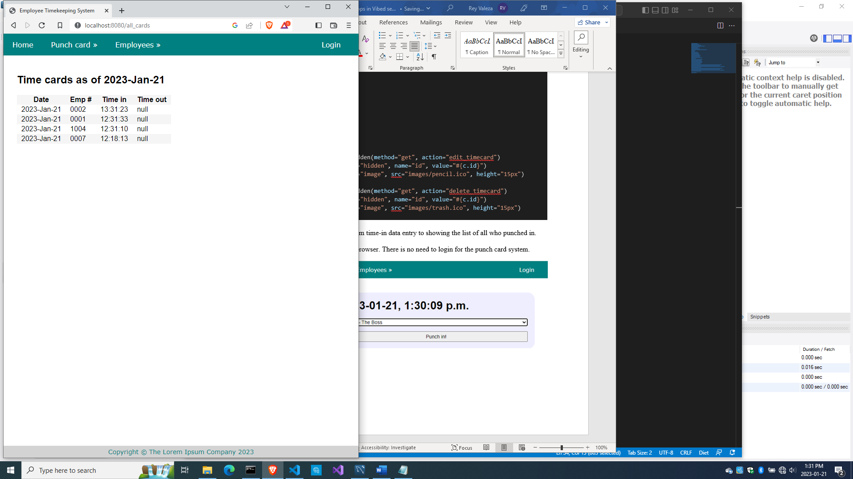

And if you punched in someone who already punched in for the day, you got this:

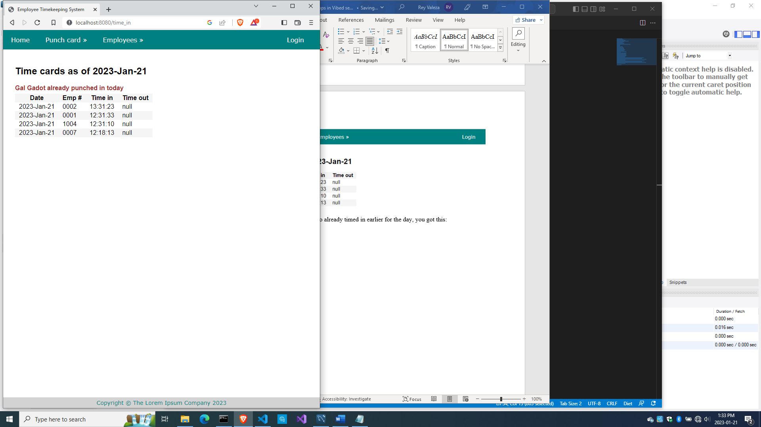

Now let’s do the punch-out system.

Punching out

We should make sure that a person who punches in should be able to punch out, but the person who failed to punch in earlier should not be able to punch out, meaning, we check if the punch-in record is already there before we save the punch out time.

Add this code to source\bundycontrol.d

  void getTimeOut()

  {

    Employee[] emps = empModel.getEmployees;

    render!("timeout.dt", emps);

  }

  @errorDisplay!getAllCards

  void postTimeOut(string empid)

  {

    string fullname = getFullname(empid);

    //the record should exist, otherwise employee did not punch in earlier

    enforce(!cardModel.noTimeIn(empid), fullname ~ " did not punched in today");

    //the timeout field should be null, otherwise employee already punched out

    enforce(cardModel.noTimeOut(empid), fullname ~ " already punched out today");

    cardModel.timeOut(empid);

    redirect("all_cards");

  }

It is calling cardModel.noTimeOut(), as well as the cardModel.timeOut(), so let’s implement them.

Add this code to source\cardmodel.d

  bool noTimeOut(string empid)

  {

    string sql = "select * from timecards where timeout is null and empid=? and thedate=?";

    Prepared pstmt = conn.prepare(sql);

    string today = getToday;

    pstmt.setArgs(empid, today);

    Row[] rows = conn.query(pstmt).array;

    if(rows.length != 0) return true;

    return false;

  }

  void timeOut(string empid)

  {

    string sql = "update timecards set timeout=curtime() where empid=? and thedate=?";

    Prepared pstmt = conn.prepare(sql);

    string today = getToday;

    pstmt.setArgs(empid, today);

    conn.exec(pstmt);

  }

That takes care of the database side.

Now let’s implement the business logic side.

Add this code to source\bundycontrol.d

  void getTimeOut()

  {

    Employee[] emps = empModel.getEmployees;

    render!("timeout.dt", emps);

  }

  @errorDisplay!getAllCards

  void postTimeOut(string empid)

  {

    string fullname = getFullname(empid);

    //the record should exist, otherwise employee did not punch in earlier

    enforce(!cardModel.noTimeIn(empid), fullname ~ " did not punched in today");

    //the timeout field should be null, otherwise employee already punched out

    enforce(cardModel.noTimeOut(empid), fullname ~ " already punched out today");

    cardModel.timeOut(empid);

    redirect("all_cards");

  }

We are making sure that our requirements for a timeout are met.

Compile, run and refresh the browser. Try to timeout someone who did not time in, and this should show:

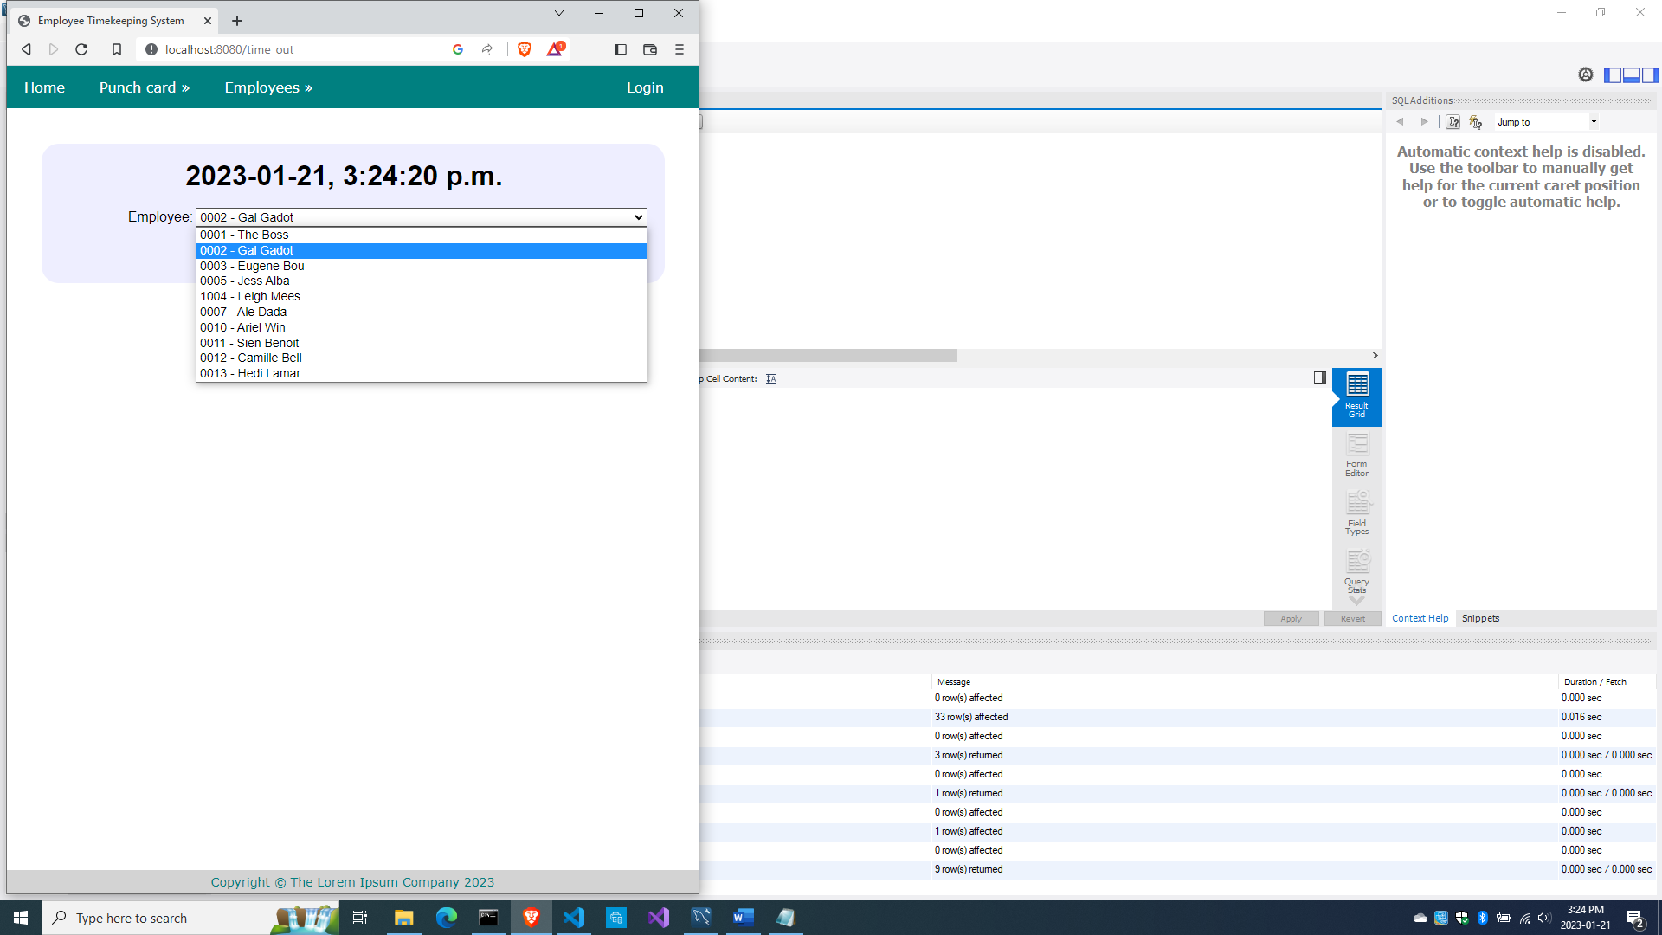

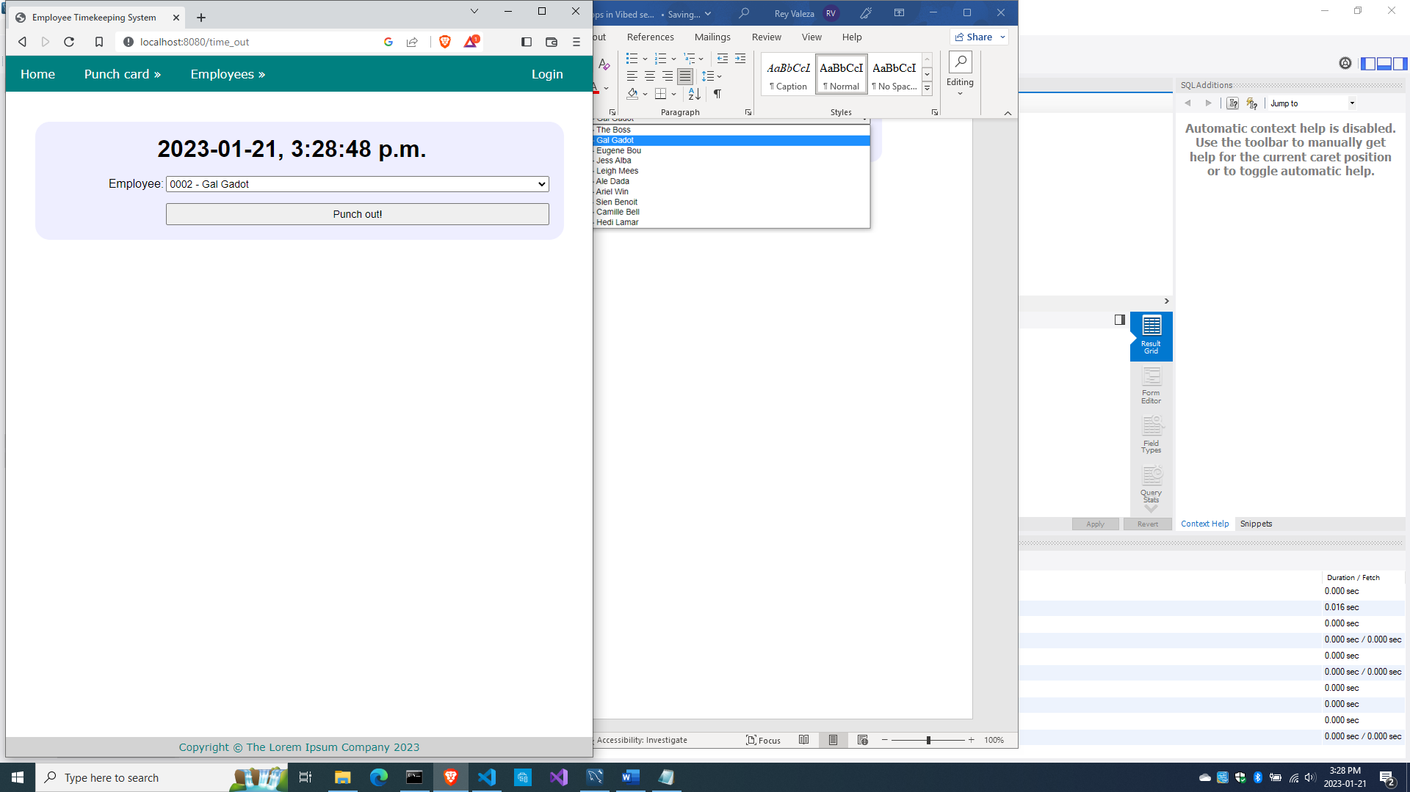

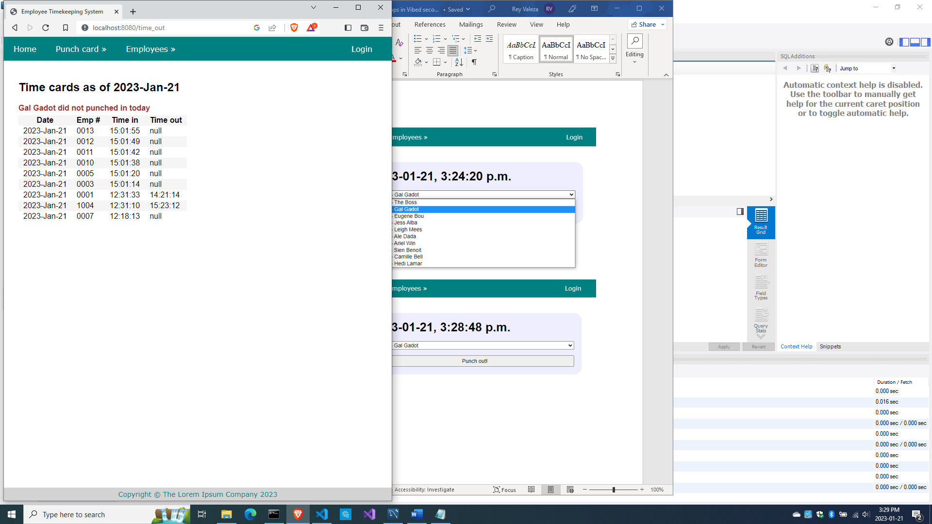

And if you try to punch out someone who already punched out, you also get this:

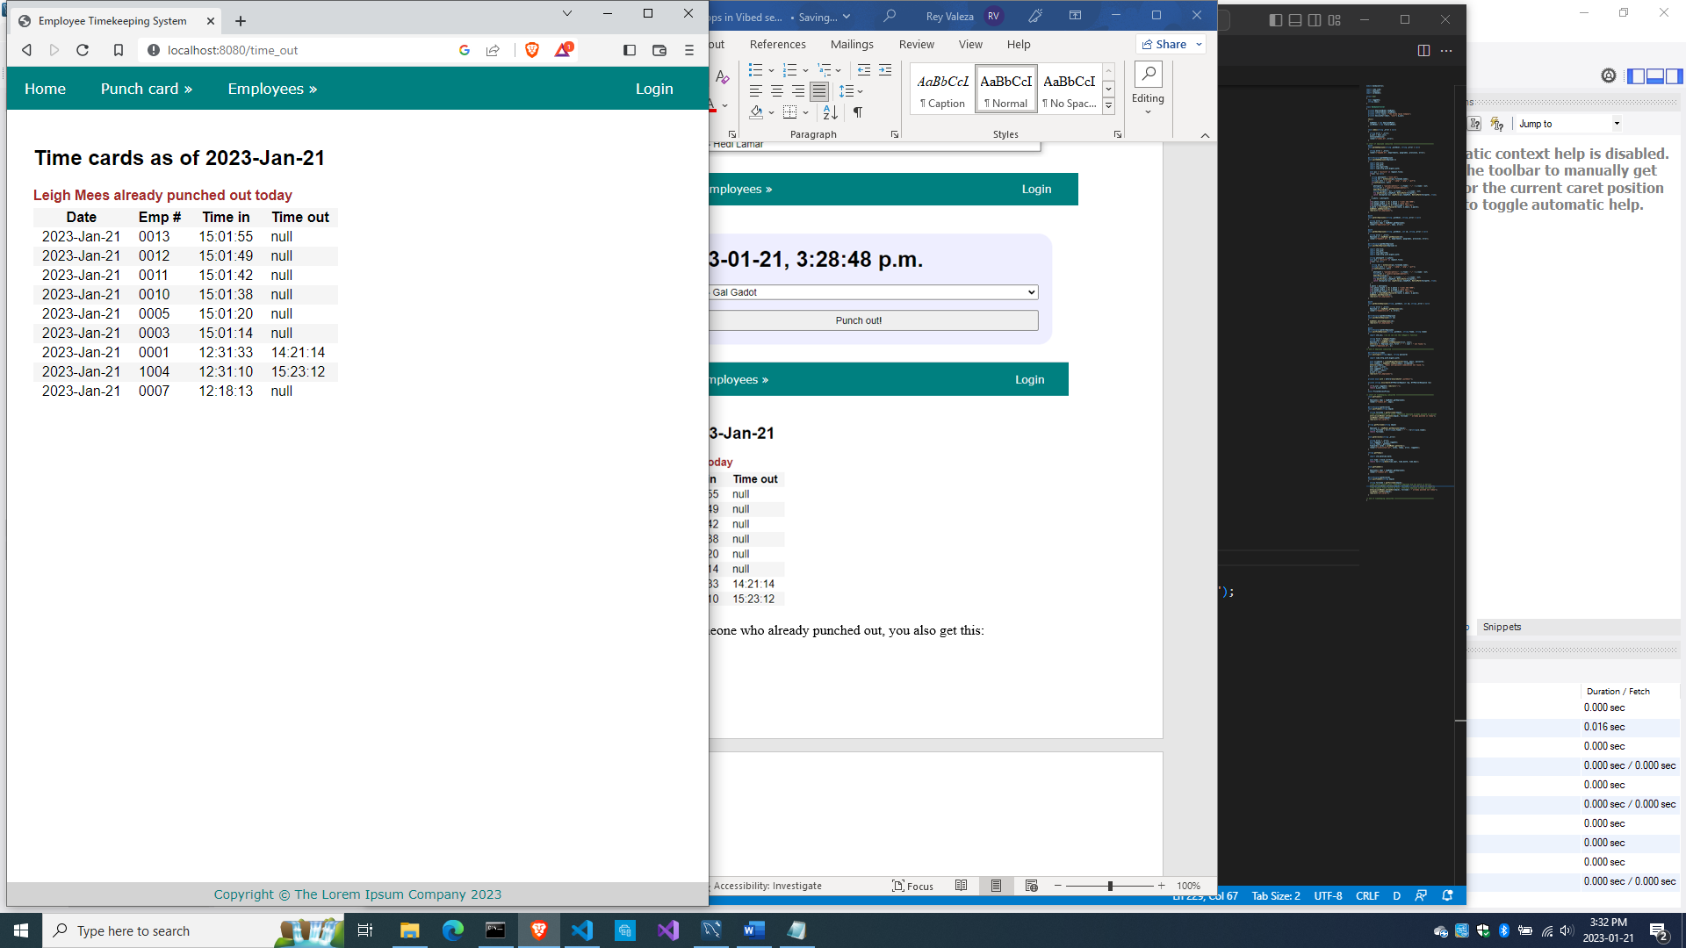

But if our conditions are met, everything’s good.

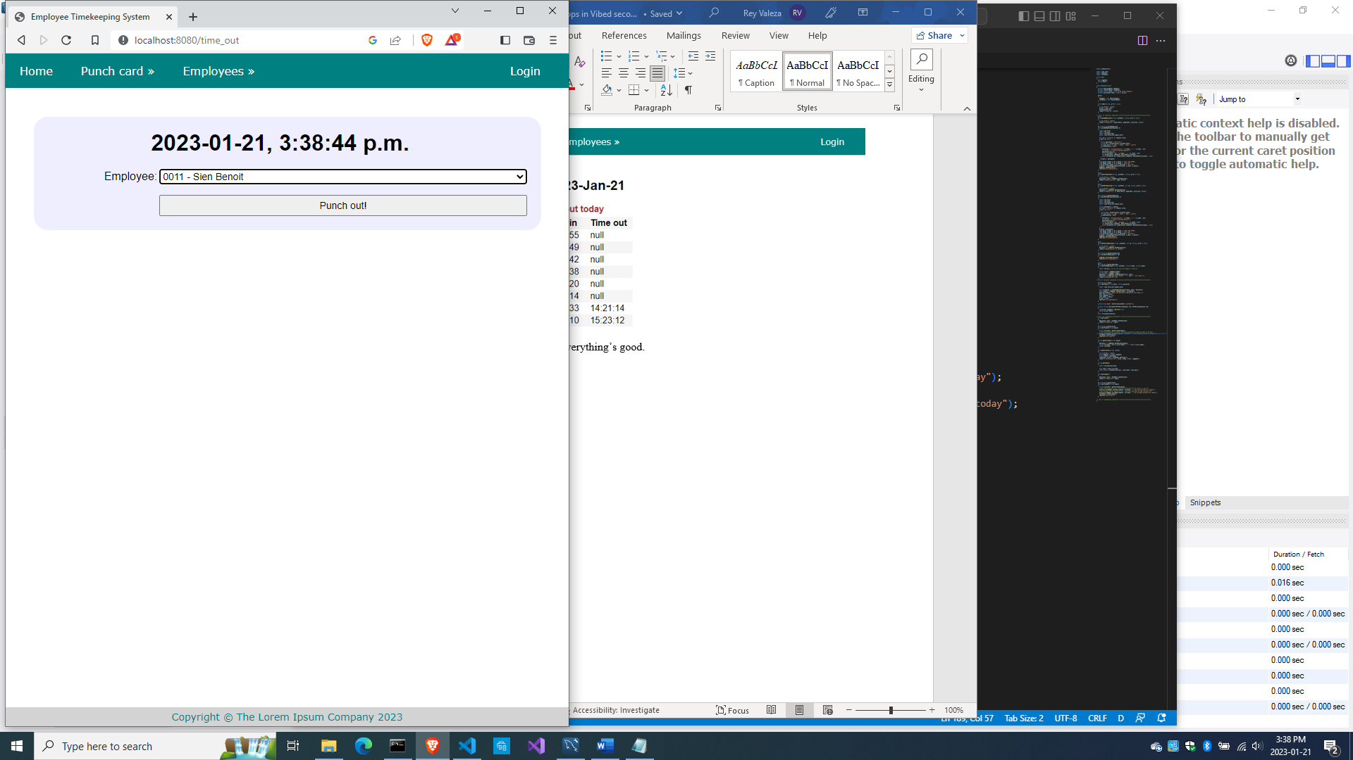

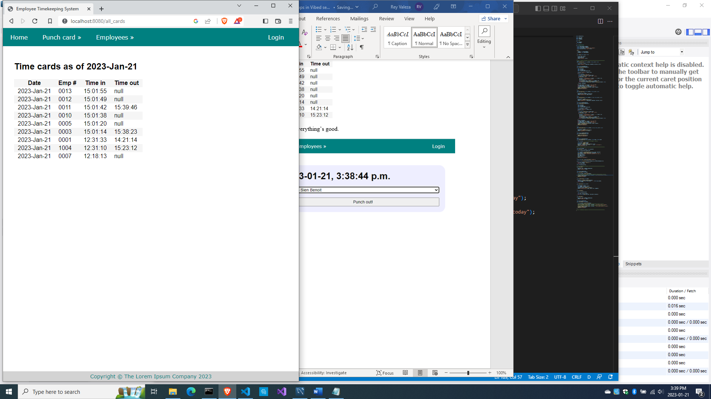

The time-in and time-out actions were covered.

So here is the full source\bundycontrol.d

module bundycontrol;

import vibe.vibe;

import empmodel;

import cardmodel;

struct User

{

  bool loggedIn;

  string email;

}

class BundyController

{

  private EmployeeModel empModel;

  private TimecardModel cardModel;

  private string realm = "The Lorem Ipsum Company";

  private SessionVar!(User, "user") m_user;

  this()

  {

    empModel = new EmployeeModel;

    cardModel = new TimecardModel;

  }

  void index(string _error = null)

  {

    string error = _error;

    m_user = User.init;

    terminateSession;

    render!("index.dt", error);

  }

/* start of employee subsystem *********************************************/

  @auth

  void getAddEmployee(string _authUser, string _error = null)

  {

    string error = _error;

    render!("empadd.dt", departments, paygrades, provinces, error);

  }

  @errorDisplay!getAddEmployee

  void postAddEmployee(Employee e)

  {

    import std.file;

    import std.path;

    import std.algorithm;

    import vibe.http.auth.digest_auth;

    auto pic = "picture" in request.files;

    if(pic !is null)

    {

      string photopath = "none yet";

      string ext = extension(pic.filename.name);

      string[] exts = [".jpg", ".jpeg", ".png", ".gif"];

      if(canFind(exts, ext))

      {

        photopath = "uploads/photos/" ~ e.fname ~ "_" ~ e.lname ~ ext;

        string dir = "./public/uploads/photos/";

        mkdirRecurse(dir);

        string fullpath = dir ~ e.fname ~ "_" ~ e.lname ~ ext;

        try moveFile(pic.tempPath, NativePath(fullpath));

        catch (Exception ex) copyFile(pic.tempPath, NativePath(fullpath), true);

      }

      e.photo = photopath;

    }

    if(e.phone.length == 0) e.phone = "(123) 456 7890";

    if(e.paygd.length == 0) e.paygd = "none yet";

    if(e.postcode.length == 0) e.postcode = "A1A 1A1";

    e.pword = createDigestPassword(realm, e.email, e.pword);

    empModel.addEmployee(e);

    redirect("all_employees");

  }

  @auth

  void getAllEmployees(string _authUser, string _error = null)

  {

    string error = _error;

    Employee[] emps = empModel.getEmployees;

    render!("emplistall.dt", emps, error);

  }

  @auth

  void getEditEmployee(string _authUser, int id, string _error = null)

  {

    string error = _error;

    Employee e = empModel.getEmployee(id);

    render!("empedit.dt", e, departments, paygrades, provinces, error);

  }

  @errorDisplay!getEditEmployee

  void postEditEmployee(Employee e)

  {

    import std.file;

    import std.path;

    import std.algorithm;

    import vibe.http.auth.digest_auth;

    string photopath = e.photo;

    auto pic = "picture" in request.files;

    if(pic !is null)

    {

      string ext = extension(pic.filename.name);

      string[] exts = [".jpg", ".jpeg", ".png", ".gif"];

      if(canFind(exts, ext))

      {

        photopath = "uploads/photos/" ~ e.fname ~ "_" ~ e.lname ~ ext;

        string dir = "./public/uploads/photos/";

        mkdirRecurse(dir);

        string fullpath = dir ~ e.fname ~ "_" ~ e.lname ~ ext;

        try moveFile(pic.tempPath, NativePath(fullpath));

        catch (Exception ex) copyFile(pic.tempPath, NativePath(fullpath), true);

      }

    }

    e.photo = photopath;

    if(e.phone.length == 0) e.phone = "(123) 456 7890";

    if(e.paygd.length == 0) e.paygd = "none yet";

    if(e.postcode.length == 0) e.postcode = "A1A 1A1";

    e.pword = createDigestPassword(realm, e.email, e.pword);

    empModel.editEmployee(e);

    redirect("all_employees");

  }

  @auth

  void getDeleteEmployee(string _authUser, int id, string _error = null)

  {

    string error = _error;

    Employee e = empModel.getEmployee(id);

    render!("empdelete.dt", e, error);

  }

  @errorDisplay!getDeleteEmployee

  void postDeleteEmployee(int id)

  {

    empModel.deleteEmployee(id);

    redirect("all_employees");

  }

  @auth

  @errorDisplay!getAllEmployees

  void postFindEmployee(string _authUser, string fname, string lname)

  {

    import std.uni; //so we can use the toUpper() function

    string first = toUpper(fname);

    string last = toUpper(lname);

    Employee e = empModel.findEmployee(first, last);

    enforce(e != Employee.init, first ~ " " ~ last ~ " not found.");

    render!("employee.dt", e);

  }

/* end of employee subsystem ***********************************************/

  @errorDisplay!index

  void postLogin(string email, string password)

  {

    import vibe.http.auth.digest_auth;

    auto scrambled = createDigestPassword(realm, email, password);

    bool isAdmin = empModel.isAdmin(email, scrambled);

    enforce(isAdmin, "Email and password combination not found.");

    User user = m_user;

    user.loggedIn = true;

    user.email = email;

    m_user = user;

    redirect("all_employees");

  }

  private enum auth = before!ensureAuth("_authUser");

  private string ensureAuth(HTTPServerRequest req, HTTPServerResponse res)

  {

    if(!m_user.loggedIn) redirect("/");

    return m_user.email;

  }

  mixin PrivateAccessProxy;

/* start of timekeeping subsystem ******************************************/

  void getTimeIn()

  {

    Employee[] emps = empModel.getEmployees;

    render!("timein.dt", emps);

  }

  @errorDisplay!getAllCards

  void postTimeIn(string empid)

  {

    string fullname = getFullname(empid);

    //the record should not exist, otherwise employee already punched in earlier

    enforce(cardModel.noTimeIn(empid), fullname ~ ", you already punched in today");

    cardModel.timeIn(empid);

    redirect("all_cards");

  }

  string getFullname(string empid)

  {

    Employee e = empModel.getEmployee(empid);

    string fullname = to!string(e.fname) ~ " " ~ to!string(e.lname);

    return fullname;

  }

  void getAllCards(string _error)

  {

    string error = _error;

    bool loggedIn = m_user.loggedIn;

    string today = getToday;

    Timecard[] cards = cardModel.getCards();

    render!("cardlistall.dt", cards, today, error, loggedIn);

  }

  string getToday()

  {

    import std.datetime.date;

    auto time = Clock.currTime;

    return to!string(Date(time.year, time.month, time.day));

  }

  void getTimeOut()

  {

    Employee[] emps = empModel.getEmployees;

    render!("timeout.dt", emps);

  }

  @errorDisplay!getAllCards

  void postTimeOut(string empid)

  {

    string fullname = getFullname(empid);

    //the record should exist, otherwise employee did not punch in earlier

    enforce(!cardModel.noTimeIn(empid), fullname ~ ", you did not punch in today");

    //the timeout field should be null, otherwise employee already punched out

    enforce(cardModel.noTimeOut(empid), fullname ~ ", you already punched out today");

    cardModel.timeOut(empid);

    redirect("all_cards");

  }

/* end of timekeeping subsystem ********************************************/

}

And here is the full source\cardmodel.d

module cardmodel;

import mysql;

import std.array;

import std.conv;

struct Timecard

{

  int id;

  string empid;

  string thedate;

  string timein;

  string timeout;

}

class TimecardModel

{

  Connection conn;

  this()

  {

    string url = "host=localhost;port=3306;user=owner;pwd=qwerty;db=empdb";

    conn = new Connection(url);

    scope(exit) conn.close;

  }

  void timeIn(string empid)

  {

    string sql = "insert into timecards(empid, thedate, timein) values(?, curdate(), curtime())";

    Prepared pstmt = conn.prepare(sql);

    pstmt.setArgs(empid);

    conn.exec(pstmt);

  }

  bool noTimeIn(string empid)

  {

    string sql = "select * from timecards where empid=? and thedate=?";

    Prepared pstmt = conn.prepare(sql);

    string today = getToday;

    pstmt.setArgs(empid, today);

    Row[] rows = conn.query(pstmt).array;

    if(rows.length == 0) return true;

    return false;

  }

  string getToday()

  {

    Row[] rows = conn.query("select curdate() + 0").array;

    return to!string(rows[0][0]);

  }

  Timecard[] getCards()

  {

    Timecard[] cards;

    string sql = "select * from timecards order by thedate desc, timein desc";

    Row[] rows = conn.query(sql).array;

    if(rows.length == 0) return cards;

    foreach(row; rows)

    {

      Timecard c;

      c.id = to!int(to!string(row[0]));

      c.empid = to!string(row[1]);

      c.thedate = to!string(row[2]);

      c.timein = to!string(row[3]);

      c.timeout = to!string(row[4]);

      cards ~= c;

    }

    return cards;

  }

  bool noTimeOut(string empid)

  {

    string sql = "select * from timecards where timeout is null and empid=? and thedate=?";

    Prepared pstmt = conn.prepare(sql);

    string today = getToday;

    pstmt.setArgs(empid, today);

    Row[] rows = conn.query(pstmt).array;

    if(rows.length != 0) return true;

    return false;

  }

  void timeOut(string empid)

  {

    string sql = "update timecards set timeout=curtime() where empid=? and thedate=?";

    Prepared pstmt = conn.prepare(sql);

    string today = getToday;

    pstmt.setArgs(empid, today);

    conn.exec(pstmt);

  }

}

How about editing of the timecards so that those who failed to punch in can still punch out?

If you login and choose ‘View cards’ on the menu, you should have a slightly different view of the cards list.

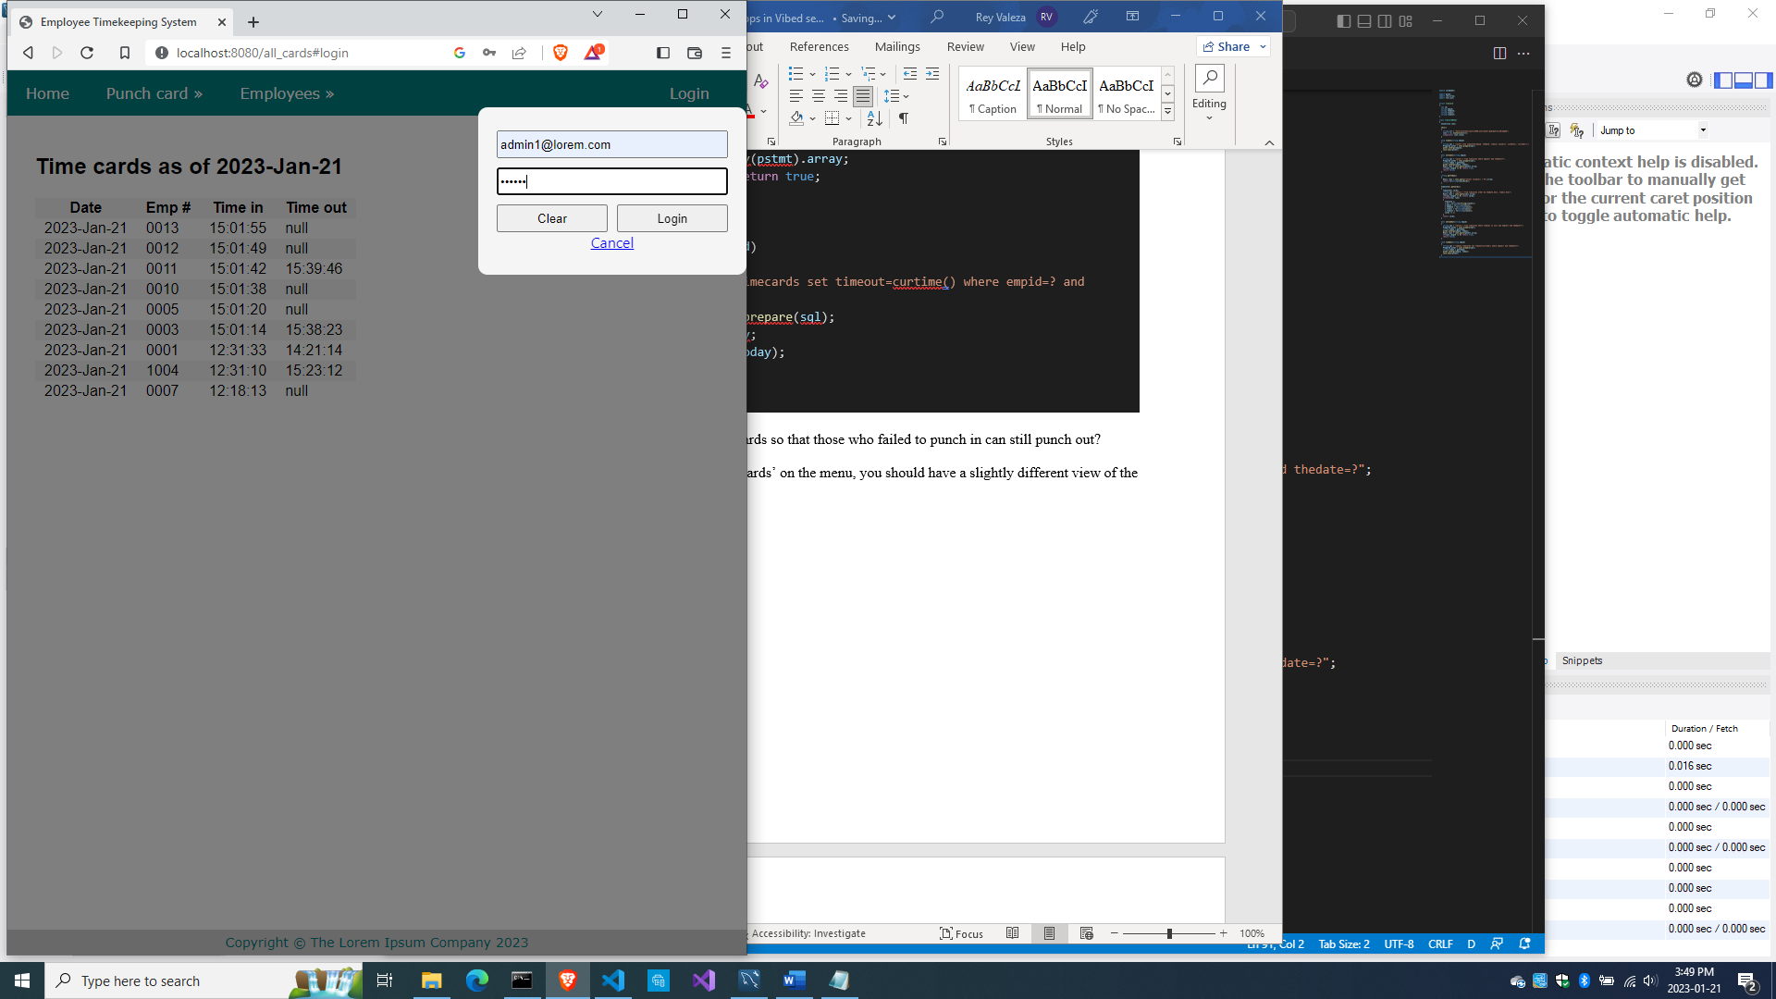

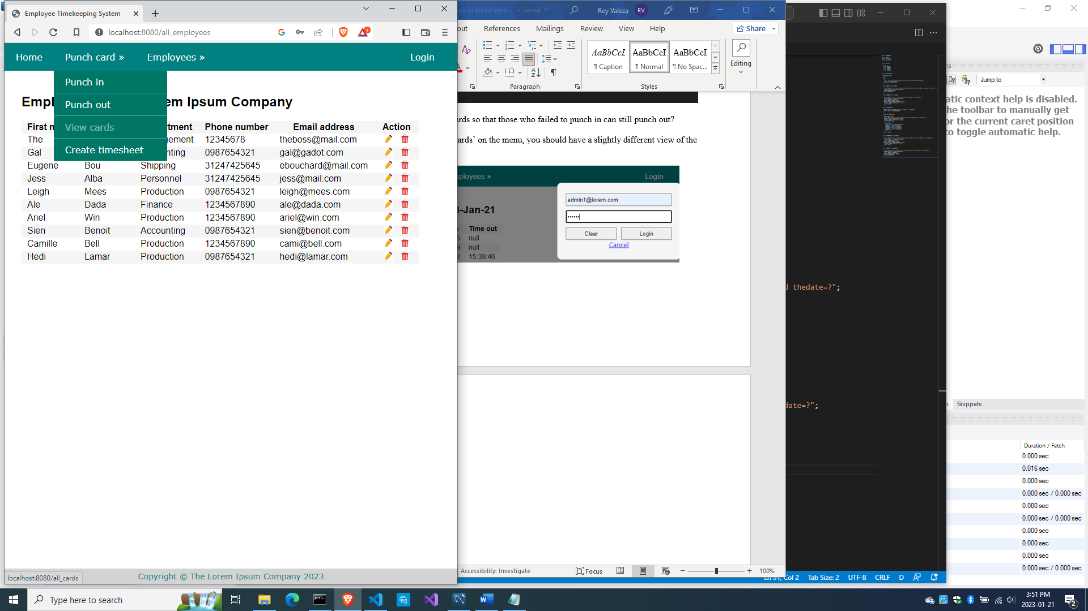

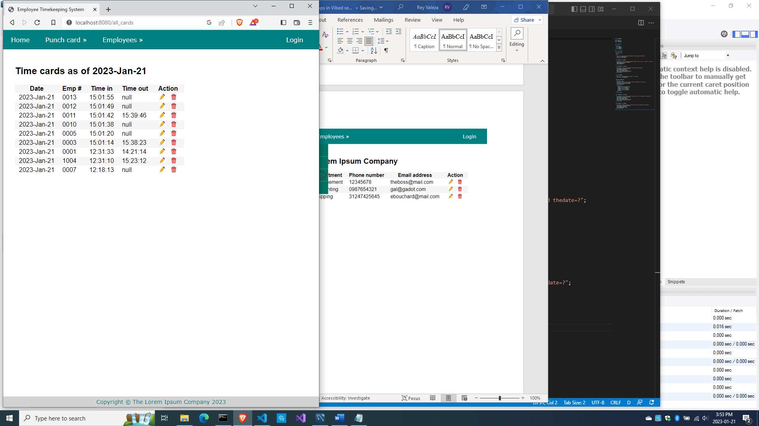

So if logged in (meaning, you are an administrator), you should be able to edit the timecards.

But if you do click on the pencil icon, you get this:

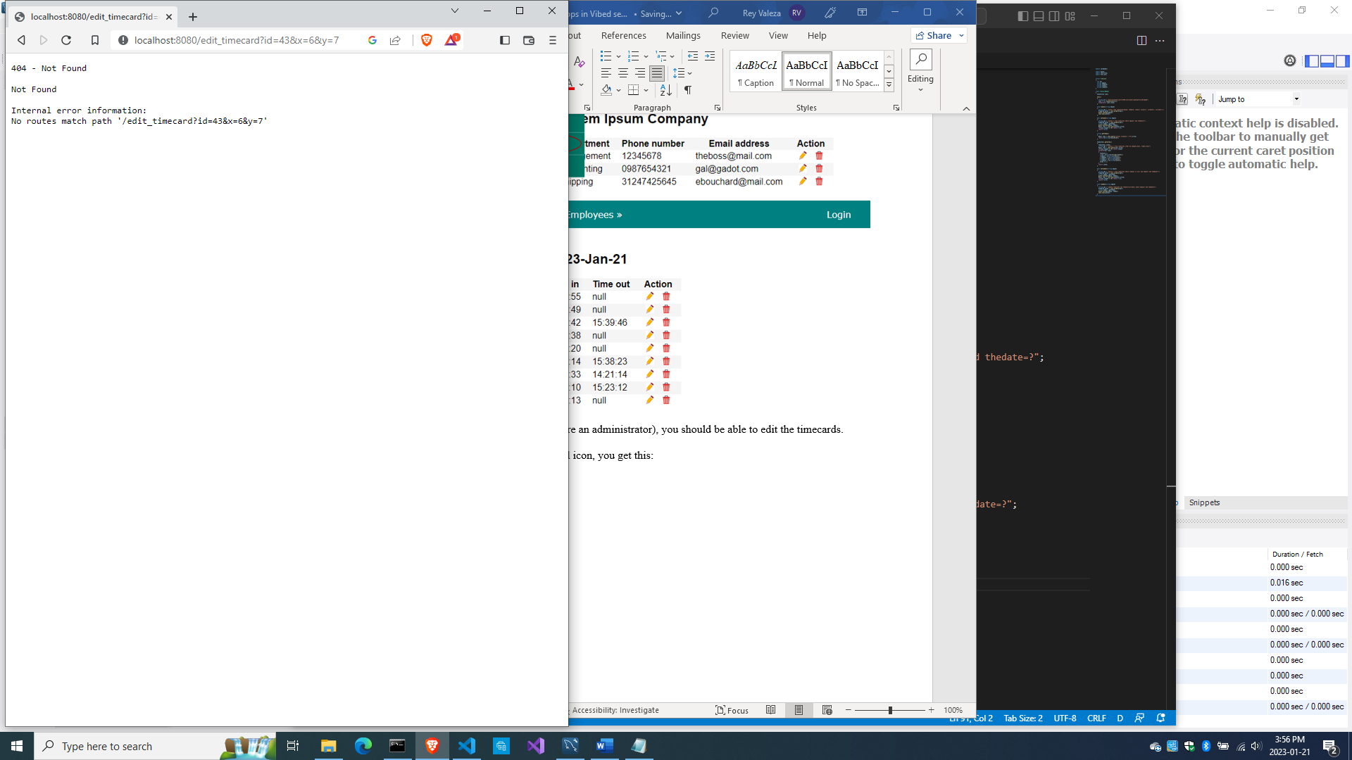

Because we haven’t written the code for the editing of timecards.

Let’s do that next.

Editing the timecards

Add this code to the end of source\bundycontrol.d

  void getEditTimecard(int id, string _error = null)

  {

    string error = _error;

    Timecard t = cardModel.getCard(id);

    Employee e = empModel.getEmployeeByEmpid(t.empid);

    render!("cardedit.dt", t, e, error);

  }

  @errorDisplay!getEditTimecard

  void postEditTimecard(Timecard t)

  {

    cardModel.editTimecard(t);

    redirect("all_cards");

  }

The getEditTimecard() method is using cardedit.dt, so let’s create it.

Create views\cardedit.dt

extends layout

block maincontent

  include cssformtimecard

  h2 Time card of #{e.fname} #{e.lname} for #{t.thedate}

  div.form-grid-wrapper

    -if(error)

      div.error-div

        span.error-message #{error}

    form.form-grid(method="post", action="edit_timecard")

      label.form-grid-label Employee :

      label.form-grid-text #{e.empid}  - #{e.fname} #{e.lname}

      label.form-grid-label Punch in :

      input.form-grid-input(type="text", name="t_timein", value="#{t.timein}")

      label.form-grid-label Punch out :

      input.form-grid-input(type="text", name="t_timeout", value="#{t.timeout}")

      div

      input(type="hidden", name="t_id", value="#{t.id}")

      input(type="hidden", name="id", value="#{t.id}")

      input(type="hidden", name="t_empid", value="#{t.empid}")

      input(type="hidden", name="t_thedate", value="#{t.thedate}")

      div

      div

        a(href="all_cards")

          button.form-grid-button(type="button") Cancel

      div

        input.form-grid-button(type="submit", value="Submit")

The getEditTimecard() method is also calling cardModel.getCard(), so let’s write it.

Add this code to source\cardmodel.d

  Timecard getCard(int id)

  {

    Timecard c;

    string sql = "select * from timecards where id=?";

    Prepared pstmt = conn.prepare(sql);

    pstmt.setArgs(id);

    Row[] rows = conn.query(pstmt).array;

    if(rows.length == 0) return c;

    Row row = rows[0];

    c.id = to!int(to!string(row[0]));

    c.empid = to!string(row[1]);

    c.thedate = to!string(row[2]);

    c.timein = to!string(row[3]);

    c.timeout = to!string(row[4]);

    return c;

  }

The getEditTimecard() method is also calling empModel.getEmployeeByEmpid(), so let’s add that to the EmployeeModel class.

Add this to source\empmodel.d

  Employee getEmployeeByEmpid(string empid)

  {

    string sql = "select * from employees where empid=?";

    Prepared pstmt = conn.prepare(sql);

    pstmt.setArgs(empid);

    Employee e;

    Row[] rows = conn.query(pstmt).array;

    if(rows.length == 0) return e;

    return prepareEmployee(rows[0]);

  }

cardedit.dt needs cssformtimecard.dt, so let’s create it.

Create views\cssformtimecard.dt

:css

  .form-grid-wrapper

  {

    width: 450px;

    height: auto;

    margin: 20px 0;

    padding: 10px;

    border-radius: 10px;

    background-color: #eef;

  }

  .form-grid

  {

    display: grid;

    grid-template-columns: 1fr 1fr;

    gap: 5px;

  }

  .form-grid-label

  {

    width: 100%;

    font-size: 16px;

    text-align: right;

    padding: 2px;

  }

  .form-grid-text

  {

    width: 100%;

    font-size: 16px;

    font-weight: bold;

    padding: 2px;

  }

  .form-grid-input

  {

    width: 95%;

    font-size: 14px;

    padding: 2px 0 2px 2px;

  }

  .form-grid-field

  {

    width: 100%;

    font-size: 16px;

    border-bottom: 1px solid black;

    padding: 2px;

  }

  .form-grid-button

  {

    width: 100%;

    font-size: 14px;

    height: 30px;

    margin: 0;

    padding: 0;

  }

And the postEditTimecard() method is calling cardModel.editTimecard(), so let’s write it.

  ulong editTimecard(Timecard t)

  {

    Prepared pstmt;

    if(to!string(t.timeout) == "null")

    {

      string sql = "update timecards set timein=?, timeout=null where id=?";

      pstmt = conn.prepare(sql);

      pstmt.setArgs(t.timein, t.id);

    }

    else

    {

      string sql = "update timecards set timein=?, timeout=? where id=?";

      pstmt = conn.prepare(sql);

      pstmt.setArgs(t.timein, t.timeout, t.id);

    }

    return conn.exec(pstmt);

  }

Now compile, run and refresh the browser. Be sure to login first so you can edit any record in the list of timecards.

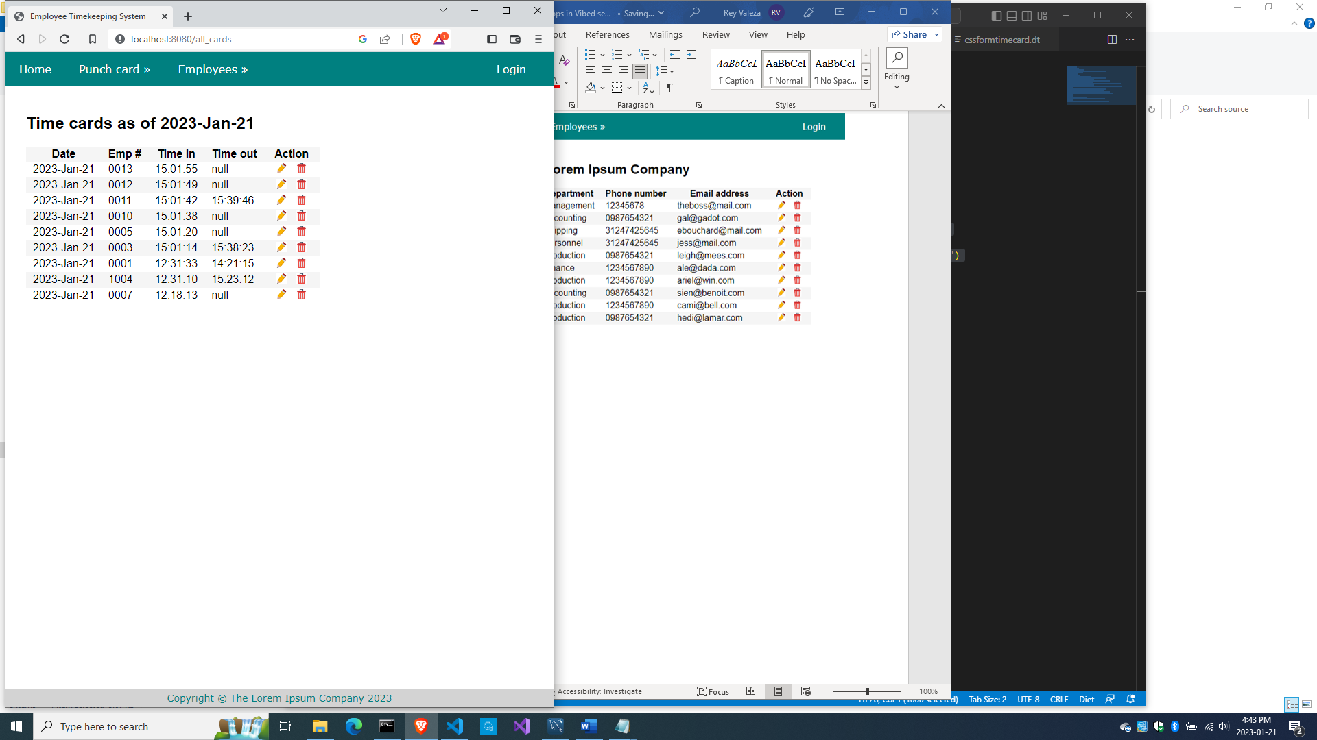

Choose any record to open the card editing page

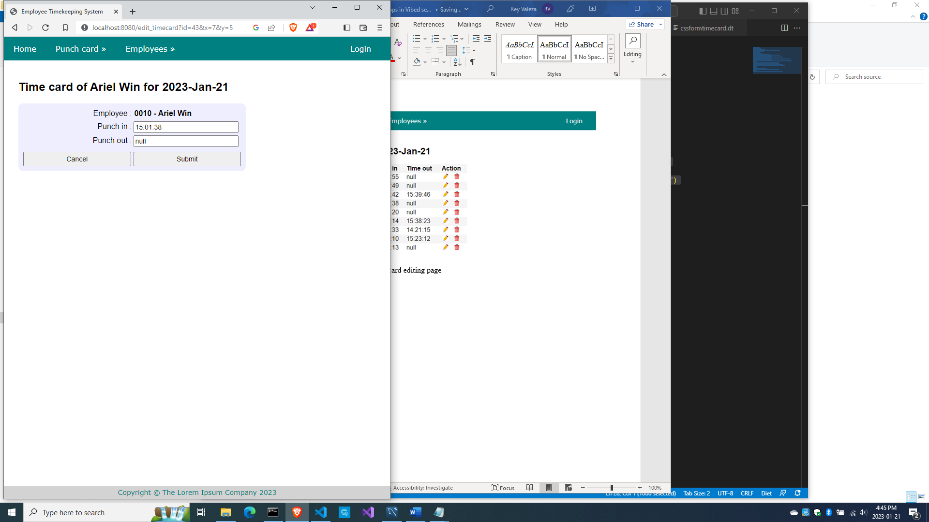

Try both the ‘Cancel’ and the ‘Submit’ buttons.

Now, how does an employee who forgot to time in can still recover?

1. The employee should time in even though it’s late.
2. The employee can now time out
3. The admin can then edit the time-in time

So here’s the full source\bundycontrol so far

module bundycontrol;

import vibe.vibe;

import empmodel;

import cardmodel;

struct User

{

  bool loggedIn;

  string email;

}

class BundyController

{

  private EmployeeModel empModel;

  private TimecardModel cardModel;

  private string realm = "The Lorem Ipsum Company";

  private SessionVar!(User, "user") m_user;

  this()

  {

    empModel = new EmployeeModel;

    cardModel = new TimecardModel;

  }

  void index(string _error = null)

  {

    string error = _error;

    m_user = User.init;

    terminateSession;

    render!("index.dt", error);

  }

/* start of employee subsystem *********************************************/

  @auth

  void getAddEmployee(string _authUser, string _error = null)

  {

    string error = _error;

    render!("empadd.dt", departments, paygrades, provinces, error);

  }

  @errorDisplay!getAddEmployee

  void postAddEmployee(Employee e)

  {

    import std.file;

    import std.path;

    import std.algorithm;

    import vibe.http.auth.digest_auth;

    auto pic = "picture" in request.files;

    if(pic !is null)

    {

      string photopath = "none yet";

      string ext = extension(pic.filename.name);

      string[] exts = [".jpg", ".jpeg", ".png", ".gif"];

      if(canFind(exts, ext))

      {

        photopath = "uploads/photos/" ~ e.fname ~ "_" ~ e.lname ~ ext;

        string dir = "./public/uploads/photos/";

        mkdirRecurse(dir);

        string fullpath = dir ~ e.fname ~ "_" ~ e.lname ~ ext;

        try moveFile(pic.tempPath, NativePath(fullpath));

        catch (Exception ex) copyFile(pic.tempPath, NativePath(fullpath), true);

      }

      e.photo = photopath;

    }

    if(e.phone.length == 0) e.phone = "(123) 456 7890";

    if(e.paygd.length == 0) e.paygd = "none yet";

    if(e.postcode.length == 0) e.postcode = "A1A 1A1";

    e.pword = createDigestPassword(realm, e.email, e.pword);

    empModel.addEmployee(e);

    redirect("all_employees");

  }

  @auth

  void getAllEmployees(string _authUser, string _error = null)

  {

    string error = _error;

    Employee[] emps = empModel.getEmployees;

    render!("emplistall.dt", emps, error);

  }

  @auth

  void getEditEmployee(string _authUser, int id, string _error = null)

  {

    string error = _error;

    Employee e = empModel.getEmployee(id);

    render!("empedit.dt", e, departments, paygrades, provinces, error);

  }

  @errorDisplay!getEditEmployee

  void postEditEmployee(Employee e)

  {

    import std.file;

    import std.path;

    import std.algorithm;

    import vibe.http.auth.digest_auth;

    string photopath = e.photo;

    auto pic = "picture" in request.files;

    if(pic !is null)

    {

      string ext = extension(pic.filename.name);

      string[] exts = [".jpg", ".jpeg", ".png", ".gif"];

      if(canFind(exts, ext))

      {

        photopath = "uploads/photos/" ~ e.fname ~ "_" ~ e.lname ~ ext;

        string dir = "./public/uploads/photos/";

        mkdirRecurse(dir);

        string fullpath = dir ~ e.fname ~ "_" ~ e.lname ~ ext;

        try moveFile(pic.tempPath, NativePath(fullpath));

        catch (Exception ex) copyFile(pic.tempPath, NativePath(fullpath), true);

      }

    }

    e.photo = photopath;

    if(e.phone.length == 0) e.phone = "(123) 456 7890";

    if(e.paygd.length == 0) e.paygd = "none yet";

    if(e.postcode.length == 0) e.postcode = "A1A 1A1";

    e.pword = createDigestPassword(realm, e.email, e.pword);

    empModel.editEmployee(e);

    redirect("all_employees");

  }

  @auth

  void getDeleteEmployee(string _authUser, int id, string _error = null)

  {

    string error = _error;

    Employee e = empModel.getEmployee(id);

    render!("empdelete.dt", e, error);

  }

  @errorDisplay!getDeleteEmployee

  void postDeleteEmployee(int id)

  {

    empModel.deleteEmployee(id);

    redirect("all_employees");

  }

  @auth

  @errorDisplay!getAllEmployees

  void postFindEmployee(string _authUser, string fname, string lname)

  {

    import std.uni; //so we can use the toUpper() function

    string first = toUpper(fname);

    string last = toUpper(lname);

    Employee e = empModel.findEmployee(first, last);

    enforce(e != Employee.init, first ~ " " ~ last ~ " not found.");

    render!("employee.dt", e);

  }

/* end of employee subsystem ***********************************************/

  @errorDisplay!index

  void postLogin(string email, string password)

  {

    import vibe.http.auth.digest_auth;

    auto scrambled = createDigestPassword(realm, email, password);

    bool isAdmin = empModel.isAdmin(email, scrambled);

    enforce(isAdmin, "Email and password combination not found.");

    User user = m_user;

    user.loggedIn = true;

    user.email = email;

    m_user = user;

    redirect("all_employees");

  }

  private enum auth = before!ensureAuth("_authUser");

  private string ensureAuth(HTTPServerRequest req, HTTPServerResponse res)

  {

    if(!m_user.loggedIn) redirect("/");

    return m_user.email;

  }

  mixin PrivateAccessProxy;

/* start of timekeeping subsystem ******************************************/

  void getTimeIn()

  {

    Employee[] emps = empModel.getEmployees;

    render!("timein.dt", emps);

  }

  @errorDisplay!getAllCards

  void postTimeIn(string empid)

  {

    string fullname = getFullname(empid);

    //the record should not exist, otherwise employee already punched in earlier

    enforce(cardModel.noTimeIn(empid), fullname ~ ", you already punched in today");

    cardModel.timeIn(empid);

    redirect("all_cards");

  }

  string getFullname(string empid)

  {

    Employee e = empModel.getEmployee(empid);

    string fullname = to!string(e.fname) ~ " " ~ to!string(e.lname);

    return fullname;

  }

  void getAllCards(string _error)

  {

    string error = _error;

    bool loggedIn = m_user.loggedIn;

    string today = getToday;

    Timecard[] cards = cardModel.getCards();

    render!("cardlistall.dt", cards, today, error, loggedIn);

  }

  string getToday()

  {

    import std.datetime.date;

    auto time = Clock.currTime;

    return to!string(Date(time.year, time.month, time.day));

  }

  void getTimeOut()

  {

    Employee[] emps = empModel.getEmployees;

    render!("timeout.dt", emps);

  }

  @errorDisplay!getAllCards

  void postTimeOut(string empid)

  {

    string fullname = getFullname(empid);

    //the record should exist, otherwise employee did not punch in earlier

    enforce(!cardModel.noTimeIn(empid), fullname ~ ", you did not punch in today");

    //the timeout field should be null, otherwise employee already punched out

    enforce(cardModel.noTimeOut(empid), fullname ~ ", you already punched out today");

    cardModel.timeOut(empid);

    redirect("all_cards");

  }

    void getEditTimecard(int id, string _error = null)

  {

    string error = _error;

    Timecard t = cardModel.getCard(id);

    Employee e = empModel.getEmployeeByEmpid(t.empid);

    render!("cardedit.dt", t, e, error);

  }

  @errorDisplay!getEditTimecard

  void postEditTimecard(Timecard t)

  {

    cardModel.editTimecard(t);

    redirect("all_cards");

  }

/* end of timekeeping subsystem ********************************************/

}

And here’s source\cardmodel.d so far

module cardmodel;

import mysql;

import std.array;

import std.conv;

struct Timecard

{

  int id;

  string empid;

  string thedate;

  string timein;

  string timeout;

}

class TimecardModel

{

  Connection conn;

  this()

  {

    string url = "host=localhost;port=3306;user=owner;pwd=qwerty;db=empdb";

    conn = new Connection(url);

    scope(exit) conn.close;

  }

  void timeIn(string empid)

  {

    string sql = "insert into timecards(empid, thedate, timein) values(?, curdate(), curtime())";

    Prepared pstmt = conn.prepare(sql);

    pstmt.setArgs(empid);

    conn.exec(pstmt);

  }

  bool noTimeIn(string empid)

  {

    string sql = "select * from timecards where empid=? and thedate=?";

    Prepared pstmt = conn.prepare(sql);

    string today = getToday;

    pstmt.setArgs(empid, today);

    Row[] rows = conn.query(pstmt).array;

    if(rows.length == 0) return true;

    return false;

  }

  string getToday()

  {

    Row[] rows = conn.query("select curdate() + 0").array;

    return to!string(rows[0][0]);

  }

  Timecard[] getCards()

  {

    Timecard[] cards;

    string sql = "select * from timecards order by thedate desc, timein desc";

    Row[] rows = conn.query(sql).array;

    if(rows.length == 0) return cards;

    foreach(row; rows)

    {

      Timecard c;

      c.id = to!int(to!string(row[0]));

      c.empid = to!string(row[1]);

      c.thedate = to!string(row[2]);

      c.timein = to!string(row[3]);

      c.timeout = to!string(row[4]);

      cards ~= c;

    }

    return cards;

  }

  bool noTimeOut(string empid)

  {

    string sql = "select * from timecards where timeout is null and empid=? and thedate=?";

    Prepared pstmt = conn.prepare(sql);

    string today = getToday;

    pstmt.setArgs(empid, today);

    Row[] rows = conn.query(pstmt).array;

    if(rows.length != 0) return true;

    return false;

  }

  void timeOut(string empid)

  {

    string sql = "update timecards set timeout=curtime() where empid=? and thedate=?";

    Prepared pstmt = conn.prepare(sql);

    string today = getToday;

    pstmt.setArgs(empid, today);

    conn.exec(pstmt);

  }

  Timecard getCard(int id)

  {

    Timecard c;

    string sql = "select * from timecards where id=?";

    Prepared pstmt = conn.prepare(sql);

    pstmt.setArgs(id);

    Row[] rows = conn.query(pstmt).array;

    if(rows.length == 0) return c;

    Row row = rows[0];

    c.id = to!int(to!string(row[0]));

    c.empid = to!string(row[1]);

    c.thedate = to!string(row[2]);

    c.timein = to!string(row[3]);

    c.timeout = to!string(row[4]);

    return c;

  }

  ulong editTimecard(Timecard t)

  {

    Prepared pstmt;

    if(to!string(t.timeout) == "null")

    {

      string sql = "update timecards set timein=?, timeout=null where id=?";

      pstmt = conn.prepare(sql);

      pstmt.setArgs(t.timein, t.id);

    }

    else

    {

      string sql = "update timecards set timein=?, timeout=? where id=?";

      pstmt = conn.prepare(sql);

      pstmt.setArgs(t.timein, t.timeout, t.id);

    }

    return conn.exec(pstmt);

  }

}

Now, how about deleting a timecard?

Deleting timecards

Add this to source\bundycontrol.d

  void getDeleteTimecard(int id, string _error = null)

  {

    string error = _error;

    Timecard t = cardModel.getCard(id);

    Employee e = empModel.getEmployeeByEmpid(t.empid);

    render!("carddelete.dt", t, e, error);

  }

  @errorDisplay!getDeleteTimecard

  void postDeleteTimecard(int id)

  {

    cardModel.deleteTimecard(id);

    redirect("all_cards");

  }

The method getDeleteTimecard() needs carddelete.dt, so let’s create it.

Create views\carddelete.dt

extends layout

block maincontent

  include cssformtimecard

  h2 Sure you want to delete #{e.fname} #{e.lname}'s punch card?

  div.form-grid-wrapper

    form.form-grid(method="post", action="delete_timecard")

      label.form-grid-label Employee :

      label.form-grid-text #{e.empid} - #{e.fname} #{e.lname}

      label.form-grid-label Date :

      label.form-grid-text #{t.thedate}

      label.form-grid-label Punched in :

      label.form-grid-text #{t.timein}

      label.form-grid-label Punched out :

      label.form-grid-text #{t.timeout}

      input(type="hidden", name="t_id", value="#{t.id}")

      input(type="hidden", name="id", value="#{t.id}")

      input(type="hidden", name="t_empid", value="#{t.empid}")

      input(type="hidden", name="t_thedate", value="#{t.thedate}")

      input(type="hidden", name="t_timein", value="#{t.timein}")

      input(type="hidden", name="t_timeout", value="#{t.timeout}")

      div

      div

      div

        a(href="all_cards")

          button.form-grid-button(type="button") Cancel

      div

        input.form-grid-button(type="submit", value="Delete")

The method getDeleteTimecard() is calling cardModel.deleteTimecard(), so let’s write it.

Add this code to source\cardmodel.d

  void deleteTimecard(int id)

  {

    string sql = "delete from timecards where id=?";

    Prepared pstmt = conn.prepare(sql);

    pstmt.setArgs(id);

    conn.exec(pstmt);

  }

Now compile, run and refresh the browser. Login again to show the pencil and trash icons, and try to delete a record.

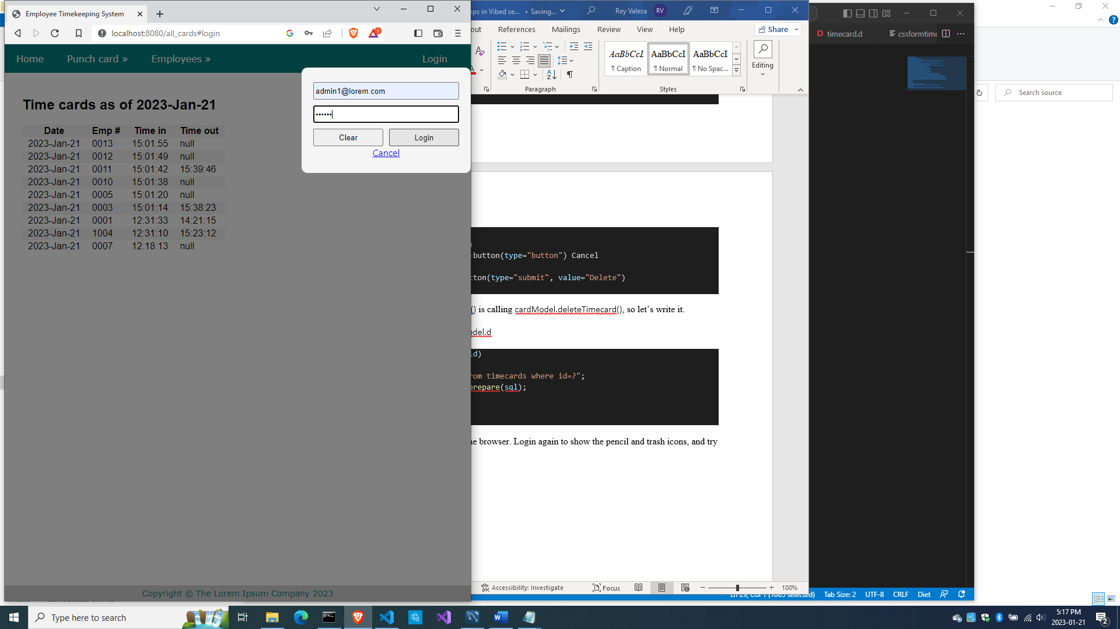

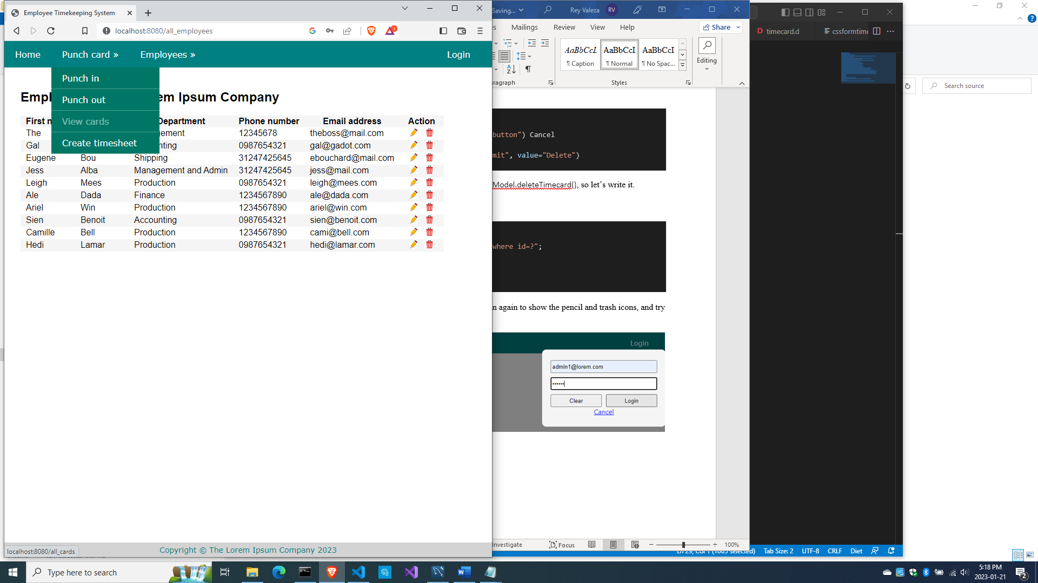

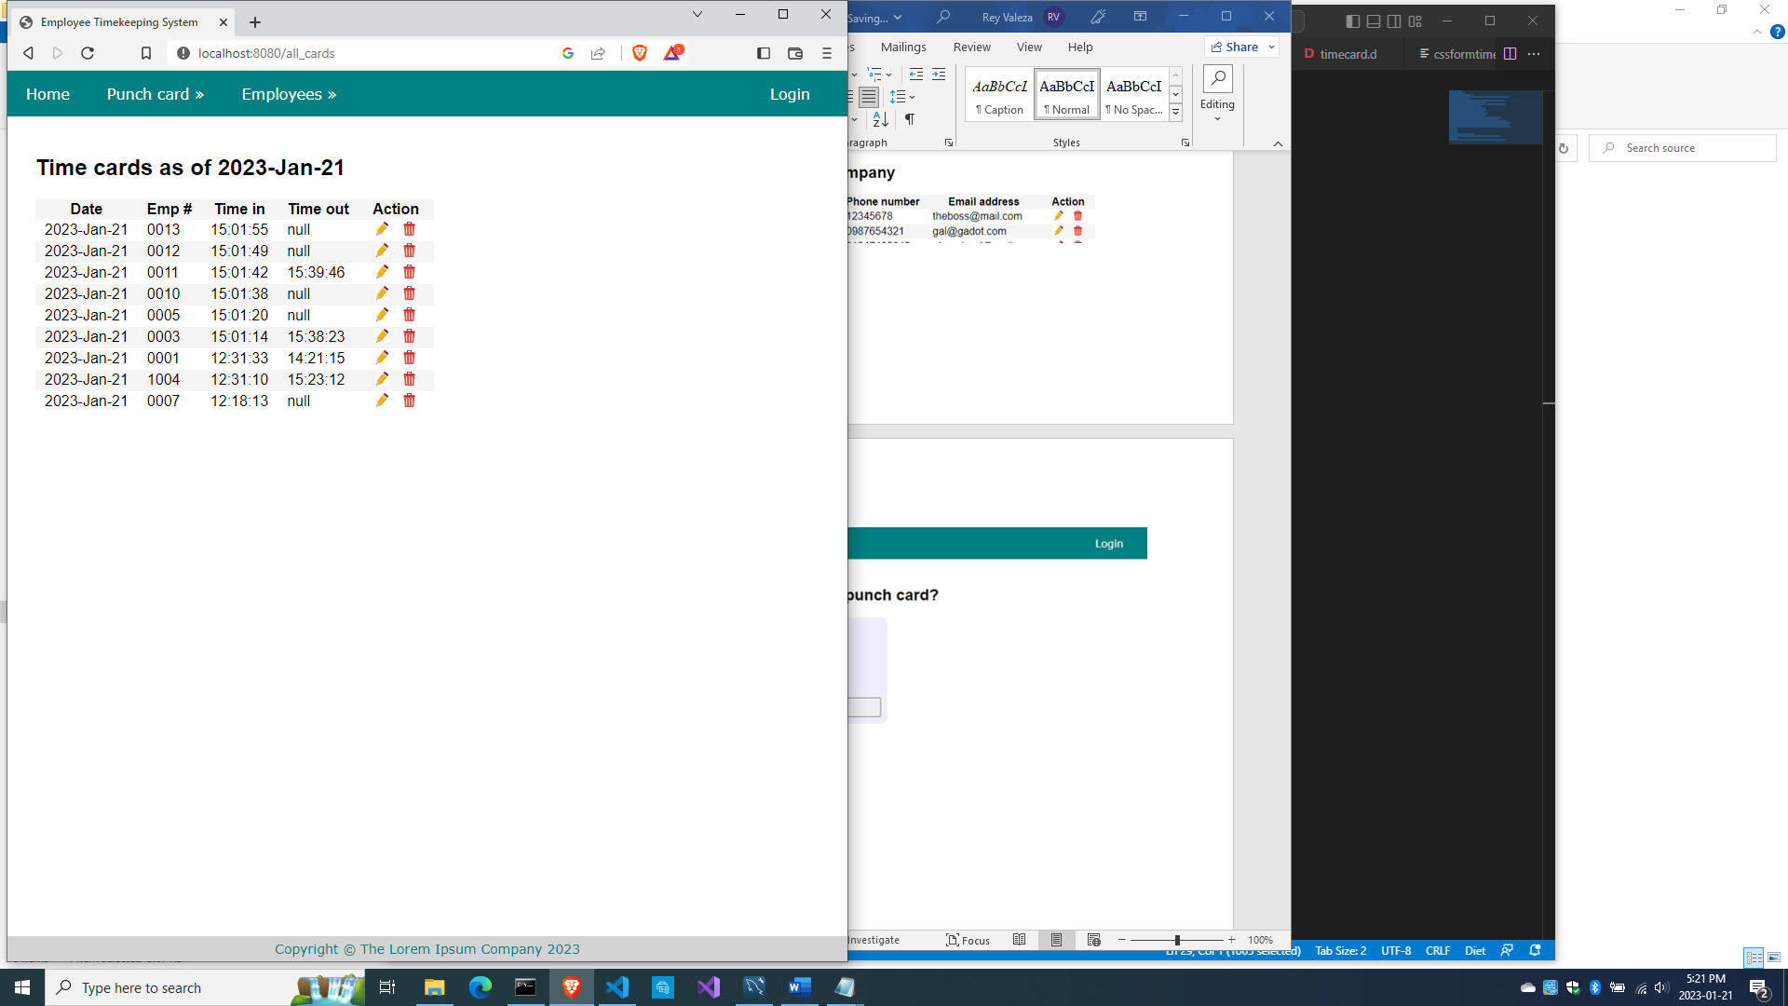

Choose a record

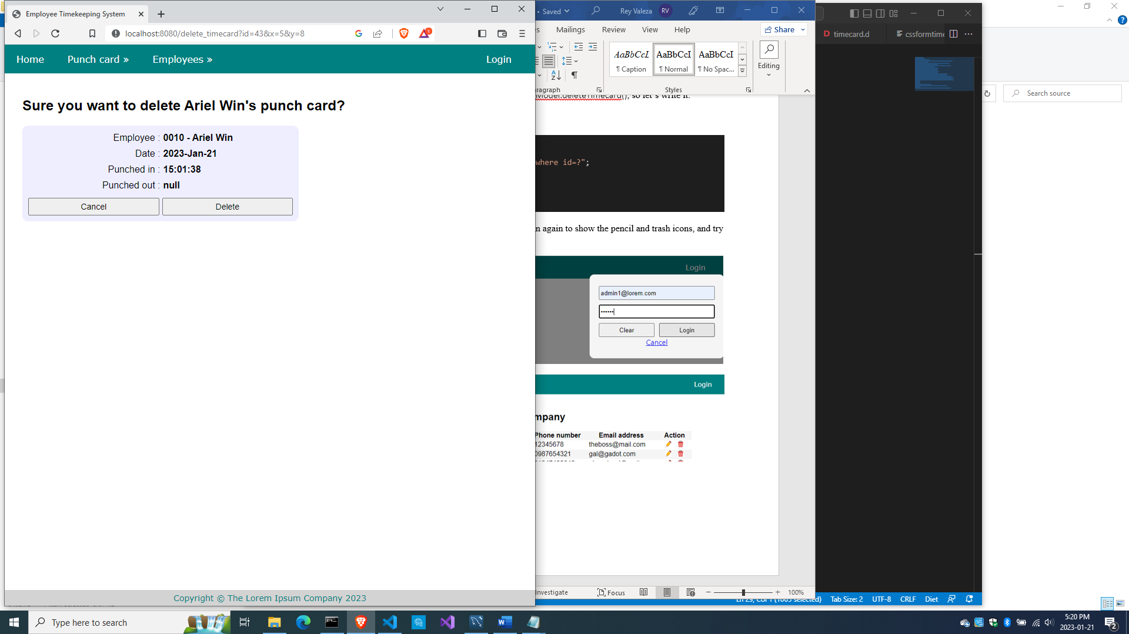

Try the ‘Delete’ button and the deleted record should be gone.

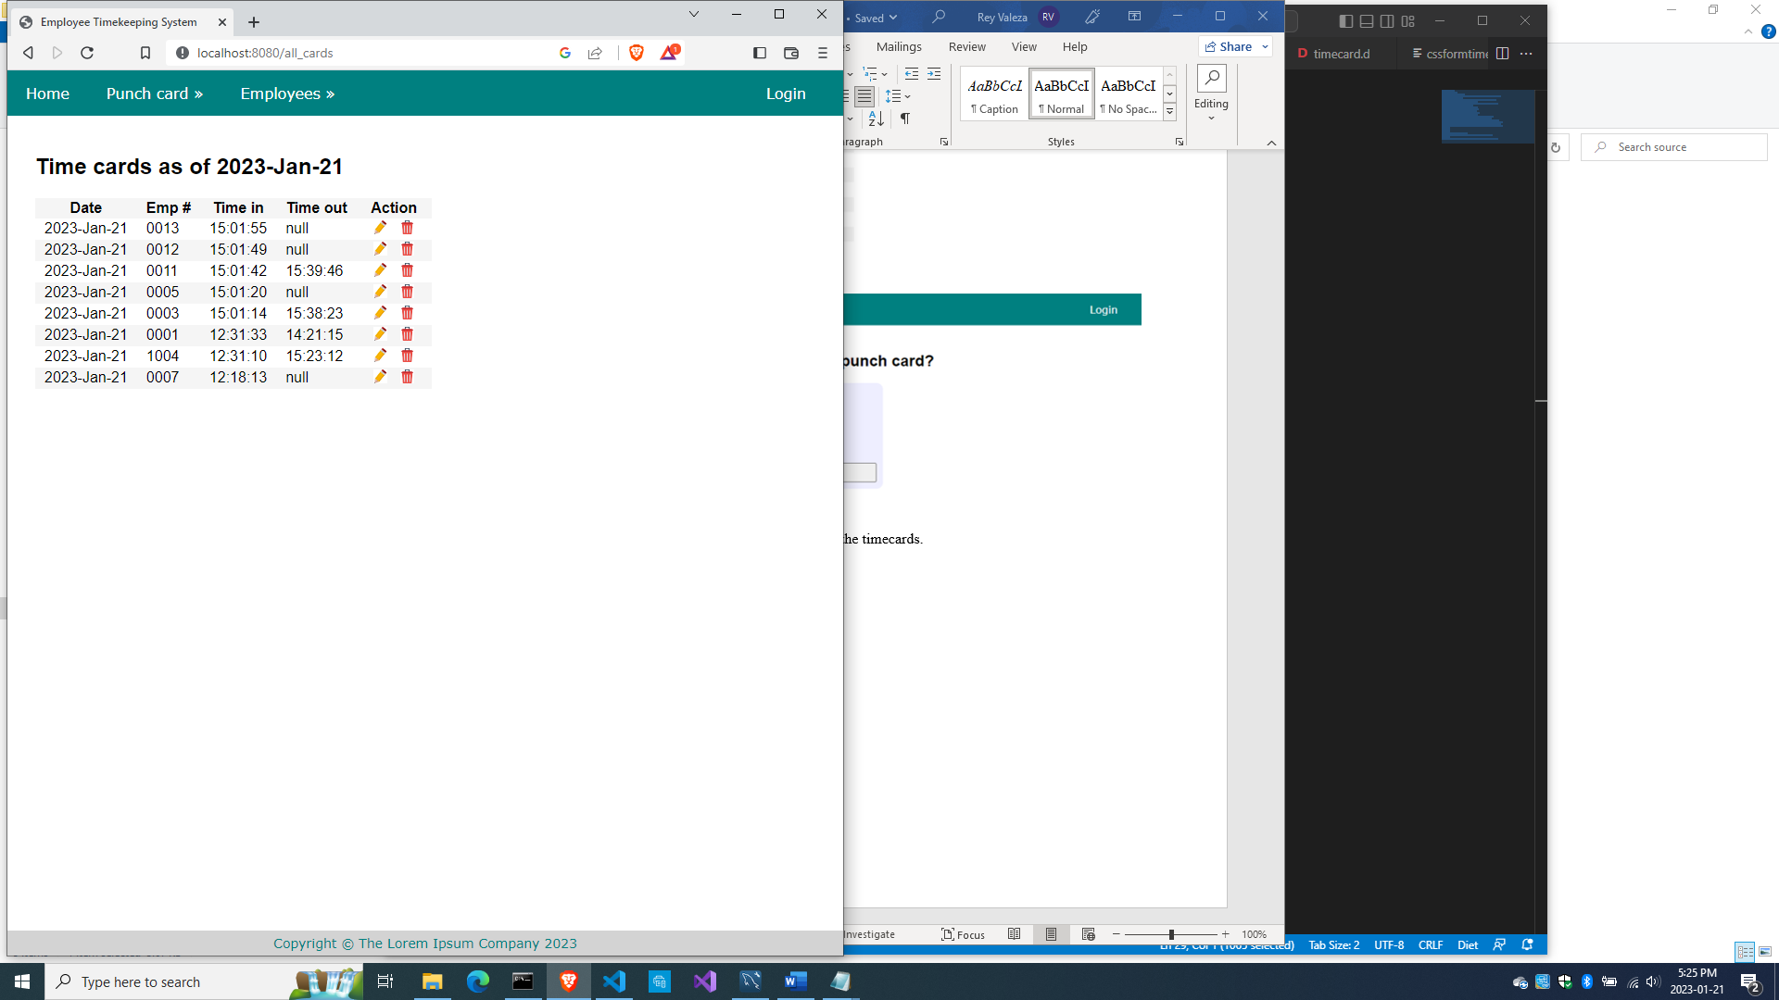

With that, we’ve done all the CRUD stuff with the timecards.

So here’s source\bundycontrol.d so far

module bundycontrol;

import vibe.vibe;

import empmodel;

import cardmodel;

struct User

{

  bool loggedIn;

  string email;

}

class BundyController

{

  private EmployeeModel empModel;

  private TimecardModel cardModel;

  private string realm = "The Lorem Ipsum Company";

  private SessionVar!(User, "user") m_user;

  this()

  {

    empModel = new EmployeeModel;

    cardModel = new TimecardModel;

  }

  void index(string _error = null)

  {

    string error = _error;

    m_user = User.init;

    terminateSession;

    render!("index.dt", error);

  }

/* start of employee subsystem *********************************************/

  @auth

  void getAddEmployee(string _authUser, string _error = null)

  {

    string error = _error;

    render!("empadd.dt", departments, paygrades, provinces, error);

  }

  @errorDisplay!getAddEmployee

  void postAddEmployee(Employee e)

  {

    import std.file;

    import std.path;

    import std.algorithm;

    import vibe.http.auth.digest_auth;

    auto pic = "picture" in request.files;

    if(pic !is null)

    {

      string photopath = "none yet";

      string ext = extension(pic.filename.name);

      string[] exts = [".jpg", ".jpeg", ".png", ".gif"];

      if(canFind(exts, ext))

      {

        photopath = "uploads/photos/" ~ e.fname ~ "_" ~ e.lname ~ ext;

        string dir = "./public/uploads/photos/";

        mkdirRecurse(dir);

        string fullpath = dir ~ e.fname ~ "_" ~ e.lname ~ ext;

        try moveFile(pic.tempPath, NativePath(fullpath));

        catch (Exception ex) copyFile(pic.tempPath, NativePath(fullpath), true);

      }

      e.photo = photopath;

    }

    if(e.phone.length == 0) e.phone = "(123) 456 7890";

    if(e.paygd.length == 0) e.paygd = "none yet";

    if(e.postcode.length == 0) e.postcode = "A1A 1A1";

    e.pword = createDigestPassword(realm, e.email, e.pword);

    empModel.addEmployee(e);

    redirect("all_employees");

  }

  @auth

  void getAllEmployees(string _authUser, string _error = null)

  {

    string error = _error;

    Employee[] emps = empModel.getEmployees;

    render!("emplistall.dt", emps, error);

  }

  @auth

  void getEditEmployee(string _authUser, int id, string _error = null)

  {

    string error = _error;

    Employee e = empModel.getEmployee(id);

    render!("empedit.dt", e, departments, paygrades, provinces, error);

  }

  @errorDisplay!getEditEmployee

  void postEditEmployee(Employee e)

  {

    import std.file;

    import std.path;

    import std.algorithm;

    import vibe.http.auth.digest_auth;

    string photopath = e.photo;

    auto pic = "picture" in request.files;

    if(pic !is null)

    {

      string ext = extension(pic.filename.name);

      string[] exts = [".jpg", ".jpeg", ".png", ".gif"];

      if(canFind(exts, ext))

      {

        photopath = "uploads/photos/" ~ e.fname ~ "_" ~ e.lname ~ ext;

        string dir = "./public/uploads/photos/";

        mkdirRecurse(dir);

        string fullpath = dir ~ e.fname ~ "_" ~ e.lname ~ ext;

        try moveFile(pic.tempPath, NativePath(fullpath));

        catch (Exception ex) copyFile(pic.tempPath, NativePath(fullpath), true);

      }

    }

    e.photo = photopath;

    if(e.phone.length == 0) e.phone = "(123) 456 7890";

    if(e.paygd.length == 0) e.paygd = "none yet";

    if(e.postcode.length == 0) e.postcode = "A1A 1A1";

    e.pword = createDigestPassword(realm, e.email, e.pword);

    empModel.editEmployee(e);

    redirect("all_employees");

  }

  @auth

  void getDeleteEmployee(string _authUser, int id, string _error = null)

  {

    string error = _error;

    Employee e = empModel.getEmployee(id);

    render!("empdelete.dt", e, error);

  }

  @errorDisplay!getDeleteEmployee

  void postDeleteEmployee(int id)

  {

    empModel.deleteEmployee(id);

    redirect("all_employees");

  }

  @auth

  @errorDisplay!getAllEmployees

  void postFindEmployee(string _authUser, string fname, string lname)

  {

    import std.uni; //so we can use the toUpper() function

    string first = toUpper(fname);

    string last = toUpper(lname);

    Employee e = empModel.findEmployee(first, last);

    enforce(e != Employee.init, first ~ " " ~ last ~ " not found.");

    render!("employee.dt", e);

  }

/* end of employee subsystem ***********************************************/

  @errorDisplay!index

  void postLogin(string email, string password)

  {

    import vibe.http.auth.digest_auth;

    auto scrambled = createDigestPassword(realm, email, password);

    bool isAdmin = empModel.isAdmin(email, scrambled);

    enforce(isAdmin, "Email and password combination not found.");

    User user = m_user;

    user.loggedIn = true;

    user.email = email;

    m_user = user;

    redirect("all_employees");

  }

  private enum auth = before!ensureAuth("_authUser");

  private string ensureAuth(HTTPServerRequest req, HTTPServerResponse res)

  {

    if(!m_user.loggedIn) redirect("/");

    return m_user.email;

  }

  mixin PrivateAccessProxy;

/* start of timekeeping subsystem ******************************************/

  void getTimeIn()

  {

    Employee[] emps = empModel.getEmployees;

    render!("timein.dt", emps);

  }

  @errorDisplay!getAllCards

  void postTimeIn(string empid)

  {

    string fullname = getFullname(empid);

    //the record should not exist, otherwise employee already punched in earlier

    enforce(cardModel.noTimeIn(empid), fullname ~ ", you already punched in today");

    cardModel.timeIn(empid);

    redirect("all_cards");

  }

  string getFullname(string empid)

  {

    Employee e = empModel.getEmployee(empid);

    string fullname = to!string(e.fname) ~ " " ~ to!string(e.lname);

    return fullname;

  }

  void getAllCards(string _error)

  {

    string error = _error;

    bool loggedIn = m_user.loggedIn;

    string today = getToday;

    Timecard[] cards = cardModel.getCards();

    render!("cardlistall.dt", cards, today, error, loggedIn);

  }

  string getToday()

  {

    import std.datetime.date;

    auto time = Clock.currTime;

    return to!string(Date(time.year, time.month, time.day));

  }

  void getTimeOut()

  {

    Employee[] emps = empModel.getEmployees;

    render!("timeout.dt", emps);

  }

  @errorDisplay!getAllCards

  void postTimeOut(string empid)

  {

    string fullname = getFullname(empid);

    //the record should exist, otherwise employee did not punch in earlier

    enforce(!cardModel.noTimeIn(empid), fullname ~ ", you did not punch in today");

    //the timeout field should be null, otherwise employee already punched out

    enforce(cardModel.noTimeOut(empid), fullname ~ ", you already punched out today");

    cardModel.timeOut(empid);

    redirect("all_cards");

  }

    void getEditTimecard(int id, string _error = null)

  {

    string error = _error;

    Timecard t = cardModel.getCard(id);

    Employee e = empModel.getEmployeeByEmpid(t.empid);

    render!("cardedit.dt", t, e, error);

  }

  @errorDisplay!getEditTimecard

  void postEditTimecard(Timecard t)

  {

    cardModel.editTimecard(t);

    redirect("all_cards");

  }

  void getDeleteTimecard(int id, string _error = null)

  {

    string error = _error;

    Timecard t = cardModel.getCard(id);

    Employee e = empModel.getEmployeeByEmpid(t.empid);

    render!("carddelete.dt", t, e, error);

  }

  @errorDisplay!getDeleteTimecard

  void postDeleteTimecard(int id)

  {

    cardModel.deleteTimecard(id);

    redirect("all_cards");

  }

/* end of timekeeping subsystem ********************************************/

}

And here’s source\cardmodel.d so far

module cardmodel;

import mysql;

import std.array;

import std.conv;

struct Timecard

{

  int id;

  string empid;

  string thedate;

  string timein;

  string timeout;

}

class TimecardModel

{

  Connection conn;

  this()

  {

    string url = "host=localhost;port=3306;user=owner;pwd=qwerty;db=empdb";

    conn = new Connection(url);

    scope(exit) conn.close;

  }

  void timeIn(string empid)

  {

    string sql = "insert into timecards(empid, thedate, timein) values(?, curdate(), curtime())";

    Prepared pstmt = conn.prepare(sql);

    pstmt.setArgs(empid);

    conn.exec(pstmt);

  }

  bool noTimeIn(string empid)

  {

    string sql = "select * from timecards where empid=? and thedate=?";

    Prepared pstmt = conn.prepare(sql);

    string today = getToday;

    pstmt.setArgs(empid, today);

    Row[] rows = conn.query(pstmt).array;

    if(rows.length == 0) return true;

    return false;

  }

  string getToday()

  {

    Row[] rows = conn.query("select curdate() + 0").array;

    return to!string(rows[0][0]);

  }

  Timecard[] getCards()

  {

    Timecard[] cards;

    string sql = "select * from timecards order by thedate desc, timein desc";

    Row[] rows = conn.query(sql).array;

    if(rows.length == 0) return cards;

    foreach(row; rows)

    {

      Timecard c;

      c.id = to!int(to!string(row[0]));

      c.empid = to!string(row[1]);

      c.thedate = to!string(row[2]);

      c.timein = to!string(row[3]);

      c.timeout = to!string(row[4]);

      cards ~= c;

    }

    return cards;

  }

  bool noTimeOut(string empid)

  {

    string sql = "select * from timecards where timeout is null and empid=? and thedate=?";

    Prepared pstmt = conn.prepare(sql);

    string today = getToday;

    pstmt.setArgs(empid, today);

    Row[] rows = conn.query(pstmt).array;

    if(rows.length != 0) return true;

    return false;

  }

  void timeOut(string empid)

  {

    string sql = "update timecards set timeout=curtime() where empid=? and thedate=?";

    Prepared pstmt = conn.prepare(sql);

    string today = getToday;

    pstmt.setArgs(empid, today);

    conn.exec(pstmt);

  }

  Timecard getCard(int id)

  {

    Timecard c;

    string sql = "select * from timecards where id=?";

    Prepared pstmt = conn.prepare(sql);

    pstmt.setArgs(id);

    Row[] rows = conn.query(pstmt).array;

    if(rows.length == 0) return c;

    Row row = rows[0];

    c.id = to!int(to!string(row[0]));

    c.empid = to!string(row[1]);

    c.thedate = to!string(row[2]);

    c.timein = to!string(row[3]);

    c.timeout = to!string(row[4]);

    return c;

  }

  ulong editTimecard(Timecard t)

  {

    Prepared pstmt;

    if(to!string(t.timeout) == "null")

    {

      string sql = "update timecards set timein=?, timeout=null where id=?";

      pstmt = conn.prepare(sql);

      pstmt.setArgs(t.timein, t.id);

    }

    else

    {

      string sql = "update timecards set timein=?, timeout=? where id=?";

      pstmt = conn.prepare(sql);

      pstmt.setArgs(t.timein, t.timeout, t.id);

    }

    return conn.exec(pstmt);

  }

  void deleteTimecard(int id)

  {

    string sql = "delete from timecards where id=?";

    Prepared pstmt = conn.prepare(sql);

    pstmt.setArgs(id);

    conn.exec(pstmt);

  }

}

We added one method to EmployeeModel, so here’s source\empmodel.d now

module empmodel;

import mysql;

import std.conv;

import std.array;

struct Employee

{

  int id; //row id or record id

  string empid; //employee number

  string deprt; //department

  string paygd; //salary grade

  string email; //email address

  string pword; //password

  string fname; //first name

  string lname; //last name

  string phone; //phone number

  string photo; //ID photo

  string street; //street address

  string city; //city name

  string province; //province name

  string postcode; //postal code

}

struct Admin

{

  string email; //email address

  string pword; //passsword

}

string[] departments =

[

  "Management",

  "Accounting",

  "Production",

  "Maintenance",

  "Shipping",

  "Purchasing",

  "IT Services",

  "HR Services",

  "Marketing"

];

string[][] provinces =

[

  ["AB", "Alberta"],

  ["BC", "British Columbia"],

  ["MB", "Manitoba"],

  ["NB", "New Brunswick"],

  ["NL", "Newfoundland and Labrador"],

  ["NS", "Nova Scotia"],

  ["NT", "Northwest Territories"],

  ["NU", "Nunavut"],

  ["ON", "Ontario"],

  ["PE", "Prince Edward Island"],

  ["QC", "Quebec"],

  ["SK", "Saskatchewan"],

  ["YT", "Yukon Territory"]

];

string[] paygrades =

[

  "A100", "A200", "A300", "A400",

  "B100", "B200", "B300", "B400",

  "C100", "C200", "C300", "C400",

  "D100", "D200", "D300", "D400",

  "E100", "E200", "E300", "E400",

  "F100", "F200", "F300", "F400"

];

class EmployeeModel

{

  Connection conn;

  this()

  {

    string url = "host=localhost;port=3306;user=owner;pwd=qwerty;db=empdb";

    conn = new Connection(url);

    scope(exit) conn.close;

  }

  ulong addEmployee(Employee e)

  {

    string sql =

      "insert into employees

      (

        empid,

        deprt, paygd, email, pword,

        fname, lname, phone, photo,

        street, city, province, postcode

      )

      values(?,?,?,?,?,?,?,?,?,?,?,?,?)";

    Prepared pstmt = conn.prepare(sql);

    pstmt.setArgs

    (

      to!string(e.empid),

      to!string(e.deprt),

      to!string(e.paygd),

      to!string(e.email),

      to!string(e.pword),

      to!string(e.fname),

      to!string(e.lname),

      to!string(e.phone),

      to!string(e.photo),

      to!string(e.street),

      to!string(e.city),

      to!string(e.province),

      to!string(e.postcode)

    );

    return conn.exec(pstmt);

  }

  Employee[] getEmployees()

  {

    Employee[] emps;

    string sql = "select * from employees";

    Row[] rows = conn.query(sql).array;

    if(rows.length == 0) return emps;

    return prepareEmployees(rows);

  }

  Employee[] prepareEmployees(Row[] rows)

  {

    Employee[] emps;

    foreach(row; rows)

    {

      Employee e = prepareEmployee(row);

      emps ~= e;

    }

    return emps;

  }

  Employee prepareEmployee(Row row)

  {

    Employee e;

    e.id = to!int(to!string(row[0]));

    e.empid = to!string(row[1]);

    e.deprt = to!string(row[2]);

    e.paygd = to!string(row[3]);

    e.email = to!string(row[4]);

    e.pword = to!string(row[5]);

    e.fname = to!string(row[6]);

    e.lname = to!string(row[7]);

    e.phone = to!string(row[8]);

    e.photo = to!string(row[9]);

    e.street = to!string(row[10]);

    e.city = to!string(row[11]);

    e.province = to!string(row[12]);

    e.postcode = to!string(row[13]);

    return e;

  }

  Employee getEmployee(int id)

  {

    string sql = "select * from employees where id=?";

    Prepared pstmt = conn.prepare(sql);

    pstmt.setArgs(id);

    Employee e;

    Row[] rows = conn.query(pstmt).array;

    if(rows.length == 0) return e;

    return prepareEmployee(rows[0]);

  }

  Employee getEmployee(string empid)

  {

    string sql = "select * from employees where empid=?";

    Prepared pstmt = conn.prepare(sql);

    pstmt.setArgs(empid);

    Employee e;

    Row[] rows = conn.query(pstmt).array;

    if(rows.length == 0) return e;

    return prepareEmployee(rows[0]);

  }

  ulong editEmployee(Employee e)

  {

    string sql = "update employees set empid=?,

      deprt=?, paygd=?, email=?, pword=?,

      fname=?, lname=?, phone=?, photo=?,

      street=?, city=?, province=?, postcode=?

      where id=?";

    Prepared pstmt = conn.prepare(sql);

    pstmt.setArgs

    (

      to!string(e.empid),

      to!string(e.deprt),

      to!string(e.paygd),

      to!string(e.email),

      to!string(e.pword),

      to!string(e.fname),

      to!string(e.lname),

      to!string(e.phone),

      to!string(e.photo),

      to!string(e.street),

      to!string(e.city),

      to!string(e.province),

      to!string(e.postcode),

      to!int(to!string(e.id))

    );

    return conn.exec(pstmt);

  }

  void deleteEmployee(int id)

  {

    string sql = "delete from employees where id=?";

    Prepared pstmt = conn.prepare(sql);

    pstmt.setArgs(id);

    conn.exec(pstmt);

  }

  Employee findEmployee(string first, string last)

  {

    Employee e;

    string sql = "select * from employees where upper(fname)=? and upper(lname)=?";

    Prepared pstmt = conn.prepare(sql);

    pstmt.setArgs(first, last);

    Row[] rows = conn.query(pstmt).array;

    if(rows.length == 0) return e;

    return prepareEmployee(rows[0]);

  }

  bool isAdmin(string email, string password)

  {

    string sql = "select * from admins where email=? and pword=?";

    Prepared pstmt = conn.prepare(sql);

    pstmt.setArgs(email, password);

    Row[] rows = conn.query(pstmt).array;

    if(rows.length == 0) return false;

    return true;

  }

  Employee getEmployeeByEmpid(string empid)

  {

    string sql = "select * from employees where empid=?";

    Prepared pstmt = conn.prepare(sql);

    pstmt.setArgs(empid);

    Employee e;

    Row[] rows = conn.query(pstmt).array;

    if(rows.length == 0) return e;

    return prepareEmployee(rows[0]);

  }

}

/*

  void insertIntoAdmins()

  {

    import vibe.http.auth.digest_auth;

    string email1 = "admin1@lorem.com";

    string email2 = "admin2@lorem.com";

    string email3 = "admin3@lorem.com";

    string realm = "The Lorem Ipsum Company";

    string pass1 = createDigestPassword(realm, email1, "secret");

    string pass2 = createDigestPassword(realm, email2, "secret");

    string pass3 = createDigestPassword(realm, email3, "secret");

    string sql = "insert into admins(email, pword)

      values ('" ~ email1 ~ "','" ~ pass1 ~ "')";

    conn.exec(sql);

    sql = "insert into admins(email, pword)

      values ('" ~ email2 ~ "','" ~ pass2 ~ "')";

    conn.exec(sql);

    sql = "insert into admins(email, pword)

      values ('" ~ email3 ~ "','" ~ pass3 ~ "')";

    conn.exec(sql);

  }

*/

Now let’s start creating the timesheet.

Timesheets

Timesheets get their data from timecards but have additional info and some summarization, and then can be further used for salary calculations, although that part we will not do.

What we will do is simply copy the contents of timecards for an indicated period into the timesheets table with calculations for the number of hours worked for each worker per day. Every time the timesheet is generated, it is erased before being filled with new data specific to the period requested, but the timecards remain growing.

Create source\sheetmodel.d

module sheetmodel;

import std.array;

import std.conv;

import mysql;

struct Timesheet

{

  int id;

  int period;

  string empid;

  string thedate;

  string timein;

  string timeout;

  double hours;

}

class TimesheetModel

{

  Connection conn;

  this()

  {

    string url = "host=localhost;port=3306;user=owner;pwd=qwerty;db=empdb";

    conn = new Connection(url);

    scope(exit) conn.close;

  }

Next, add this code to source\bundycontrol.d

  void getCreateTimesheet(string _error = null)

  {

    string error = _error;

    string[] dates = cardModel.getThedates;

    render!("sheetcreate.dt", dates, error);

  }

This code is calling cardModel.getThedates() method and rendering a form, so let’s write them.

Add this code to source\cardmodel.d

  string[] getThedates()

  {

    string sql = "select distinct thedate from timecards order by thedate";

    Row[] rows = conn.query(sql).array;

    string[] dates;

    foreach (row; rows) dates ~= to!string(row[0]);

    return dates;

  }

Next, create views\sheetcreate.dt

extends layout

block maincontent

  include cssformgrid.dt

  div.form-grid-wrapper

    -if(error)

      div.error-div

        span.error-message #{error}

    form.form-grid(method="post", action="create_timesheet")

      label.form-grid-label From:

      select#from.form-grid-input(name="from")

        -foreach(d; dates)

          option(value="#{d}") #{d}

      div

      div

      label.form-grid-label Up to:

      select#from.form-grid-input(name="upto")

        -foreach(d; dates)

          option(value="#{d}") #{d}

      div

      div

        input.form-grid-button(type="submit", value="Generate timesheet")

Then compile and run and refresh the browser to test what we just did.

When you click ‘Create timesheet’ on the menu, you should see this:

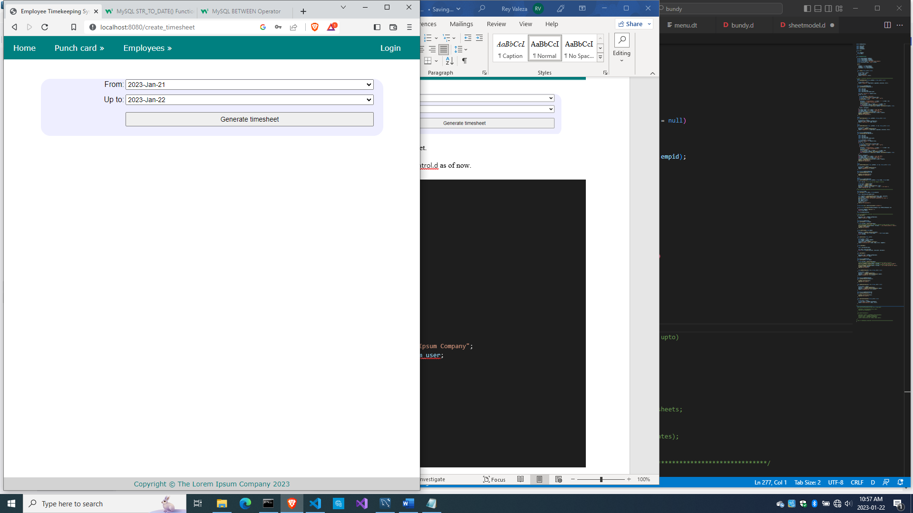

But when you click on ‘Generate timesheet’, you see this:

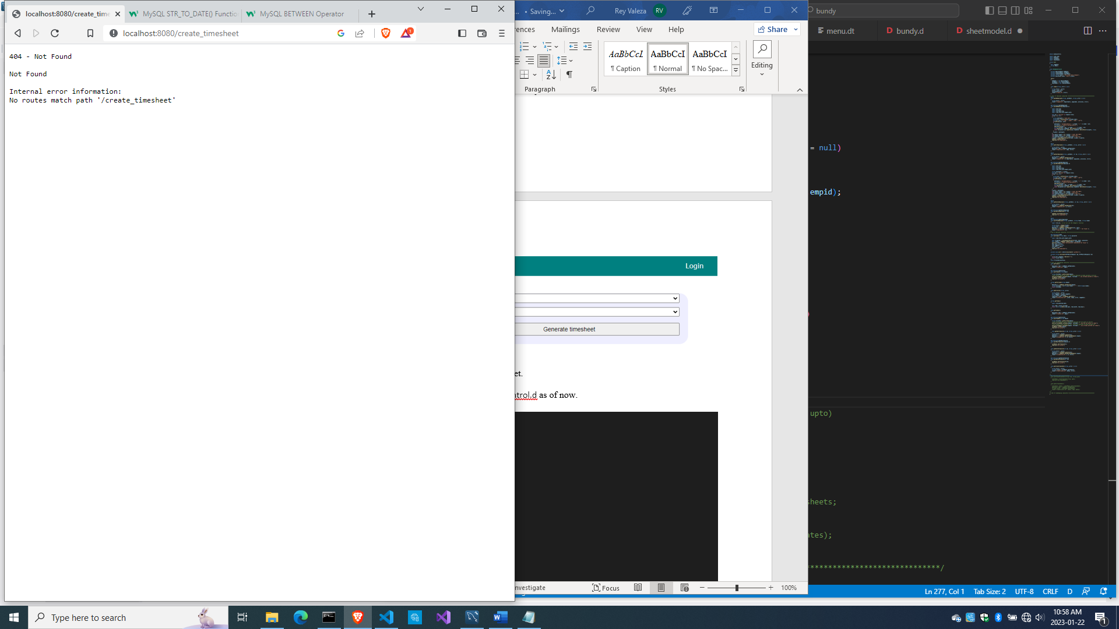

So let’s write the code for creating the timesheet.

But first, here’s the whole source\bundycontrol.d as of now:

module bundycontrol;

import vibe.vibe;

import empmodel;

import cardmodel;

import sheetmodel;

struct User

{

  bool loggedIn;

  string email;

}

class BundyController

{

  private EmployeeModel empModel;

  private TimecardModel cardModel;

  private TimesheetModel sheetModel;

  private string realm = "The Lorem Ipsum Company";

  private SessionVar!(User, "user") m_user;

  this()

  {

    empModel = new EmployeeModel;

    cardModel = new TimecardModel;

    sheetModel = new TimesheetModel;

  }

  void index(string _error = null)

  {

    string error = _error;

    m_user = User.init;

    terminateSession;

    render!("index.dt", error);

  }

/* start of employee subsystem *********************************************/

  @auth

  void getAddEmployee(string _authUser, string _error = null)

  {

    string error = _error;

    render!("empadd.dt", departments, paygrades, provinces, error);

  }

  @errorDisplay!getAddEmployee

  void postAddEmployee(Employee e)

  {

    import std.file;

    import std.path;

    import std.algorithm;

    import vibe.http.auth.digest_auth;

    auto pic = "picture" in request.files;

    if(pic !is null)

    {

      string photopath = "none yet";

      string ext = extension(pic.filename.name);

      string[] exts = [".jpg", ".jpeg", ".png", ".gif"];

      if(canFind(exts, ext))

      {

        photopath = "uploads/photos/" ~ e.fname ~ "_" ~ e.lname ~ ext;

        string dir = "./public/uploads/photos/";

        mkdirRecurse(dir);

        string fullpath = dir ~ e.fname ~ "_" ~ e.lname ~ ext;

        try moveFile(pic.tempPath, NativePath(fullpath));

        catch (Exception ex) copyFile(pic.tempPath, NativePath(fullpath), true);

      }

      e.photo = photopath;

    }

    if(e.phone.length == 0) e.phone = "(123) 456 7890";

    if(e.paygd.length == 0) e.paygd = "none yet";

    if(e.postcode.length == 0) e.postcode = "A1A 1A1";

    e.pword = createDigestPassword(realm, e.email, e.pword);

    empModel.addEmployee(e);

    redirect("all_employees");

  }

  @auth

  void getAllEmployees(string _authUser, string _error = null)

  {

    string error = _error;

    Employee[] emps = empModel.getEmployees;

    render!("emplistall.dt", emps, error);

  }

  @auth

  void getEditEmployee(string _authUser, int id, string _error = null)

  {

    string error = _error;

    Employee e = empModel.getEmployee(id);

    render!("empedit.dt", e, departments, paygrades, provinces, error);

  }

  @errorDisplay!getEditEmployee

  void postEditEmployee(Employee e)

  {

    import std.file;

    import std.path;

    import std.algorithm;

    import vibe.http.auth.digest_auth;

    string photopath = e.photo;

    auto pic = "picture" in request.files;

    if(pic !is null)

    {

      string ext = extension(pic.filename.name);

      string[] exts = [".jpg", ".jpeg", ".png", ".gif"];

      if(canFind(exts, ext))

      {

        photopath = "uploads/photos/" ~ e.fname ~ "_" ~ e.lname ~ ext;

        string dir = "./public/uploads/photos/";

        mkdirRecurse(dir);

        string fullpath = dir ~ e.fname ~ "_" ~ e.lname ~ ext;

        try moveFile(pic.tempPath, NativePath(fullpath));

        catch (Exception ex) copyFile(pic.tempPath, NativePath(fullpath), true);

      }

    }

    e.photo = photopath;

    if(e.phone.length == 0) e.phone = "(123) 456 7890";

    if(e.paygd.length == 0) e.paygd = "none yet";

    if(e.postcode.length == 0) e.postcode = "A1A 1A1";

    e.pword = createDigestPassword(realm, e.email, e.pword);

    empModel.editEmployee(e);

    redirect("all_employees");

  }

  @auth

  void getDeleteEmployee(string _authUser, int id, string _error = null)

  {

    string error = _error;

    Employee e = empModel.getEmployee(id);

    render!("empdelete.dt", e, error);

  }

  @errorDisplay!getDeleteEmployee

  void postDeleteEmployee(int id)

  {

    empModel.deleteEmployee(id);

    redirect("all_employees");

  }

  @auth

  @errorDisplay!getAllEmployees

  void postFindEmployee(string _authUser, string fname, string lname)

  {

    import std.uni; //so we can use the toUpper() function

    string first = toUpper(fname);

    string last = toUpper(lname);

    Employee e = empModel.findEmployee(first, last);

    enforce(e != Employee.init, first ~ " " ~ last ~ " not found.");

    render!("employee.dt", e);

  }

/* end of employee subsystem ***********************************************/

  @errorDisplay!index

  void postLogin(string email, string password)

  {

    import vibe.http.auth.digest_auth;

    auto scrambled = createDigestPassword(realm, email, password);

    bool isAdmin = empModel.isAdmin(email, scrambled);

    enforce(isAdmin, "Email and password combination not found.");

    User user = m_user;

    user.loggedIn = true;

    user.email = email;

    m_user = user;

    redirect("all_employees");

  }

  private enum auth = before!ensureAuth("_authUser");

  private string ensureAuth(HTTPServerRequest req, HTTPServerResponse res)

  {

    if(!m_user.loggedIn) redirect("/");

    return m_user.email;

  }

  mixin PrivateAccessProxy;

/* start of timekeeping subsystem ******************************************/

  void getTimeIn()

  {

    Employee[] emps = empModel.getEmployees;

    render!("timein.dt", emps);

  }

  @errorDisplay!getAllCards

  void postTimeIn(string empid)

  {

    string fullname = getFullname(empid);

    //the record should not exist, otherwise employee already punched in earlier

    enforce(cardModel.noTimeIn(empid), fullname ~ ", you already punched in today");

    cardModel.timeIn(empid);

    redirect("all_cards");

  }

  string getFullname(string empid)

  {

    Employee e = empModel.getEmployee(empid);

    string fullname = to!string(e.fname) ~ " " ~ to!string(e.lname);

    return fullname;

  }

  void getAllCards(string _error)

  {

    string error = _error;

    bool loggedIn = m_user.loggedIn;

    string today = getToday;

    Timecard[] cards = cardModel.getCards();

    render!("cardlistall.dt", cards, today, error, loggedIn);

  }

  string getToday()

  {

    import std.datetime.date;

    auto time = Clock.currTime;

    return to!string(Date(time.year, time.month, time.day));

  }

  void getTimeOut()

  {

    Employee[] emps = empModel.getEmployees;

    render!("timeout.dt", emps);

  }

  @errorDisplay!getAllCards

  void postTimeOut(string empid)

  {

    string fullname = getFullname(empid);

    //the record should exist, otherwise employee did not punch in earlier

    enforce(!cardModel.noTimeIn(empid), fullname ~ ", you did not punch in today");

    //the timeout field should be null, otherwise employee already punched out

    enforce(cardModel.noTimeOut(empid), fullname ~ ", you already punched out today");

    cardModel.timeOut(empid);

    redirect("all_cards");

  }

    void getEditTimecard(int id, string _error = null)

  {

    string error = _error;

    Timecard t = cardModel.getCard(id);

    Employee e = empModel.getEmployeeByEmpid(t.empid);

    render!("cardedit.dt", t, e, error);

  }

  @errorDisplay!getEditTimecard

  void postEditTimecard(Timecard t)

  {

    cardModel.editTimecard(t);

    redirect("all_cards");

  }

  void getDeleteTimecard(int id, string _error = null)

  {

    string error = _error;

    Timecard t = cardModel.getCard(id);

    Employee e = empModel.getEmployeeByEmpid(t.empid);

    render!("carddelete.dt", t, e, error);

  }

  @errorDisplay!getDeleteTimecard

  void postDeleteTimecard(int id)

  {

    cardModel.deleteTimecard(id);

    redirect("all_cards");

  }

  void getCreateTimesheet(string _error = null)

  {

    string error = _error;

    string[] dates = cardModel.getThedates;

    render!("sheetcreate.dt", dates, error);

  }

/* end of timekeeping subsystem ********************************************/

}

And here’s source\sheetmodel.d as of now:

module sheetmodel;

import std.array;

import std.conv;

import mysql;

struct Timesheet

{

  int id;

  int period;

  string empid;

  string thedate;

  string timein;

  string timeout;

  double hours;

}

class TimesheetModel

{

  Connection conn;

  this()

  {

    string url = "host=localhost;port=3306;user=owner;pwd=qwerty;db=empdb";

    conn = new Connection(url);

    scope(exit) conn.close;

  }

}

We added one method to the TimecardModel class so here’s source\cardmodel.d as of now.

module cardmodel;

import mysql;

import std.array;

import std.conv;

struct Timecard

{

  int id;

  string empid;

  string thedate;

  string timein;

  string timeout;

}

class TimecardModel

{

  Connection conn;

  this()

  {

    string url = "host=localhost;port=3306;user=owner;pwd=qwerty;db=empdb";

    conn = new Connection(url);

    scope(exit) conn.close;

  }

  void timeIn(string empid)

  {

    string sql = "insert into timecards(empid, thedate, timein) values(?, curdate(), curtime())";

    Prepared pstmt = conn.prepare(sql);

    pstmt.setArgs(empid);

    conn.exec(pstmt);

  }

  bool noTimeIn(string empid)

  {

    string sql = "select * from timecards where empid=? and thedate=?";

    Prepared pstmt = conn.prepare(sql);

    string today = getToday;

    pstmt.setArgs(empid, today);

    Row[] rows = conn.query(pstmt).array;

    if(rows.length == 0) return true;

    return false;

  }

  string getToday()

  {

    Row[] rows = conn.query("select curdate() + 0").array;

    return to!string(rows[0][0]);

  }

  string[] getThedates()

  {

    string sql = "select distinct thedate from timecards order by thedate";

    Row[] rows = conn.query(sql).array;

    string[] dates;

    foreach (row; rows) dates ~= to!string(row[0]);

    return dates;

  }

  Timecard[] getCards()

  {

    Timecard[] cards;

    string sql = "select * from timecards order by thedate desc, timein desc";

    Row[] rows = conn.query(sql).array;

    if(rows.length == 0) return cards;

    foreach(row; rows)

    {

      Timecard c;

      c.id = to!int(to!string(row[0]));

      c.empid = to!string(row[1]);

      c.thedate = to!string(row[2]);

      c.timein = to!string(row[3]);

      c.timeout = to!string(row[4]);

      cards ~= c;

    }

    return cards;

  }

  bool noTimeOut(string empid)

  {

    string sql = "select * from timecards where timeout is null and empid=? and thedate=?";

    Prepared pstmt = conn.prepare(sql);

    string today = getToday;

    pstmt.setArgs(empid, today);

    Row[] rows = conn.query(pstmt).array;

    if(rows.length != 0) return true;

    return false;

  }

  void timeOut(string empid)

  {

    string sql = "update timecards set timeout=curtime() where empid=? and thedate=?";

    Prepared pstmt = conn.prepare(sql);

    string today = getToday;

    pstmt.setArgs(empid, today);

    conn.exec(pstmt);

  }

  Timecard getCard(int id)

  {

    Timecard c;

    string sql = "select * from timecards where id=?";

    Prepared pstmt = conn.prepare(sql);

    pstmt.setArgs(id);

    Row[] rows = conn.query(pstmt).array;

    if(rows.length == 0) return c;

    Row row = rows[0];

    c.id = to!int(to!string(row[0]));

    c.empid = to!string(row[1]);

    c.thedate = to!string(row[2]);

    c.timein = to!string(row[3]);

    c.timeout = to!string(row[4]);

    return c;

  }

  ulong editTimecard(Timecard t)

  {

    Prepared pstmt;

    if(to!string(t.timeout) == "null")

    {

      string sql = "update timecards set timein=?, timeout=null where id=?";

      pstmt = conn.prepare(sql);

      pstmt.setArgs(t.timein, t.id);

    }

    else

    {

      string sql = "update timecards set timein=?, timeout=? where id=?";

      pstmt = conn.prepare(sql);

      pstmt.setArgs(t.timein, t.timeout, t.id);

    }

    return conn.exec(pstmt);

  }

  void deleteTimecard(int id)

  {

    string sql = "delete from timecards where id=?";

    Prepared pstmt = conn.prepare(sql);

    pstmt.setArgs(id);

    conn.exec(pstmt);

  }

}

Now let’s go on to creating the timesheet.

Creating the timesheet

We are going to extract data from the timecards table to the timesheets table, using the dates passed from the form as basis for copying.

Add this code to source\bundycontrol.d

 @errorDisplay!getCreateTimesheet

  void postCreateTimesheet(string from, string upto)

  {

    sheetModel.createTimesheets(from, upto);

    redirect("all_timesheets");

  }

  void getAllTimesheets()

  {

    Timesheet[] sheets = sheetModel.getAllTimesheets;

    Employee[] emps = empModel.getEmployees;

    string[] dates = sheetModel.getThedates;

    render!("sheetlistall.dt", sheets, emps, dates);

  }

Each of these methods are calling methods from another class. But since they are related, we opted to simply write them together as these steps look familiar now: we open a form to get input data, we use that input data to process the database data, then output the result to a web page.

The code is calling createTimsheets(), getAllTimesheets() and getTheDates() methods from TimesheetModel, so let’s write them.

Add this code to source\sheetmodel.d

  string[] getThedates()

  {

    string sql = "select distinct thedate from timesheets order by thedate";

    Row[] rows = conn.query(sql).array;

    string[] dates;

    foreach (row; rows) dates ~= to!string(row[0]);

    return dates;

  }

  void createTimesheets(string from, string upto)

  {

    string sql = "delete from timesheets";

    conn.exec(sql);

    sql = "insert into timesheets(period, empid, thedate, timein, timeout, hours)

                  select week(thedate), empid, thedate, timein, timeout,

                  round((time_to_sec(timeout)-time_to_sec(timein))/3600,2)

                  from timecards where timeout is not null

                  and thedate between str_to_date(?,'%Y-%b-%d') and str_to_date(?,'%Y-%b-%d')

                  order by thedate desc, empid";

    Prepared pstmt = conn.prepare(sql);

    pstmt.setArgs(from, upto);

    conn.exec(pstmt);

  }

  Timesheet[] getAllTimesheets()

  {

    string sql = "select * from timesheets";

    Row[] rows = conn.query(sql).array;

    Timesheet[] sheets;

    foreach (row; rows)

    {

      Timesheet t;

      t.id = to!int(to!string(row[0]));

      t.period = to!int(to!string(row[1]));

      t.empid = to!string(row[2]);

      t.thedate = to!string(row[3]);

      t.timein = to!string(row[4]);

      t.timeout = to!string(row[5]);

      t.hours = to!double(to!string(row[6]));

      sheets ~= t;

    }

    return sheets;

  }

The shitlistall.dt template is being rendered, so let’s create it.

Create views\sheetlistall.dt

extends layout

block maincontent

  include csstable.dt

  h2 Timesheets

  div.form-grid-wrapper

    form.form-grid(method="post", action="by_empid")

      input.form-grid-input(type="submit", value="By employee")

      select.form-grid-input(name="empid")

        -foreach(e; emps)

          option(value="#{e.empid}") #{e.fname} #{e.lname} - #{e.empid}

      br

      br

    form.form-grid(method="post", action="by_date")

      input.form-grid-input(type="submit", value="Arrange by date")

      br

      br

      input(type="hidden", name="empid", value="0")

  div.table-wrapper

    table

      tr

        th Week

        th Emp #

        th Date

        th Time in

        th Time out

        th Hours

      -foreach(s; sheets)

        tr

          td #{s.period}

          td #{s.empid}

          td #{s.thedate}

          td #{s.timein}

          td #{s.timeout}

          td.right-align #{s.hours}

Now compile, run, refresh you browser and click on ‘Create timesheet’.

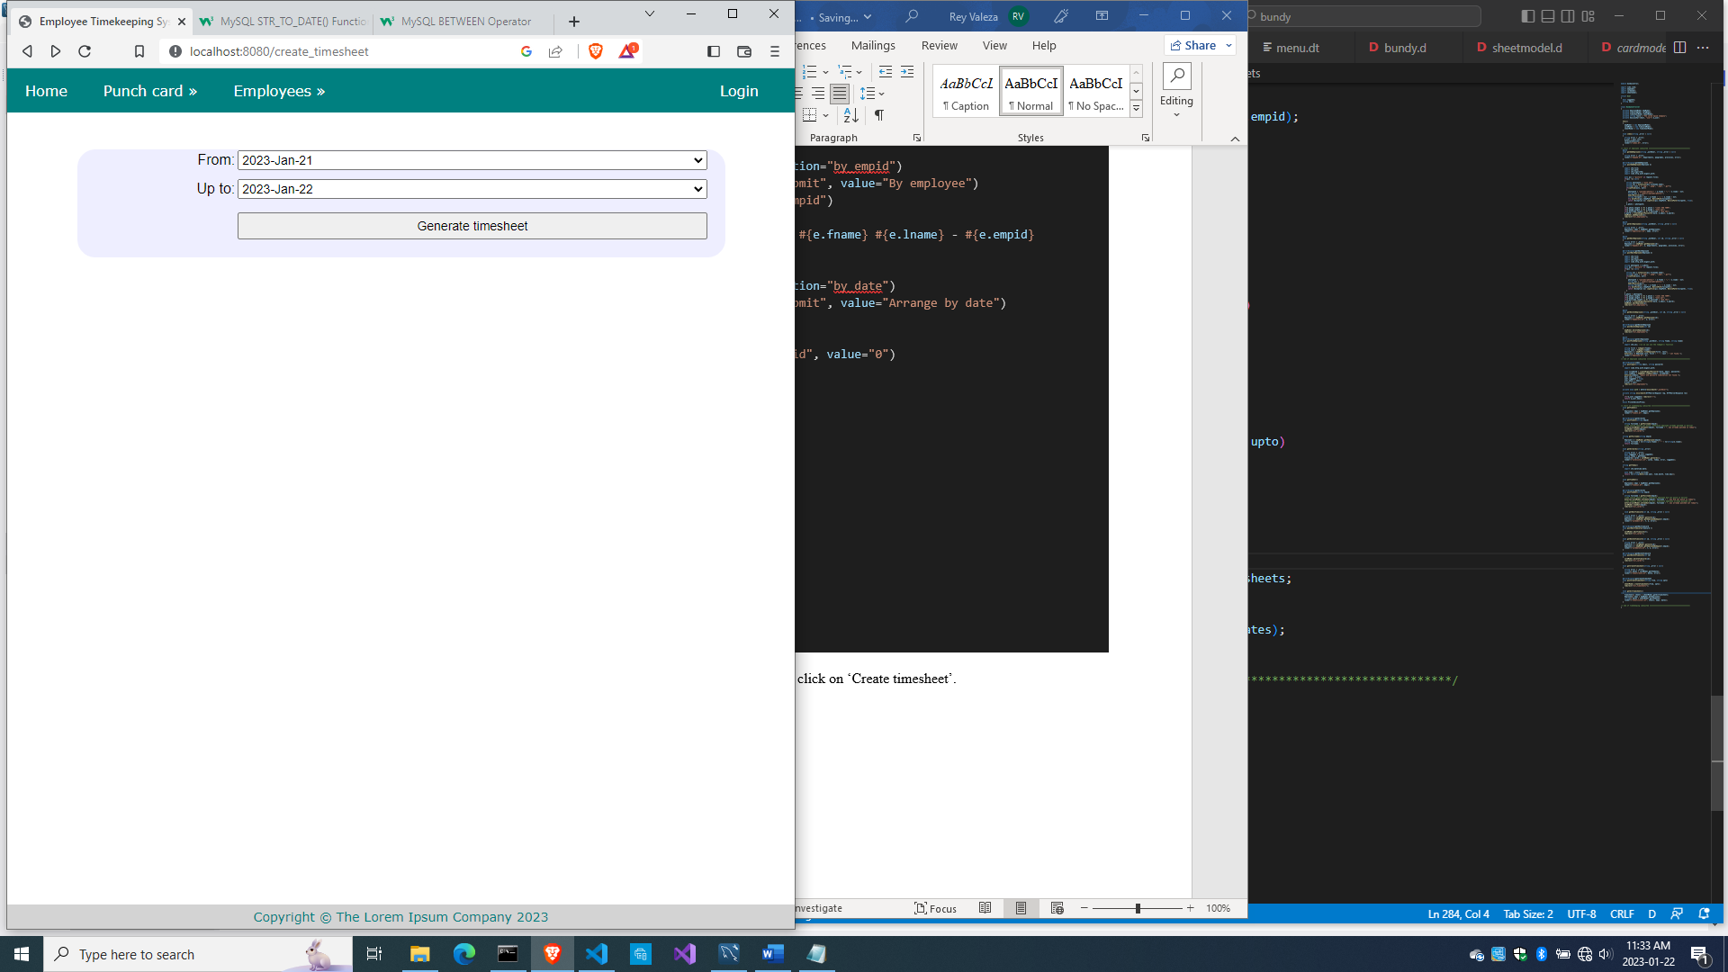

Pick a start date and an end date for the time period and click on ‘Generate timesheet’ and you should see something like this:

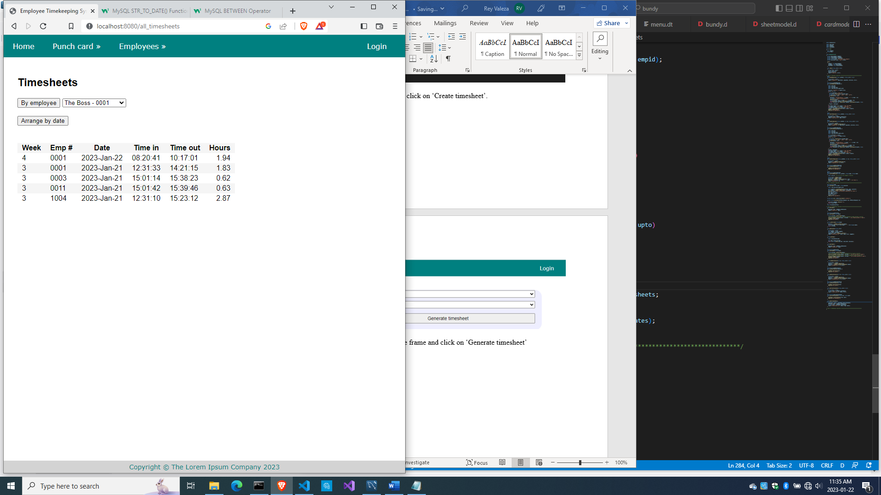

So we were able to generate a timesheet from a given time period.

So here’s the whole source\bundycontrol.d so far

module bundycontrol;

import vibe.vibe;

import empmodel;

import cardmodel;

import sheetmodel;

struct User

{

  bool loggedIn;

  string email;

}

class BundyController

{

  private EmployeeModel empModel;

  private TimecardModel cardModel;

  private TimesheetModel sheetModel;

  private string realm = "The Lorem Ipsum Company";

  private SessionVar!(User, "user") m_user;

  this()

  {

    empModel = new EmployeeModel;

    cardModel = new TimecardModel;

    sheetModel = new TimesheetModel;

  }

  void index(string _error = null)

  {

    string error = _error;

    m_user = User.init;

    terminateSession;

    render!("index.dt", error);

  }

/* start of employee subsystem *********************************************/

  @auth

  void getAddEmployee(string _authUser, string _error = null)

  {

    string error = _error;

    render!("empadd.dt", departments, paygrades, provinces, error);

  }

  @errorDisplay!getAddEmployee

  void postAddEmployee(Employee e)

  {

    import std.file;

    import std.path;

    import std.algorithm;

    import vibe.http.auth.digest_auth;

    auto pic = "picture" in request.files;

    if(pic !is null)

    {

      string photopath = "none yet";

      string ext = extension(pic.filename.name);

      string[] exts = [".jpg", ".jpeg", ".png", ".gif"];

      if(canFind(exts, ext))

      {

        photopath = "uploads/photos/" ~ e.fname ~ "_" ~ e.lname ~ ext;

        string dir = "./public/uploads/photos/";

        mkdirRecurse(dir);

        string fullpath = dir ~ e.fname ~ "_" ~ e.lname ~ ext;

        try moveFile(pic.tempPath, NativePath(fullpath));

        catch (Exception ex) copyFile(pic.tempPath, NativePath(fullpath), true);

      }

      e.photo = photopath;

    }

    if(e.phone.length == 0) e.phone = "(123) 456 7890";

    if(e.paygd.length == 0) e.paygd = "none yet";

    if(e.postcode.length == 0) e.postcode = "A1A 1A1";

    e.pword = createDigestPassword(realm, e.email, e.pword);

    empModel.addEmployee(e);

    redirect("all_employees");

  }

  @auth

  void getAllEmployees(string _authUser, string _error = null)

  {

    string error = _error;

    Employee[] emps = empModel.getEmployees;

    render!("emplistall.dt", emps, error);

  }

  @auth

  void getEditEmployee(string _authUser, int id, string _error = null)

  {

    string error = _error;

    Employee e = empModel.getEmployee(id);

    render!("empedit.dt", e, departments, paygrades, provinces, error);

  }

  @errorDisplay!getEditEmployee

  void postEditEmployee(Employee e)

  {

    import std.file;

    import std.path;

    import std.algorithm;

    import vibe.http.auth.digest_auth;

    string photopath = e.photo;

    auto pic = "picture" in request.files;

    if(pic !is null)

    {

      string ext = extension(pic.filename.name);

      string[] exts = [".jpg", ".jpeg", ".png", ".gif"];

      if(canFind(exts, ext))

      {

        photopath = "uploads/photos/" ~ e.fname ~ "_" ~ e.lname ~ ext;

        string dir = "./public/uploads/photos/";

        mkdirRecurse(dir);

        string fullpath = dir ~ e.fname ~ "_" ~ e.lname ~ ext;

        try moveFile(pic.tempPath, NativePath(fullpath));

        catch (Exception ex) copyFile(pic.tempPath, NativePath(fullpath), true);

      }

    }

    e.photo = photopath;

    if(e.phone.length == 0) e.phone = "(123) 456 7890";

    if(e.paygd.length == 0) e.paygd = "none yet";

    if(e.postcode.length == 0) e.postcode = "A1A 1A1";

    e.pword = createDigestPassword(realm, e.email, e.pword);

    empModel.editEmployee(e);

    redirect("all_employees");

  }

  @auth

  void getDeleteEmployee(string _authUser, int id, string _error = null)

  {

    string error = _error;

    Employee e = empModel.getEmployee(id);

    render!("empdelete.dt", e, error);

  }

  @errorDisplay!getDeleteEmployee

  void postDeleteEmployee(int id)

  {

    empModel.deleteEmployee(id);

    redirect("all_employees");

  }

  @auth

  @errorDisplay!getAllEmployees

  void postFindEmployee(string _authUser, string fname, string lname)

  {

    import std.uni; //so we can use the toUpper() function

    string first = toUpper(fname);

    string last = toUpper(lname);

    Employee e = empModel.findEmployee(first, last);

    enforce(e != Employee.init, first ~ " " ~ last ~ " not found.");

    render!("employee.dt", e);

  }

/* end of employee subsystem ***********************************************/

  @errorDisplay!index

  void postLogin(string email, string password)

  {

    import vibe.http.auth.digest_auth;

    auto scrambled = createDigestPassword(realm, email, password);

    bool isAdmin = empModel.isAdmin(email, scrambled);

    enforce(isAdmin, "Email and password combination not found.");

    User user = m_user;

    user.loggedIn = true;

    user.email = email;

    m_user = user;

    redirect("all_employees");

  }

  private enum auth = before!ensureAuth("_authUser");

  private string ensureAuth(HTTPServerRequest req, HTTPServerResponse res)

  {

    if(!m_user.loggedIn) redirect("/");

    return m_user.email;

  }

  mixin PrivateAccessProxy;

/* start of timekeeping subsystem ******************************************/

  void getTimeIn()

  {

    Employee[] emps = empModel.getEmployees;

    render!("timein.dt", emps);

  }

  @errorDisplay!getAllCards

  void postTimeIn(string empid)

  {

    string fullname = getFullname(empid);

    //the record should not exist, otherwise employee already punched in earlier

    enforce(cardModel.noTimeIn(empid), fullname ~ ", you already punched in today");

    cardModel.timeIn(empid);

    redirect("all_cards");

  }

  string getFullname(string empid)

  {

    Employee e = empModel.getEmployee(empid);

    string fullname = to!string(e.fname) ~ " " ~ to!string(e.lname);

    return fullname;

  }

  void getAllCards(string _error)

  {

    string error = _error;

    bool loggedIn = m_user.loggedIn;

    string today = getToday;

    Timecard[] cards = cardModel.getCards();

    render!("cardlistall.dt", cards, today, error, loggedIn);

  }

  string getToday()

  {

    import std.datetime.date;

    auto time = Clock.currTime;

    return to!string(Date(time.year, time.month, time.day));

  }

  void getTimeOut()

  {

    Employee[] emps = empModel.getEmployees;

    render!("timeout.dt", emps);

  }

  @errorDisplay!getAllCards

  void postTimeOut(string empid)

  {

    string fullname = getFullname(empid);

    //the record should exist, otherwise employee did not punch in earlier

    enforce(!cardModel.noTimeIn(empid), fullname ~ ", you did not punch in today");

    //the timeout field should be null, otherwise employee already punched out

    enforce(cardModel.noTimeOut(empid), fullname ~ ", you already punched out today");

    cardModel.timeOut(empid);

    redirect("all_cards");

  }

    void getEditTimecard(int id, string _error = null)

  {

    string error = _error;

    Timecard t = cardModel.getCard(id);

    Employee e = empModel.getEmployeeByEmpid(t.empid);

    render!("cardedit.dt", t, e, error);

  }

  @errorDisplay!getEditTimecard

  void postEditTimecard(Timecard t)

  {

    cardModel.editTimecard(t);

    redirect("all_cards");

  }

  void getDeleteTimecard(int id, string _error = null)

  {

    string error = _error;

    Timecard t = cardModel.getCard(id);

    Employee e = empModel.getEmployeeByEmpid(t.empid);

    render!("carddelete.dt", t, e, error);

  }

  @errorDisplay!getDeleteTimecard

  void postDeleteTimecard(int id)

  {

    cardModel.deleteTimecard(id);

    redirect("all_cards");

  }

  void getCreateTimesheet(string _error = null)

  {

    string error = _error;

    string[] dates = cardModel.getThedates;

    render!("sheetcreate.dt", dates, error);

  }

  @errorDisplay!getCreateTimesheet

  void postCreateTimesheet(string from, string upto)

  {

    sheetModel.createTimesheets(from, upto);

    redirect("all_timesheets");

  }

  void getAllTimesheets()

  {

    Timesheet[] sheets = sheetModel.getAllTimesheets;

    Employee[] emps = empModel.getEmployees;

    string[] dates = sheetModel.getThedates;

    render!("sheetlistall.dt", sheets, emps, dates);

  }

/* end of timekeeping subsystem ********************************************/

}

And here’s source\sheetmodel.d so far

module sheetmodel;

import std.array;

import std.conv;

import mysql;

struct Timesheet

{

  int id;

  int period;

  string empid;

  string thedate;

  string timein;

  string timeout;

  double hours;

}

class TimesheetModel

{

  Connection conn;

  this()

  {

    string url = "host=localhost;port=3306;user=owner;pwd=qwerty;db=empdb";

    conn = new Connection(url);

    scope(exit) conn.close;

  }

  string[] getThedates()

  {

    string sql = "select distinct thedate from timesheets order by thedate";

    Row[] rows = conn.query(sql).array;

    string[] dates;

    foreach (row; rows) dates ~= to!string(row[0]);

    return dates;

  }

  void createTimesheets(string from, string upto)

  {

    string sql = "delete from timesheets";

    conn.exec(sql);

    sql = "insert into timesheets(period, empid, thedate, timein, timeout, hours)

                  select week(thedate), empid, thedate, timein, timeout,

                  round((time_to_sec(timeout)-time_to_sec(timein))/3600,2)

                  from timecards where timeout is not null

                  and thedate between str_to_date(?,'%Y-%b-%d') and str_to_date(?,'%Y-%b-%d')

                  order by thedate desc, empid";

    Prepared pstmt = conn.prepare(sql);

    pstmt.setArgs(from, upto);

    conn.exec(pstmt);

  }

  Timesheet[] getAllTimesheets()

  {

    string sql = "select * from timesheets";

    Row[] rows = conn.query(sql).array;

    Timesheet[] sheets;

    foreach (row; rows)

    {

      Timesheet t;

      t.id = to!int(to!string(row[0]));

      t.period = to!int(to!string(row[1]));

      t.empid = to!string(row[2]);

      t.thedate = to!string(row[3]);

      t.timein = to!string(row[4]);

      t.timeout = to!string(row[5]);

      t.hours = to!double(to!string(row[6]));

      sheets ~= t;

    }

    return sheets;

  }

}

Now let’s see about custom arrangement of the timesheet data.

Rearranging the timesheet data

We provided two buttons on the list of timesheets, one for filtering the data so only the data for a given employee is shown, and the other for arranging the data by date. These operations are just samples of rearranging data and are somewhat contrived.

Add this code to source\bundycontrol.d

  void postByEmpid(string empid)

  {

    Timesheet[] sheets = sheetModel.getByEmpid(empid);

    Employee e = empModel.getEmployee(empid);

    string fullname = to!string(e.fname) ~ " " ~ to!string(e.lname);

    render!("sheetbyempid.dt", sheets, empid, fullname);

  }

  void postByDate()

  {

    Timesheet[] sheets = sheetModel.getByDate;

    string today = getToday;

    render!("sheetbydate.dt", sheets, today);

  }

So we defined the two methods in one go, meant for the actions when clicking the two buttons.

Create views\sheetbyempid.dt

extends layout

block maincontent

  include csstable.dt

  h2 Timesheet for #{fullname} - #{empid}

  div.form-grid-wrapper

    form.form-grid(method="get", action="all_timesheets")

      input.form-grid-input(type="submit", value="Back")

  div.table-wrapper

    table

      tr

        th Week

        th Date

        th Time in

        th Time out

        th Hours

      -double totalhours = 0.0;

      -foreach(s; sheets)

        -totalhours += s.hours;

        tr

          td #{s.period}

          td #{s.thedate}

          td #{s.timein}

          td #{s.timeout}

          td.right-align #{s.hours}

      tr

        td.right-align(colspan="5") ----------

      tr

        td.right-align(colspan="4") Total hours:

        td.right-align #{totalhours}

and create views\sheetbydate.dt

extends layout

block maincontent

  include csstable.dt

  h2 Timesheet as of #{today}

  div.form-grid-wrapper

    form.form-grid(method="get", action="all_timesheets")

      input.form-grid-input(type="submit", value="Back")

  div.table-wrapper

    table

      tr

        th Date

        th Week

        th Emp #

        th Time in

        th Time out

        th Hours

      -foreach(s; sheets)

        tr

          td #{s.thedate}

          td #{s.period}

          td #{s.empid}

          td #{s.timein}

          td #{s.timeout}

          td.right-align #{s.hours}

and add this code to source\sheetmodel.d

  Timesheet[] getByEmpid(string empid)

  {

    string sql = "select * from timesheets where empid=?";

    Prepared pstmt = conn.prepare(sql);

    pstmt.setArgs(empid);

    Row[] rows = conn.query(pstmt).array;

    Timesheet[] sheets;

    foreach (row; rows)

    {

      Timesheet t;

      t.id = to!int(to!string(row[0]));

      t.period = to!int(to!string(row[1]));

      t.empid = to!string(row[2]);

      t.thedate = to!string(row[3]);

      t.timein = to!string(row[4]);

      t.timeout = to!string(row[5]);

      t.hours = to!double(to!string(row[6]));

      sheets ~= t;

    }

    return sheets;

  }

  Timesheet[] getByDate()

  {

    string sql = "select * from timesheets order by thedate";

    Row[] rows = conn.query(sql).array;

    Timesheet[] sheets;

    foreach (row; rows)

    {

      Timesheet t;

      t.id = to!int(to!string(row[0]));

      t.period = to!int(to!string(row[1]));

      t.empid = to!string(row[2]);

      t.thedate = to!string(row[3]);

      t.timein = to!string(row[4]);

      t.timeout = to!string(row[5]);

      t.hours = to!double(to!string(row[6]));

      sheets ~= t;

    }

    return sheets;

  }

Now compile, run and refresh the browser.

Choose one employee:

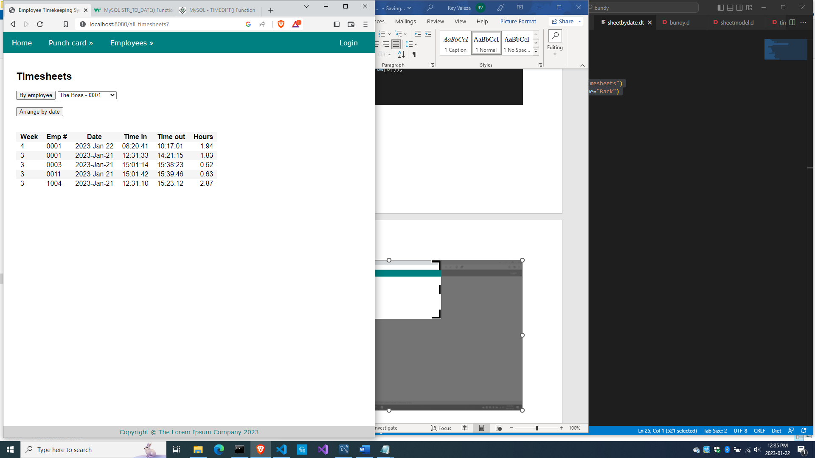

And you should see this:

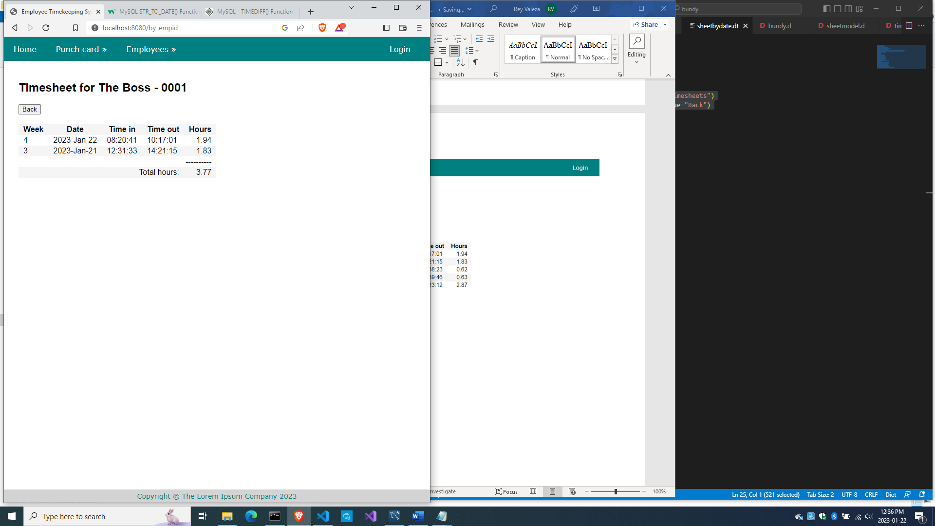

And if you choose ‘Arrange by date’, you should see this

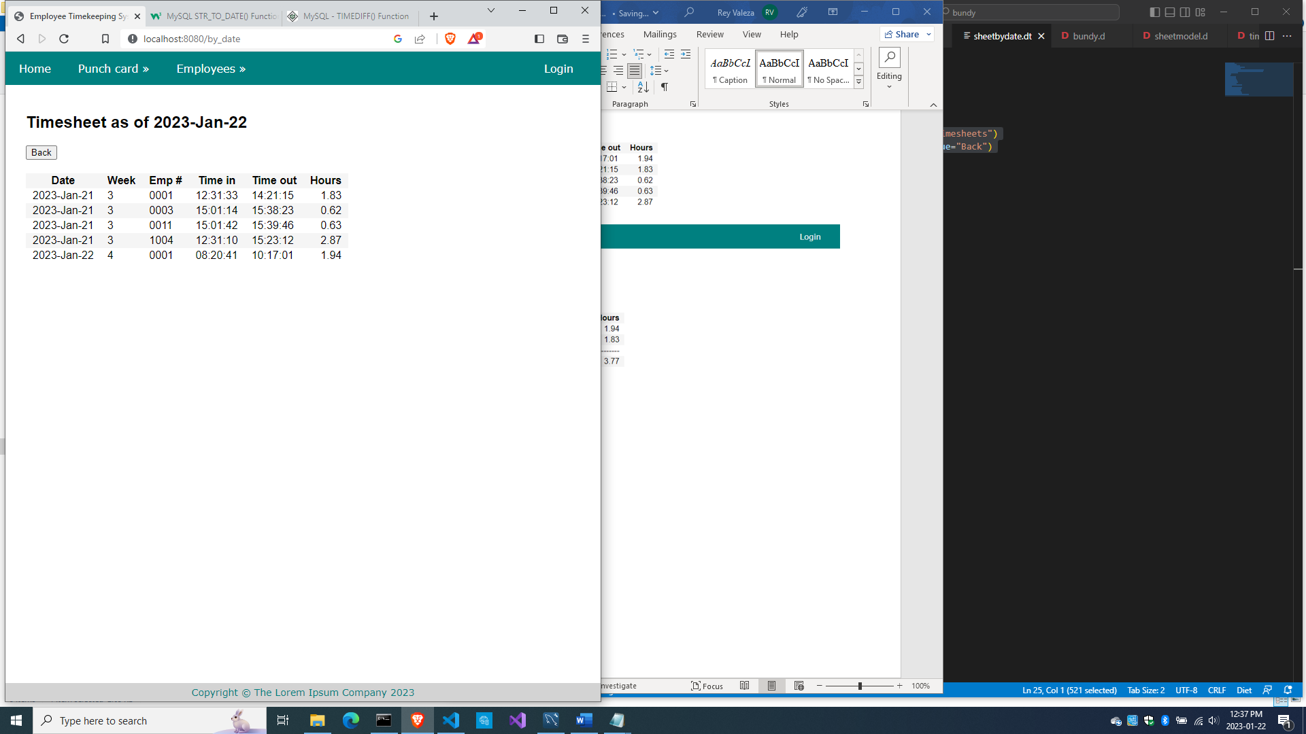

And with that, we are done!

All the source code

Here is source\app.d

import vibe.vibe;

import bundycontrol;

void main()

{

  auto settings = new HTTPServerSettings;

  settings.port = 8080;

  settings.bindAddresses = ["::1", "127.0.0.1"];

  settings.sessionStore = new MemorySessionStore;

  auto router = new URLRouter;

  router.get("*", serveStaticFiles("public/"));

  router.registerWebInterface(new BundyController);

  auto listener = listenHTTP(settings, router);

  scope (exit) listener.stopListening();

  runApplication();

}

Here is source\bundycontrol.d

module bundycontrol;

import vibe.vibe;

import empmodel;

import cardmodel;

import sheetmodel;

struct User

{

  bool loggedIn;

  string email;

}

class BundyController

{

  private EmployeeModel empModel;

  private TimecardModel cardModel;

  private TimesheetModel sheetModel;

  private string realm = "The Lorem Ipsum Company";

  private SessionVar!(User, "user") m_user;

  this()

  {

    empModel = new EmployeeModel;

    cardModel = new TimecardModel;

    sheetModel = new TimesheetModel;

  }

  void index(string _error = null)

  {

    string error = _error;

    m_user = User.init;

    terminateSession;

    render!("index.dt", error);

  }

/* start of employee subsystem *********************************************/

  @auth

  void getAddEmployee(string _authUser, string _error = null)

  {

    string error = _error;

    render!("empadd.dt", departments, paygrades, provinces, error);

  }

  @errorDisplay!getAddEmployee

  void postAddEmployee(Employee e)

  {

    import std.file;

    import std.path;

    import std.algorithm;

    import vibe.http.auth.digest_auth;

    auto pic = "picture" in request.files;

    if(pic !is null)

    {

      string photopath = "none yet";

      string ext = extension(pic.filename.name);

      string[] exts = [".jpg", ".jpeg", ".png", ".gif"];

      if(canFind(exts, ext))

      {

        photopath = "uploads/photos/" ~ e.fname ~ "_" ~ e.lname ~ ext;

        string dir = "./public/uploads/photos/";

        mkdirRecurse(dir);

        string fullpath = dir ~ e.fname ~ "_" ~ e.lname ~ ext;

        try moveFile(pic.tempPath, NativePath(fullpath));

        catch (Exception ex) copyFile(pic.tempPath, NativePath(fullpath), true);

      }

      e.photo = photopath;

    }

    if(e.phone.length == 0) e.phone = "(123) 456 7890";

    if(e.paygd.length == 0) e.paygd = "none yet";

    if(e.postcode.length == 0) e.postcode = "A1A 1A1";

    e.pword = createDigestPassword(realm, e.email, e.pword);

    empModel.addEmployee(e);

    redirect("all_employees");

  }

  @auth

  void getAllEmployees(string _authUser, string _error = null)

  {

    string error = _error;

    Employee[] emps = empModel.getEmployees;

    render!("emplistall.dt", emps, error);

  }

  @auth

  void getEditEmployee(string _authUser, int id, string _error = null)

  {

    string error = _error;

    Employee e = empModel.getEmployee(id);

    render!("empedit.dt", e, departments, paygrades, provinces, error);

  }

  @errorDisplay!getEditEmployee

  void postEditEmployee(Employee e)

  {

    import std.file;

    import std.path;

    import std.algorithm;

    import vibe.http.auth.digest_auth;

    string photopath = e.photo;

    auto pic = "picture" in request.files;

    if(pic !is null)

    {

      string ext = extension(pic.filename.name);

      string[] exts = [".jpg", ".jpeg", ".png", ".gif"];

      if(canFind(exts, ext))

      {

        photopath = "uploads/photos/" ~ e.fname ~ "_" ~ e.lname ~ ext;

        string dir = "./public/uploads/photos/";

        mkdirRecurse(dir);

        string fullpath = dir ~ e.fname ~ "_" ~ e.lname ~ ext;

        try moveFile(pic.tempPath, NativePath(fullpath));

        catch (Exception ex) copyFile(pic.tempPath, NativePath(fullpath), true);

      }

    }

    e.photo = photopath;

    if(e.phone.length == 0) e.phone = "(123) 456 7890";

    if(e.paygd.length == 0) e.paygd = "none yet";

    if(e.postcode.length == 0) e.postcode = "A1A 1A1";

    e.pword = createDigestPassword(realm, e.email, e.pword);

    empModel.editEmployee(e);

    redirect("all_employees");

  }

  @auth

  void getDeleteEmployee(string _authUser, int id, string _error = null)

  {

    string error = _error;

    Employee e = empModel.getEmployee(id);

    render!("empdelete.dt", e, error);

  }

  @errorDisplay!getDeleteEmployee

  void postDeleteEmployee(int id)

  {

    empModel.deleteEmployee(id);

    redirect("all_employees");

  }

  @auth

  @errorDisplay!getAllEmployees

  void postFindEmployee(string _authUser, string fname, string lname)

  {

    import std.uni; //so we can use the toUpper() function

    string first = toUpper(fname);

    string last = toUpper(lname);

    Employee e = empModel.findEmployee(first, last);

    enforce(e != Employee.init, first ~ " " ~ last ~ " not found.");

    render!("employee.dt", e);

  }

/* end of employee subsystem ***********************************************/

  @errorDisplay!index

  void postLogin(string email, string password)

  {

    import vibe.http.auth.digest_auth;

    auto scrambled = createDigestPassword(realm, email, password);

    bool isAdmin = empModel.isAdmin(email, scrambled);

    enforce(isAdmin, "Email and password combination not found.");

    User user = m_user;

    user.loggedIn = true;

    user.email = email;

    m_user = user;

    redirect("all_employees");

  }

  private enum auth = before!ensureAuth("_authUser");

  private string ensureAuth(HTTPServerRequest req, HTTPServerResponse res)

  {

    if(!m_user.loggedIn) redirect("/");

    return m_user.email;

  }

  mixin PrivateAccessProxy;

/* start of timekeeping subsystem ******************************************/

  void getTimeIn()

  {

    Employee[] emps = empModel.getEmployees;

    render!("timein.dt", emps);

  }

  @errorDisplay!getAllCards

  void postTimeIn(string empid)

  {

    string fullname = getFullname(empid);

    //the record should not exist, otherwise employee already punched in earlier

    enforce(cardModel.noTimeIn(empid), fullname ~ ", you already punched in today");

    cardModel.timeIn(empid);

    redirect("all_cards");

  }

  string getFullname(string empid)

  {

    Employee e = empModel.getEmployee(empid);

    string fullname = to!string(e.fname) ~ " " ~ to!string(e.lname);

    return fullname;

  }

  void getAllCards(string _error)

  {

    string error = _error;

    bool loggedIn = m_user.loggedIn;

    string today = getToday;

    Timecard[] cards = cardModel.getCards();

    render!("cardlistall.dt", cards, today, error, loggedIn);

  }

  string getToday()

  {

    import std.datetime.date;

    auto time = Clock.currTime;

    return to!string(Date(time.year, time.month, time.day));

  }

  void getTimeOut()

  {

    Employee[] emps = empModel.getEmployees;

    render!("timeout.dt", emps);

  }

  @errorDisplay!getAllCards

  void postTimeOut(string empid)

  {

    string fullname = getFullname(empid);

    //the record should exist, otherwise employee did not punch in earlier

    enforce(!cardModel.noTimeIn(empid), fullname ~ ", you did not punch in today");

    //the timeout field should be null, otherwise employee already punched out

    enforce(cardModel.noTimeOut(empid), fullname ~ ", you already punched out today");

    cardModel.timeOut(empid);

    redirect("all_cards");

  }

    void getEditTimecard(int id, string _error = null)

  {

    string error = _error;

    Timecard t = cardModel.getCard(id);

    Employee e = empModel.getEmployeeByEmpid(t.empid);

    render!("cardedit.dt", t, e, error);

  }

  @errorDisplay!getEditTimecard

  void postEditTimecard(Timecard t)

  {

    cardModel.editTimecard(t);

    redirect("all_cards");

  }

  void getDeleteTimecard(int id, string _error = null)

  {

    string error = _error;

    Timecard t = cardModel.getCard(id);

    Employee e = empModel.getEmployeeByEmpid(t.empid);

    render!("carddelete.dt", t, e, error);

  }

  @errorDisplay!getDeleteTimecard

  void postDeleteTimecard(int id)

  {

    cardModel.deleteTimecard(id);

    redirect("all_cards");

  }

  void getCreateTimesheet(string _error = null)

  {

    string error = _error;

    string[] dates = cardModel.getThedates;

    render!("sheetcreate.dt", dates, error);

  }

  @errorDisplay!getCreateTimesheet

  void postCreateTimesheet(string from, string upto)

  {

    sheetModel.createTimesheets(from, upto);

    redirect("all_timesheets");

  }

  void getAllTimesheets()

  {

    Timesheet[] sheets = sheetModel.getAllTimesheets;

    Employee[] emps = empModel.getEmployees;

    string[] dates = sheetModel.getThedates;

    render!("sheetlistall.dt", sheets, emps, dates);

  }

  void postByEmpid(string empid)

  {

    Timesheet[] sheets = sheetModel.getByEmpid(empid);

    Employee e = empModel.getEmployee(empid);

    string fullname = to!string(e.fname) ~ " " ~ to!string(e.lname);

    render!("sheetbyempid.dt", sheets, empid, fullname);

  }

  void postByDate()

  {

    Timesheet[] sheets = sheetModel.getByDate;

    string today = getToday;

    render!("sheetbydate.dt", sheets, today);

  }

/* end of timekeeping subsystem ********************************************/

}

Here is source\cardmodel.d

module cardmodel;

import mysql;

import std.array;

import std.conv;

struct Timecard

{

  int id;

  string empid;

  string thedate;

  string timein;

  string timeout;

}

class TimecardModel

{

  Connection conn;

  this()

  {

    string url = "host=localhost;port=3306;user=owner;pwd=qwerty;db=empdb";

    conn = new Connection(url);

    scope(exit) conn.close;

  }

  void timeIn(string empid)

  {

    string sql = "insert into timecards(empid, thedate, timein) values(?, curdate(), curtime())";

    Prepared pstmt = conn.prepare(sql);

    pstmt.setArgs(empid);

    conn.exec(pstmt);

  }

  bool noTimeIn(string empid)

  {

    string sql = "select * from timecards where empid=? and thedate=?";

    Prepared pstmt = conn.prepare(sql);

    string today = getToday;

    pstmt.setArgs(empid, today);

    Row[] rows = conn.query(pstmt).array;

    if(rows.length == 0) return true;

    return false;

  }

  string getToday()

  {

    Row[] rows = conn.query("select curdate() + 0").array;

    return to!string(rows[0][0]);

  }

  string[] getThedates()

  {

    string sql = "select distinct thedate from timecards order by thedate";

    Row[] rows = conn.query(sql).array;

    string[] dates;

    foreach (row; rows) dates ~= to!string(row[0]);

    return dates;

  }

  Timecard[] getCards()

  {

    Timecard[] cards;

    string sql = "select * from timecards order by thedate desc, timein desc";

    Row[] rows = conn.query(sql).array;

    if(rows.length == 0) return cards;

    foreach(row; rows)

    {

      Timecard c;

      c.id = to!int(to!string(row[0]));

      c.empid = to!string(row[1]);

      c.thedate = to!string(row[2]);

      c.timein = to!string(row[3]);

      c.timeout = to!string(row[4]);

      cards ~= c;

    }

    return cards;

  }

  bool noTimeOut(string empid)

  {

    string sql = "select * from timecards where timeout is null and empid=? and thedate=?";

    Prepared pstmt = conn.prepare(sql);

    string today = getToday;

    pstmt.setArgs(empid, today);

    Row[] rows = conn.query(pstmt).array;

    if(rows.length != 0) return true;

    return false;

  }

  void timeOut(string empid)

  {

    string sql = "update timecards set timeout=curtime() where empid=? and thedate=?";

    Prepared pstmt = conn.prepare(sql);

    string today = getToday;

    pstmt.setArgs(empid, today);

    conn.exec(pstmt);

  }

  Timecard getCard(int id)

  {

    Timecard c;

    string sql = "select * from timecards where id=?";

    Prepared pstmt = conn.prepare(sql);

    pstmt.setArgs(id);

    Row[] rows = conn.query(pstmt).array;

    if(rows.length == 0) return c;

    Row row = rows[0];

    c.id = to!int(to!string(row[0]));

    c.empid = to!string(row[1]);

    c.thedate = to!string(row[2]);

    c.timein = to!string(row[3]);

    c.timeout = to!string(row[4]);

    return c;

  }

  ulong editTimecard(Timecard t)

  {

    Prepared pstmt;

    if(to!string(t.timeout) == "null")

    {

      string sql = "update timecards set timein=?, timeout=null where id=?";

      pstmt = conn.prepare(sql);

      pstmt.setArgs(t.timein, t.id);

    }

    else

    {

      string sql = "update timecards set timein=?, timeout=? where id=?";

      pstmt = conn.prepare(sql);

      pstmt.setArgs(t.timein, t.timeout, t.id);

    }

    return conn.exec(pstmt);

  }

  void deleteTimecard(int id)

  {

    string sql = "delete from timecards where id=?";

    Prepared pstmt = conn.prepare(sql);

    pstmt.setArgs(id);

    conn.exec(pstmt);

  }

}

Here is source\empmodel.d

module empmodel;

import mysql;

import std.conv;

import std.array;

struct Employee

{

  int id; //row id or record id

  string empid; //employee number

  string deprt; //department

  string paygd; //salary grade

  string email; //email address

  string pword; //password

  string fname; //first name

  string lname; //last name

  string phone; //phone number

  string photo; //ID photo

  string street; //street address

  string city; //city name

  string province; //province name

  string postcode; //postal code

}

struct Admin

{

  string email; //email address

  string pword; //passsword

}

string[] departments =

[

  "Management",

  "Accounting",

  "Production",

  "Maintenance",

  "Shipping",

  "Purchasing",

  "IT Services",

  "HR Services",

  "Marketing"

];

string[][] provinces =

[

  ["AB", "Alberta"],

  ["BC", "British Columbia"],

  ["MB", "Manitoba"],

  ["NB", "New Brunswick"],

  ["NL", "Newfoundland and Labrador"],

  ["NS", "Nova Scotia"],

  ["NT", "Northwest Territories"],

  ["NU", "Nunavut"],

  ["ON", "Ontario"],

  ["PE", "Prince Edward Island"],

  ["QC", "Quebec"],

  ["SK", "Saskatchewan"],

  ["YT", "Yukon Territory"]

];

string[] paygrades =

[

  "A100", "A200", "A300", "A400",

  "B100", "B200", "B300", "B400",

  "C100", "C200", "C300", "C400",

  "D100", "D200", "D300", "D400",

  "E100", "E200", "E300", "E400",

  "F100", "F200", "F300", "F400"

];

class EmployeeModel

{

  Connection conn;

  this()

  {

    string url = "host=localhost;port=3306;user=owner;pwd=qwerty;db=empdb";

    conn = new Connection(url);

    scope(exit) conn.close;

  }

  ulong addEmployee(Employee e)

  {

    string sql =

      "insert into employees

      (

        empid,

        deprt, paygd, email, pword,

        fname, lname, phone, photo,

        street, city, province, postcode

      )

      values(?,?,?,?,?,?,?,?,?,?,?,?,?)";

    Prepared pstmt = conn.prepare(sql);

    pstmt.setArgs

    (

      to!string(e.empid),

      to!string(e.deprt),

      to!string(e.paygd),

      to!string(e.email),

      to!string(e.pword),

      to!string(e.fname),

      to!string(e.lname),

      to!string(e.phone),

      to!string(e.photo),

      to!string(e.street),

      to!string(e.city),

      to!string(e.province),

      to!string(e.postcode)

    );

    return conn.exec(pstmt);

  }

  Employee[] getEmployees()

  {

    Employee[] emps;

    string sql = "select * from employees";

    Row[] rows = conn.query(sql).array;

    if(rows.length == 0) return emps;

    return prepareEmployees(rows);

  }

  Employee[] prepareEmployees(Row[] rows)

  {

    Employee[] emps;

    foreach(row; rows)

    {

      Employee e = prepareEmployee(row);

      emps ~= e;

    }

    return emps;

  }

  Employee prepareEmployee(Row row)

  {

    Employee e;

    e.id = to!int(to!string(row[0]));

    e.empid = to!string(row[1]);

    e.deprt = to!string(row[2]);

    e.paygd = to!string(row[3]);

    e.email = to!string(row[4]);

    e.pword = to!string(row[5]);

    e.fname = to!string(row[6]);

    e.lname = to!string(row[7]);

    e.phone = to!string(row[8]);

    e.photo = to!string(row[9]);

    e.street = to!string(row[10]);

    e.city = to!string(row[11]);

    e.province = to!string(row[12]);

    e.postcode = to!string(row[13]);

    return e;

  }

  Employee getEmployee(int id)

  {

    string sql = "select * from employees where id=?";

    Prepared pstmt = conn.prepare(sql);

    pstmt.setArgs(id);

    Employee e;

    Row[] rows = conn.query(pstmt).array;

    if(rows.length == 0) return e;

    return prepareEmployee(rows[0]);

  }

  Employee getEmployee(string empid)

  {

    string sql = "select * from employees where empid=?";

    Prepared pstmt = conn.prepare(sql);

    pstmt.setArgs(empid);

    Employee e;

    Row[] rows = conn.query(pstmt).array;

    if(rows.length == 0) return e;

    return prepareEmployee(rows[0]);

  }

  ulong editEmployee(Employee e)

  {

    string sql = "update employees set empid=?,

      deprt=?, paygd=?, email=?, pword=?,

      fname=?, lname=?, phone=?, photo=?,

      street=?, city=?, province=?, postcode=?

      where id=?";

    Prepared pstmt = conn.prepare(sql);

    pstmt.setArgs

    (

      to!string(e.empid),

      to!string(e.deprt),

      to!string(e.paygd),

      to!string(e.email),

      to!string(e.pword),

      to!string(e.fname),

      to!string(e.lname),

      to!string(e.phone),

      to!string(e.photo),

      to!string(e.street),

      to!string(e.city),

      to!string(e.province),

      to!string(e.postcode),

      to!int(to!string(e.id))

    );

    return conn.exec(pstmt);

  }

  void deleteEmployee(int id)

  {

    string sql = "delete from employees where id=?";

    Prepared pstmt = conn.prepare(sql);

    pstmt.setArgs(id);

    conn.exec(pstmt);

  }

  Employee findEmployee(string first, string last)

  {

    Employee e;

    string sql = "select * from employees where upper(fname)=? and upper(lname)=?";

    Prepared pstmt = conn.prepare(sql);

    pstmt.setArgs(first, last);

    Row[] rows = conn.query(pstmt).array;

    if(rows.length == 0) return e;

    return prepareEmployee(rows[0]);

  }

  bool isAdmin(string email, string password)

  {

    string sql = "select * from admins where email=? and pword=?";

    Prepared pstmt = conn.prepare(sql);

    pstmt.setArgs(email, password);

    Row[] rows = conn.query(pstmt).array;

    if(rows.length == 0) return false;

    return true;

  }

  Employee getEmployeeByEmpid(string empid)

  {

    string sql = "select * from employees where empid=?";

    Prepared pstmt = conn.prepare(sql);

    pstmt.setArgs(empid);

    Employee e;

    Row[] rows = conn.query(pstmt).array;

    if(rows.length == 0) return e;

    return prepareEmployee(rows[0]);

  }

}

/*

  void insertIntoAdmins()

  {

    import vibe.http.auth.digest_auth;

    string email1 = "admin1@lorem.com";

    string email2 = "admin2@lorem.com";

    string email3 = "admin3@lorem.com";

    string realm = "The Lorem Ipsum Company";

    string pass1 = createDigestPassword(realm, email1, "secret");

    string pass2 = createDigestPassword(realm, email2, "secret");

    string pass3 = createDigestPassword(realm, email3, "secret");

    string sql = "insert into admins(email, pword)

      values ('" ~ email1 ~ "','" ~ pass1 ~ "')";

    conn.exec(sql);

    sql = "insert into admins(email, pword)

      values ('" ~ email2 ~ "','" ~ pass2 ~ "')";

    conn.exec(sql);

    sql = "insert into admins(email, pword)

      values ('" ~ email3 ~ "','" ~ pass3 ~ "')";

    conn.exec(sql);

  }

*/

Here is source\sheetmodel.d

module sheetmodel;

import std.array;

import std.conv;

import mysql;

struct Timesheet

{

  int id;

  int period;

  string empid;

  string thedate;

  string timein;

  string timeout;

  double hours;

}

class TimesheetModel

{

  Connection conn;

  this()

  {

    string url = "host=localhost;port=3306;user=owner;pwd=qwerty;db=empdb";

    conn = new Connection(url);

    scope(exit) conn.close;

  }

  string[] getThedates()

  {

    string sql = "select distinct thedate from timesheets order by thedate";

    Row[] rows = conn.query(sql).array;

    string[] dates;

    foreach (row; rows) dates ~= to!string(row[0]);

    return dates;

  }

  void createTimesheets(string from, string upto)

  {

    string sql = "delete from timesheets";

    conn.exec(sql);

    sql = "insert into timesheets(period, empid, thedate, timein, timeout, hours)

                  select week(thedate), empid, thedate, timein, timeout,

                  round((time_to_sec(timeout)-time_to_sec(timein))/3600,2)

                  from timecards

                  where timeout is not null

                  and thedate between str_to_date(?,'%Y-%b-%d') and str_to_date(?,'%Y-%b-%d')

                  order by thedate desc, empid";

    Prepared pstmt = conn.prepare(sql);

    pstmt.setArgs(from, upto);

    conn.exec(pstmt);

  }

  Timesheet[] getAllTimesheets()

  {

    string sql = "select * from timesheets";

    Row[] rows = conn.query(sql).array;

    Timesheet[] sheets;

    foreach (row; rows)

    {

      Timesheet t;

      t.id = to!int(to!string(row[0]));

      t.period = to!int(to!string(row[1]));

      t.empid = to!string(row[2]);

      t.thedate = to!string(row[3]);

      t.timein = to!string(row[4]);

      t.timeout = to!string(row[5]);

      t.hours = to!double(to!string(row[6]));

      sheets ~= t;

    }

    return sheets;

  }

  Timesheet[] getByEmpid(string empid)

  {

    string sql = "select * from timesheets where empid=?";

    Prepared pstmt = conn.prepare(sql);

    pstmt.setArgs(empid);

    Row[] rows = conn.query(pstmt).array;

    Timesheet[] sheets;

    foreach (row; rows)

    {

      Timesheet t;

      t.id = to!int(to!string(row[0]));

      t.period = to!int(to!string(row[1]));

      t.empid = to!string(row[2]);

      t.thedate = to!string(row[3]);

      t.timein = to!string(row[4]);

      t.timeout = to!string(row[5]);

      t.hours = to!double(to!string(row[6]));

      sheets ~= t;

    }

    return sheets;

  }

  Timesheet[] getByDate()

  {

    string sql = "select * from timesheets order by thedate";

    Row[] rows = conn.query(sql).array;

    Timesheet[] sheets;

    foreach (row; rows)

    {

      Timesheet t;

      t.id = to!int(to!string(row[0]));

      t.period = to!int(to!string(row[1]));

      t.empid = to!string(row[2]);

      t.thedate = to!string(row[3]);

      t.timein = to!string(row[4]);

      t.timeout = to!string(row[5]);

      t.hours = to!double(to!string(row[6]));

      sheets ~= t;

    }

    return sheets;

  }

}

Here is views\carddelete.dt

extends layout

block maincontent

  include cssformtimecard

  h2 Sure you want to delete #{e.fname} #{e.lname}'s punch card?

  div.form-grid-wrapper

    form.form-grid(method="post", action="delete_timecard")

      label.form-grid-label Employee :

      label.form-grid-text #{e.empid} - #{e.fname} #{e.lname}

      label.form-grid-label Date :

      label.form-grid-text #{t.thedate}

      label.form-grid-label Punched in :

      label.form-grid-text #{t.timein}

      label.form-grid-label Punched out :

      label.form-grid-text #{t.timeout}

      input(type="hidden", name="t_id", value="#{t.id}")

      input(type="hidden", name="id", value="#{t.id}")

      input(type="hidden", name="t_empid", value="#{t.empid}")

      input(type="hidden", name="t_thedate", value="#{t.thedate}")

      input(type="hidden", name="t_timein", value="#{t.timein}")

      input(type="hidden", name="t_timeout", value="#{t.timeout}")

      div

      div

      div

        a(href="all_cards")

          button.form-grid-button(type="button") Cancel

      div

        input.form-grid-button(type="submit", value="Delete")

Here is views\cardedit.dt

extends layout

block maincontent

  include cssformtimecard

  h2 Time card of #{e.fname} #{e.lname} for #{t.thedate}

  div.form-grid-wrapper

    -if(error)

      div.error-div

        span.error-message #{error}

    form.form-grid(method="post", action="edit_timecard")

      label.form-grid-label Employee :

      label.form-grid-text #{e.empid}  - #{e.fname} #{e.lname}

      label.form-grid-label Punch in :

      input.form-grid-input(type="text", name="t_timein", value="#{t.timein}")

      label.form-grid-label Punch out :

      input.form-grid-input(type="text", name="t_timeout", value="#{t.timeout}")

      div

      input(type="hidden", name="t_id", value="#{t.id}")

      input(type="hidden", name="id", value="#{t.id}")

      input(type="hidden", name="t_empid", value="#{t.empid}")

      input(type="hidden", name="t_thedate", value="#{t.thedate}")

      div

      div

        a(href="all_cards")

          button.form-grid-button(type="button") Cancel

      div

        input.form-grid-button(type="submit", value="Submit")

Here is views\cardlistall.dt

extends layout

block maincontent

  include csstable.dt

  h2 Time cards as of #{today}

  div.table-wrapper

    -if(error)

      div.error-div

        span.error-message #{error}

    table

      tr

        th Date

        th Emp #

        th Time in

        th Time out

        -if(loggedIn)

          th Action

      -foreach(c; cards)

        tr

          td #{c.thedate}

          td #{c.empid}

          td #{c.timein}

          td #{c.timeout}

          -if(loggedIn)

            td &nbsp;

              form.form-hidden(method="get", action="edit_timecard")

                input(type="hidden", name="id", value="#{c.id}")

                input(type="image", src="images/pencil.ico", height="15px")

              | &nbsp;

              form.form-hidden(method="get", action="delete_timecard")

                input(type="hidden", name="id", value="#{c.id}")

                input(type="image", src="images/trash.ico", height="15px")

              | &nbsp;

Here is views\cssformgrid.dt

:css

  .form-grid-wrapper

  {

    width: 700px;

    height: auto;

    margin: 20px auto;

    padding: 1px 20px 20px 0;

    border-radius: 20px;

    background-color: #eef;

  }

  .form-grid

  {

    display: grid;

    grid-template-columns: 1fr 3fr;

    gap: 5px;

  }

  .center-align

  {

    text-align: center;

  }

  .form-grid-label

  {

    width: 100%;

    font-size: 16px;

    text-align: right;

    padding: 2px;

  }

  .form-grid-input

  {

    width: 100%;

    font-size: 14px;

    padding: 0;

  }

  .form-grid-field

  {

    width: 100%;

    font-size: 16px;

    border-bottom: 1px solid black;

    padding: 2px;

  }

  .form-grid-button

  {

    width: 100%;

    font-size: 14px;

    height: 30px;

    margin-top: 10px;

  }

Here is views\cssformtimecard.dt

:css

  .form-grid-wrapper

  {

    width: 450px;

    height: auto;

    margin: 20px 0;

    padding: 10px;

    border-radius: 10px;

    background-color: #eef;

  }

  .form-grid

  {

    display: grid;

    grid-template-columns: 1fr 1fr;

    gap: 5px;

  }

  .form-grid-label

  {

    width: 100%;

    font-size: 16px;

    text-align: right;

    padding: 2px;

  }

  .form-grid-text

  {

    width: 100%;

    font-size: 16px;

    font-weight: bold;

    padding: 2px;

  }

  .form-grid-input

  {

    width: 95%;

    font-size: 14px;

    padding: 2px 0 2px 2px;

  }

  .form-grid-field

  {

    width: 100%;

    font-size: 16px;

    border-bottom: 1px solid black;

    padding: 2px;

  }

  .form-grid-button

  {

    width: 100%;

    font-size: 14px;

    height: 30px;

    margin: 0;

    padding: 0;

  }

Here views\csslayout.dt

:css

  body

  {

    margin: 0;

    padding: 0;

  }

  .container

  {

    display: grid;

    grid-template-rows: 30px auto 30px;

    height: 100%;

    width: 100%;

    margin: 0;

    padding: 0;

  }

  .menu

  {

    margin: 0;

    padding: 0;

  }

  /*modal form styles******************************************/

  .modal-form

  {

    position: fixed;

    font-family: 'Segoe UI', Tahoma, Geneva, Verdana, sans-serif;

    top: 0;

    right: 0;

    bottom: 0;

    left: 0;

    background: rgba(0,0,0,0.5);

    z-index: 99999;

    opacity: 0;

    pointer-events: none;

  }

  #login:target, #find_employee:target

  {

    opacity: 1;

    pointer-events: auto;

  }

  .modal-form-grid

  {

    display: grid;

    grid-template: 30px 30px 30px / 1fr 1fr;

    grid-gap: 10px;

  }

  .text-control

  {

    grid-column: 1 / 3;

  }

  #but-reset

  {

    grid-column: 1 / 2;

  }

  #but-submit

  {

    grid-column: 2 / 3;

  }

  .modal-form-wrapper-login

  {

    width: 250px;

    position: absolute;

    right: 0;

    margin-top: 40px;

    padding: 25px 20px;

    border-radius: 10px;

    text-align: center;

    background-color: whitesmoke;

  }

  .modal-form-wrapper-find_employee

  {

    width: 250px;

    position: relative;

    left: 280px;

    margin-top: 40px;

    padding: 25px 20px;

    border-radius: 10px;

    text-align: center;

    background-color: whitesmoke;

  }

  /*end of modal form styles*/

  /*content styles**************************************************/

  .content

  {

    padding: 40px 30px;

    font-family: Sans-serif;

  }

  /*end of content styles/*

  /*footer styles***************************************************/

  .footer

  {

    position: fixed;

    bottom: 0;

    width: 100%;

    background-color: lightgray;

    padding: 5px 0;

  }

  .copyright

  {

    font-family: Verdana, Geneva, Tahoma, sans-serif;

    font-size: 14px;

    text-align: center;

    color: teal;

  }

  .error-div

  {

    margin: 5px 0;

  }

  .error-message

  {

    color: brown;

    font-weight: bold;

  }

  .center-align

  {

    margin: 0 auto;

    text-align: center;

  }

  .right-align

  {

    text-align: right;

  }

  .form-hidden

  {

    padding: 0;

    margin: 0;

    display: inline;

  }

Here is views\cssmenu.dt

:css

  nav

  {

    margin: 0 auto;

    padding:0;

    width: 100%;

    height: auto;

    display: inline-block;

    background: teal; /*#37bc9b;*/

    font-family: Verdana, Geneva, Tahoma, sans-serif;

  }

  nav ul

  {

    margin:0;

    padding:0;

    list-style-type:none;

    float:left;

    display:inline-block;

  }

  nav ul li

  {

    position: relative;

    margin: 0;

    float: left;

    display: inline-block;

  }

  li > a:after { content: ' »'; } /* Change this in order to change the Dropdown symbol */

  li > a:only-child:after { content: ''; }

  nav ul li a

  {

    padding: 15px 20px;

    display: inline-block;

    color: white;

    text-decoration: none;

  }

  nav ul li a:hover

  {

    opacity: 0.5;

  }

  nav ul li ul

  {

    display: none;

    position: absolute;

    left: 0;

    background: #076;

    float: left;

    width: 200px;

  }

  nav ul li ul li

  {

    width: 100%;

    border-bottom: 1px solid rgba(255,255,255,.3);

  }

  nav ul li ul li a

  {

    padding: 10px 20px;

  }

  nav ul li:hover ul

  {

    display: block;

  }

  .link-right

  {

    float: right;

    margin-right: 20px;

  }

Here is views\csstable.dt

:css

  .table-wrapper

  {

    margin: 20px auto;

  }

  table

  {

    padding: 10px 0;

    border-spacing: 0;

    border-collapse: collapse;

  }

  table td, table th

  {

    margin: 0;

    padding: 2px 10px;

  }

  .no-border

  {

    border: 0;

  }

  tr:nth-child(odd)

  {

    background: whitesmoke;

  }

Here is views\empadd.dt

extends layout

block maincontent

  include cssformgrid.dt

  -if(error)

    div.error-div

      span.error-message #{error}

  div.form-grid-wrapper

    h2.center-align New employee details

    form.form-grid(method="post", action="add_employee", enctype="multipart/form-data")

      label.form-grid-label Employee number

      input.form-grid-input(type="empid", name="e_empid", placeholder="employee number", required)

      label.form-grid-label Department

      select#deprt.form-grid-input(name="e_deprt")

        -foreach(dep; departments)

          option(value="#{dep}") #{dep}

      label.form-grid-label Salary grade

      select#deprt.form-grid-input(name="e_paygd")

        -foreach(pay; paygrades)

          option(value="#{pay}") #{pay}

      label.form-grid-label Email address

      input.form-grid-input(type="email", name="e_email", placeholder="email@company.com", required)

      label.form-grid-label Password

      input.form-grid-input(type="password", name="e_pword", placeholder="password", required)

      label.form-grid-label First name

      input.form-grid-input(type="text", name="e_fname", placeholder="First name", required)

      label.form-grid-label Last name

      input.form-grid-input(type="text", name="e_lname", placeholder="Last name", required)

      label.form-grid-label Phone

      input.form-grid-input(type="text", name="e_phone", placeholder="Phone number")

      label.form-grid-label Street address (no city)

      input.form-grid-input(type="text", name="e_street", placeholder="Street address", required)

      label.form-grid-label City

      input.form-grid-input(type="text", name="e_city", placeholder="City", required)

      label.form-grid-label Province

      select#province.form-grid-input(name="e_province")

        -foreach(prov; provinces)

          option(value="#{prov[0]}") #{prov[1]}

      label.form-grid-label Postal code

      input.form-grid-input(type="text", name="e_postcode", placeholder="A1A 1A1")

      label.form-grid-label ID Picture

      input.form-grid-input(type="file", name="picture")

      input(type="hidden", name="e_photo")

      input(type="hidden", name="e_id", value="1")

      div

      div

        input.form-grid-button(type="reset", value="Clear the form")

        input.form-grid-button(type="submit", value="Submit")

Here is views\empdelete.dt

extends layout

block maincontent

  include cssformgrid.dt

  -if(error)

    div.error-div

      span.error-message #{error}

  div.form-grid-wrapper

    h2.center-align Are you sure you want to delete this record?

    form.form-grid(method="post", action="delete_employee")

      span.form-grid-label Employee number:

      span.form-grid-field #{e.empid}

      span.form-grid-label Department:

      span.form-grid-field #{e.deprt}

      span.form-grid-label Salary grade:

      span.form-grid-field #{e.paygd}

      span.form-grid-label Email address:

      span.form-grid-field #{e.email}

      span.form-grid-label First name:

      span.form-grid-field #{e.fname}

      span.form-grid-label Last name:

      span.form-grid-field #{e.lname}

      span.form-grid-label Phone:

      span.form-grid-field #{e.phone}

      span.form-grid-label Street address:

      span.form-grid-field #{e.street}

      span.form-grid-label City:

      span.form-grid-field #{e.city}

      span.form-grid-label Province:

      span.form-grid-field #{e.province}

      span.form-grid-label Postal code:

      span.form-grid-field #{e.postcode}

      span.form-grid-label ID Picture:

      img(src="#{e.photo}", height="80px")

      input(type="hidden", name="id", value="#{e.id}")

      div

      div

        a(href="all_employees")

          button.form-grid-button(type="button") Cancel

        input.form-grid-button(type="submit", value="Delete")

Here is views\empedit.dt

extends layout

block maincontent

  include cssformgrid.dt

  -if(error)

    div.error-div

      span.error-message #{error}

  div.form-grid-wrapper

    h2.center-align Edit employee details

    form.form-grid(method="post", action="edit_employee", enctype="multipart/form-data")

      label.form-grid-label Employee number

      input.form-grid-input(type="empid", name="e_empid", value="#{e.empid}")

      label.form-grid-label Department

      select#deprt.form-grid-input(name="e_deprt", value="#{e.deprt}")

        -foreach(dep; departments)

          -if(dep == e.deprt)

            option(value="#{dep}", selected) #{dep}

          -else

            option(value="#{dep}") #{dep}

      label.form-grid-label Salary grade

      select#paygd.form-grid-input(name="e_paygd", value="#{e.paygd}")

        -foreach(pay; paygrades)

          -if(pay == e.paygd)

            option(value="#{pay}", selected) #{pay}

          -else

            option(value="#{pay}") #{pay}

      label.form-grid-label Email address

      input.form-grid-input(type="email", name="e_email", value="#{e.email}")

      label.form-grid-label Password

      input.form-grid-input(type="password", name="e_pword", value="#{e.pword}")

      label.form-grid-label First name

      input.form-grid-input(type="text", name="e_fname", value="#{e.fname}")

      label.form-grid-label Last name

      input.form-grid-input(type="text", name="e_lname", value="#{e.lname}")

      label.form-grid-label Phone

      input.form-grid-input(type="text", name="e_phone", value="#{e.phone}")

      label.form-grid-label Street address (no city)

      input.form-grid-input(type="text", name="e_street", value="#{e.street}")

      label.form-grid-label City

      input.form-grid-input(type="text", name="e_city", value="#{e.city}")

      label.form-grid-label Province

      select#province.form-grid-input(name="e_province", value="#{e.province}")

        -foreach(prov; provinces)

          -if(prov[0] == e.province)

            option(value="#{prov[0]}", selected) #{prov[1]}

          -else

            option(value="#{prov[0]}") #{prov[1]}

      label.form-grid-label Postal code

      input.form-grid-input(type="text", name="e_postcode", value="#{e.postcode}")

      label.form-grid-label ID Picture

      img(src="#{e.photo}", height="100px")

      div

      input.form-grid-input(type="file", name="picture")

      input(type="hidden", name="e_photo", value="#{e.photo}")

      input(type="hidden", name="e_id", value="#{e.id}")

      input(type="hidden", name="id", value="#{e.id}")

      div

      div

        a(href="all_employees")

          button.form-grid-button(type="button") Cancel

        input.form-grid-button(type="submit", value="Submit")

Here is views\emplistall.dt

extends layout

block maincontent

  include csstable

  -if(error)

    div.error-div

      span.error-message #{error}

  h2 Employees of The Lorem Ipsum Company

  div.table-wrapper

    table

      tr

        th First name

        th Last name

        th Department

        th Phone number

        th Email address

        th Action

      -foreach(e; emps)

        tr

          td #{e.fname}

          td #{e.lname}

          td #{e.deprt}

          td #{e.phone}

          td #{e.email}

          td &nbsp;

            form.form-hidden(method="get", action="edit_employee")

              input(type="hidden", name="id", value="#{e.id}")

              input(type="image", src="images/pencil.ico", height="15px")

            | &nbsp;

            form.form-hidden(method="get", action="delete_employee")

              input(type="hidden", name="id", value="#{e.id}")

              input(type="image", src="images/trash.ico", height="15px")

            | &nbsp;

Here is views\employee.dt

extends layout

block maincontent

  include cssformgrid.dt

  div.form-grid-wrapper

    h2.center-align Employee details

    div.form-grid

      span.form-grid-label Employee number:

      span.form-grid-field #{e.empid}

      span.form-grid-label Department:

      span.form-grid-field #{e.deprt}

      span.form-grid-label Salary grade:

      span.form-grid-field #{e.paygd}

      span.form-grid-label Email address:

      span.form-grid-field #{e.email}

      span.form-grid-label First name:

      span.form-grid-field #{e.fname}

      span.form-grid-label Last name:

      span.form-grid-field #{e.lname}

      span.form-grid-label Phone:

      span.form-grid-field #{e.phone}

      span.form-grid-label Street address:

      span.form-grid-field #{e.street}

      span.form-grid-label City:

      span.form-grid-field #{e.city}

      span.form-grid-label Province:

      span.form-grid-field #{e.province}

      span.form-grid-label Postal code:

      span.form-grid-field #{e.postcode}

      span.form-grid-label ID Picture:

      img(src="#{e.photo}", height="80px")

      div

      div

        a(href="all_employees")

          button.form-grid-button(type="button") Close

Here is views\footer.dt

div.copyright Copyright &copy; The Lorem Ipsum Company 2023

Here is views\index.dt

extends layout

block maincontent

  h2 The Lorem Ipsum Company

  -if(error)

    div.error-div

      span.error-message #{error}

  div.

    Lorem ipsum dolor sit amet, consectetur adipiscing elit.

    Nam nec urna arcu. Quisque eleifend posuere vestibulum.

    In sed magna mauris. Phasellus bibendum ligula et placerat

    vulputate. In non suscipit lectus, a laoreet odio. Donec

    at sapien eu nisi porta condimentum. Morbi non varius ex,

    nec luctus nisl. Aenean varius dui quis arcu auctor luctus.

    Integer efficitur ornare massa, ac suscipit enim sagittis et.

    Proin vestibulum tellus in ipsum ultrices, sed imperdiet

    sapien euismod. Praesent vel facilisis mauris. Proin finibus

    congue tellus, non varius ante. Nullam tincidunt dolor felis.

    Pellentesque non luctus tellus. Curabitur et sapien at justo

    fringilla feugiat et a erat.

    <br /><br />

Here is views\layout.dt

doctype 5

html

  head

    title Employee Timekeeping System

    include csslayout.dt

  body

    div.container

      div.menu

        include menu.dt

      div.content

        block maincontent

      div.footer

        include footer.dt

Here is views\menu.dt

include cssmenu.dt

nav

  ul

    li

      a(href="/") Home

    li

      a(href="#") Punch card

      ul

        li

          a(href="time_in") Punch in

        li

          a(href="time_out") Punch out

        li

          a(href="all_cards") View cards

        li

          a(href="create_timesheet") Create timesheet

    li

      a(href="#") Employees

      ul

        li

          a(href="all_employees") Show all employees

        li

          a(href="#find_employee") Find an employee

        li

          a(href="add_employee") Add new employee

  ul.link-right

    li

      a(href="#login") Login

div#find_employee.modal-form

  div.modal-form-wrapper-find_employee

    form.modal-form-grid(method="post", action="find_employee")

      input.text-control(name="fname", type="text", placeholder=" First name", required)

      input.text-control(name="lname", type="text", placeholder=" Last name", required)

      input#but-reset(type="reset", value="Clear")

      input#but-submit(type="submit", value="Find")

    a.close(href="#close") Cancel

div#login.modal-form

  div.modal-form-wrapper-login

    form.modal-form-grid(method="post", action="login")

      input.text-control(name="email", type="email", placeholder=" email address")

      input.text-control(name="password", type="password", placeholder=" password")

      input#but-reset(type="reset", value="Clear")

      input#but-submit(type="submit", value="Login")

    a.close(href="#close") Cancel

Here is views\sheetbydate.dt

extends layout

block maincontent

  include csstable.dt

  h2 Timesheet as of #{today}

  div.form-grid-wrapper

    form.form-grid(method="get", action="all_timesheets")

      input.form-grid-input(type="submit", value="Back")

  div.table-wrapper

    table

      tr

        th Date

        th Week

        th Emp #

        th Time in

        th Time out

        th Hours

      -foreach(s; sheets)

        tr

          td #{s.thedate}

          td #{s.period}

          td #{s.empid}

          td #{s.timein}

          td #{s.timeout}

          td.right-align #{s.hours}

Here is views\sheebyempid.dt

extends layout

block maincontent

  include csstable.dt

  h2 Timesheet for #{fullname} - #{empid}

  div.form-grid-wrapper

    form.form-grid(method="get", action="all_timesheets")

      input.form-grid-input(type="submit", value="Back")

  div.table-wrapper

    table

      tr

        th Week

        th Date

        th Time in

        th Time out

        th Hours

      -double totalhours = 0.0;

      -foreach(s; sheets)

        -totalhours += s.hours;

        tr

          td #{s.period}

          td #{s.thedate}

          td #{s.timein}

          td #{s.timeout}

          td.right-align #{s.hours}

      tr

        td.right-align(colspan="5") ----------

      tr

        td.right-align(colspan="4") Total hours:

        td.right-align #{totalhours}

Here is views\sheetcreate.dt

extends layout

block maincontent

  include cssformgrid.dt

  div.form-grid-wrapper

    -if(error)

      div.error-div

        span.error-message #{error}

    form.form-grid(method="post", action="create_timesheet")

      label.form-grid-label From:

      select#from.form-grid-input(name="from")

        -foreach(d; dates)

          option(value="#{d}") #{d}

      div

      div

      label.form-grid-label Up to:

      select#from.form-grid-input(name="upto")

        -foreach(d; dates)

          option(value="#{d}") #{d}

      div

      div

        input.form-grid-button(type="submit", value="Generate timesheet")

Here is views\sheetlistall.dt

extends layout

block maincontent

  include csstable.dt

  h2 Timesheets

  div.form-grid-wrapper

    form.form-grid(method="post", action="by_empid")

      input.form-grid-input(type="submit", value="By employee")

      select.form-grid-input(name="empid")

        -foreach(e; emps)

          option(value="#{e.empid}") #{e.fname} #{e.lname} - #{e.empid}

      br

      br

    form.form-grid(method="post", action="by_date")

      input.form-grid-input(type="submit", value="Arrange by date")

      br

      br

      input(type="hidden", name="empid", value="0")

  div.table-wrapper

    table

      tr

        th Week

        th Emp #

        th Date

        th Time in

        th Time out

        th Hours

      -foreach(s; sheets)

        tr

          td #{s.period}

          td #{s.empid}

          td #{s.thedate}

          td #{s.timein}

          td #{s.timeout}

          td.right-align #{s.hours}

Here is views\timein.dt

extends layout

block maincontent

  include cssformgrid.dt

  div.form-grid-wrapper

    br

    h1#time.center-align

    br

    form.form-grid(method="post", action="time_in")

      label.form-grid-label Employee:

      select#empid.form-grid-input(name="empid")

        -foreach(e; emps)

          option(value="#{e.empid}") #{e.empid} - #{e.fname} #{e.lname}

      div

      div

        input.form-grid-button(type="submit", value="Punch in!")

  :javascript

    const displayTime = document.querySelector("#time");

    function showTime() {

      let time = new Date();

      displayTime.innerText = time.toLocaleString("en-CA", { hour12: true });

      setTimeout(showTime, 1000);

    }

    showTime();

Here is views\timeout.dt

extends layout

block maincontent

  include cssformgrid.dt

  div.form-grid-wrapper

    br

    h1#time.center-align

    br

    form.form-grid(method="post", action="time_out")

      label.form-grid-label Employee:

      select#empid.form-grid-input(name="empid")

        -foreach(e; emps)

          option(value="#{e.empid}") #{e.empid} - #{e.fname} #{e.lname}

      div

      div

        input.form-grid-button(type="submit", value="Punch out!")

  :javascript

    const displayTime = document.querySelector("#time");

    function showTime() {

      let time = new Date();

      displayTime.innerText = time.toLocaleString("en-CA", { hour12: true });

      setTimeout(showTime, 1000);

    }

    showTime();

And here is, at last, dub.json

{

  "authors": [

    "Owner"

  ],

  "copyright": "Copyright © 2023, Owner",

  "dependencies": {

    "mysql-native": "~>3.2.0",

    "vibe-d": "~>0.9"

  },

  "description": "A simple vibe.d server application.",

  "license": "proprietary",

  "name": "bundy"

}

That’s it! Yaaaaaay!